WORKWAYZ
Enterprise AI-Powered Project & Portfolio Management Platform
USER MANUAL & ROLE-BASED OPERATIONAL GUIDE
Author: Raman C Nair
Version 8.1 — Consolidated Lifecycle Navigation & Two-Tier Bug/Defect Architecture

Table of Contents
1. Setup Wizard
1.1 Database Setup
1.2 Authentication Setup
1.3 Super Admin User Creation
1.4 AI Configuration Setup
1.5 Finish Setup
2. Signup, Login & Account Management
2.1 Login Portal (Home)
2.2 Self-Service Signup
2.3 First-Login Password Reset & Pending Enablement
2.4 Profile & Account Settings
3. Access Levels & Role-Based Workspace Guide
3.1 Super Admin & Administrator Workspace View
3.2 Senior Management Workspace View
3.3 Project Manager Workspace View
3.4 Lead Workspace View
3.5 Team Member Workspace View
3.6 PMO Workspace View
4. Portfolio Flow
4.1 My Workspace — My Projects (/my-projects)
4.2 My Workspace — Global Worklog (/worklog)
4.3 My Workspace — Leave Tracker (/holidays/leave-tracker)
4.4 My Workspace — Messages (/messages)
4.5 Projects — Project Home (/project-home)
4.6 Projects — Portfolio Dashboard (/portfolio-dashboard)
4.7 Projects — Portfolio PromptBoard (/fp-portfolio-dash)
4.8 Quality — Estimation Variance (/quality/estimations)
4.9 Quality — Defect Containment (/quality/defects)
4.10 Billing — Portfolio Billing Dashboard (/billing)
4.11 Billing — Billing Rate & Rate Cards (/billing-rate)
4.12 Users — User List (/users)
4.13 Users — Resource Utilization (/utilization)
4.14 Time Off — Company Holidays (/holidays/holiday-calendar)
4.15 Time Off — Leave Policy & Quotas (/holidays/leave-settings)
5. Initial Estimation Flow
5.1 Specifications, Stack Suggest & Impacted Systems
5.2 Horizontals, AI Estimator & Confirming Estimation
5.3 Initial Estimation — Project Status
6. Project Flow
6.1 Project Details — PM Dashboard (/project-details/pm-dashboard)
6.2 Project Details — Project PromptBoard (/project-details/fp-pm-dash)
6.3 Project Details — Project Status (/project-details/project-status)
6.4 Project Details — Specifications & Environments (/project-details/specifications)
6.5 Project Details — Project Releases, Stages & Milestones (/releases/project-releases)
6.6 Development — Development Dashboard (/development/dashboard)
6.7 Development — Product Backlog, Add Requirement & Escaped Defects (/development/backlog)
6.8 Development — Grooming Board (/development/grooming)
6.9 Development — Kanban Board (/development/kanban)
6.10 Development — Sub-Tasks (/development/development-tasks)
6.11 Testing — Test Dashboard (/testing/dashboard)
6.12 Testing — Test Cases, Test Cycles & Test Executions
6.13 Testing — Bugs (/testing/defects)
6.14 Testing — Bug Tracker (/testing/defect-tracker)
6.15 Resources — Project Resources & Capacity Planning (/resources/project-resources)
6.16 Resources — Resource Workload (/resources/resource-workload)
6.17 Resources — Leave Calendar, Leave Summary & Company Holidays
6.18 Governance — RAID Dashboard, Risks, Assumptions, Issues & Dependencies
6.19 PMO — Project Documents & Governance Gates (/pmo/documents)
6.20 PMO — Fixed Bid (FB) Billing & Payment Milestones
6.21 PMO — Time & Material (TnM) Billing & Payment Milestones
6.22 PMO — Business Continuity (/pmo/business-continuity)
6.23 Project Settings & Project Trash
7. Admin Flow
7.1 Portfolio Settings — Access Settings (/portfolio-settings/access-settings)
7.2 Portfolio Settings — Database (/portfolio-settings/database)
7.3 Portfolio Settings — Authentication (/portfolio-settings/authentication)
7.4 Portfolio Settings — AI Config (/portfolio-settings/ai-config)
7.5 Portfolio Settings — Inactive Projects & Archiving (/portfolio-settings/archive)
7.6 Portfolio Settings — Cron Jobs Management (/portfolio-settings/cron-jobs)
7.7 Portfolio Settings — Test Data Studio (/portfolio-settings/test-data-studio)
7.8 Portfolio Trash (/portfolio-trash)

1. Setup Wizard
When opening the Workwayz application for the first time (or launching the Setup Wizard at /setup-wizard), a guided 5-step wizard configures your database engine, authentication provider, master Super Admin user account, and generative AI integration.

1.1 Database Setup
Configure your primary database connection. Workwayz supports zero-configuration local storage as well as cloud/containerized databases:
• Project Name: An identifier label for this database connection profile (e.g., Local Workspace DB or Production DB).
• Database Provider: Supports Local Embedded Database (Built-in / Zero-Config stored in ~/.workwayz), Supabase (cloud or self-hosted Docker), and Firebase (Firestore).
• Credentials: When Local Embedded Database is selected, no external URL or API key is required. When Firebase or Supabase is selected, enter the Project ID / URL and API / Publishable Key from your provider console.
• Actions: Click Next → to proceed to Authentication Setup.
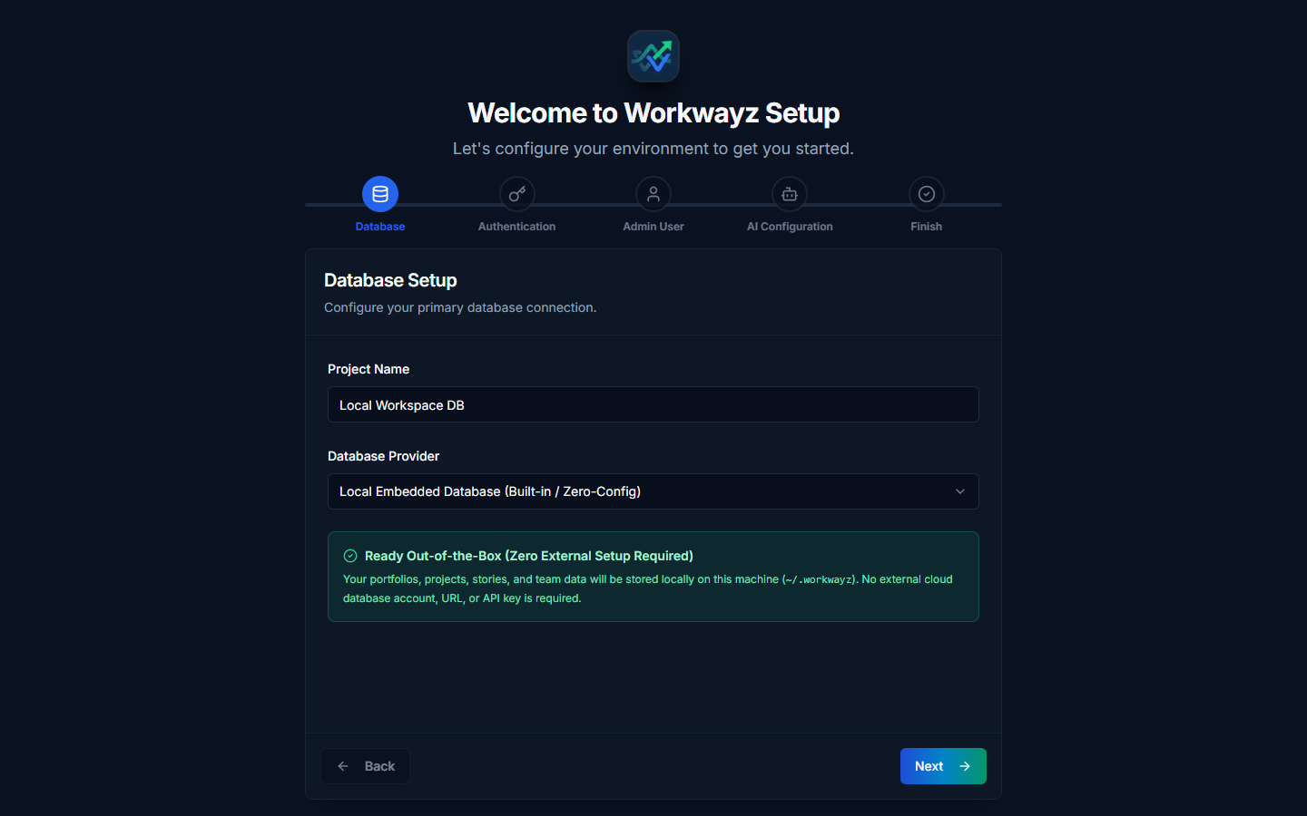
Figure 1.1 — Setup Wizard Step 1: Database Setup

1.2 Authentication Setup
Configure how users authenticate when signing into Workwayz. The Authentication Provider automatically aligns with your selected Database Provider:
• Authentication Provider: Supports Local Built-in Auth (hashes and stores credentials locally with zero external setup), Supabase Auth, and Firebase Auth.
• Single Sign-On (SSO): Optional toggles to Enable Google SSO and Enable GitHub SSO.
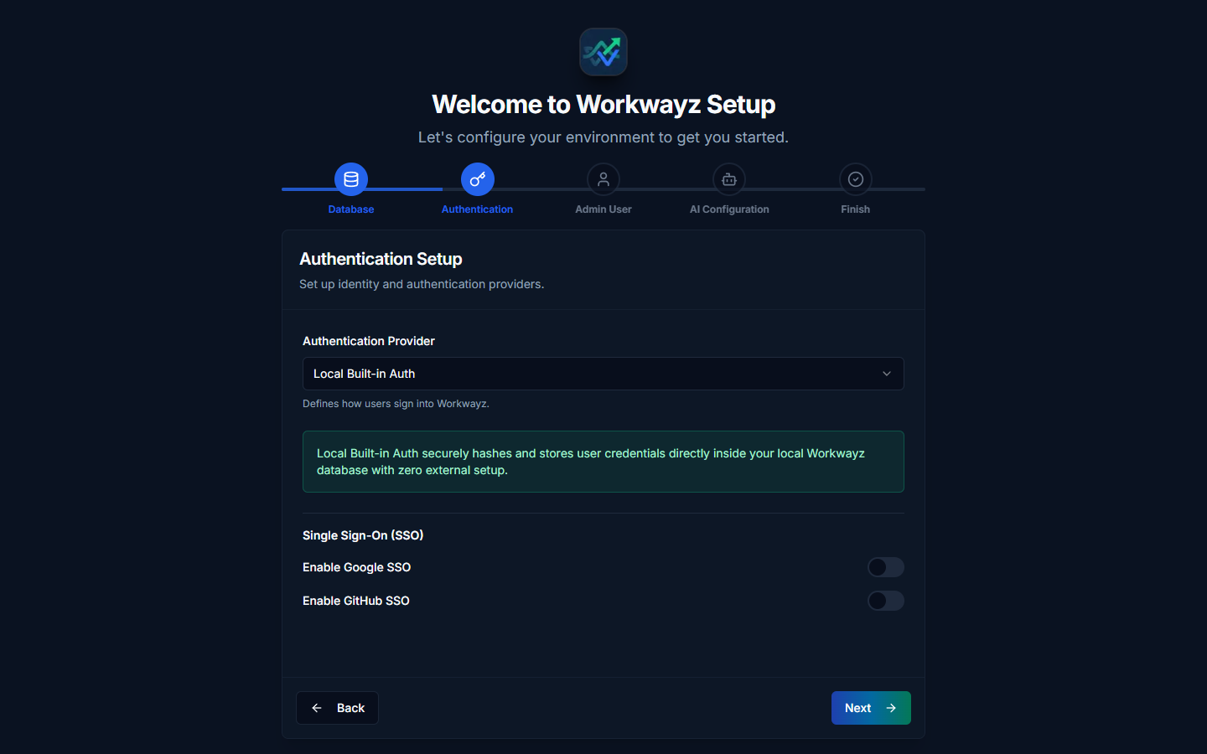
Figure 1.2 — Setup Wizard Step 2: Authentication Setup

1.3 Super Admin User Creation
Establish or reconnect the master Super Admin account for the Workwayz instance:
• Create New Super Admin: Enter First Name, Last Name, Email ID, Password, and Re-enter Password to provision a fresh master Super Admin account.
• Use Existing Credentials: If reconnecting to an existing database after reinstallation, toggle to "Use Existing Credentials" to verify and link your existing Super Admin account without resetting data.
• Role & Project Assignment Rules: The first user created is assigned the Super Admin role with full access across all modules and settings. This account cannot be deleted from the UI. Note that Super Admin and Administrator accounts act strictly as system/portfolio administrators and cannot be assigned to projects as team resources or Project Managers.
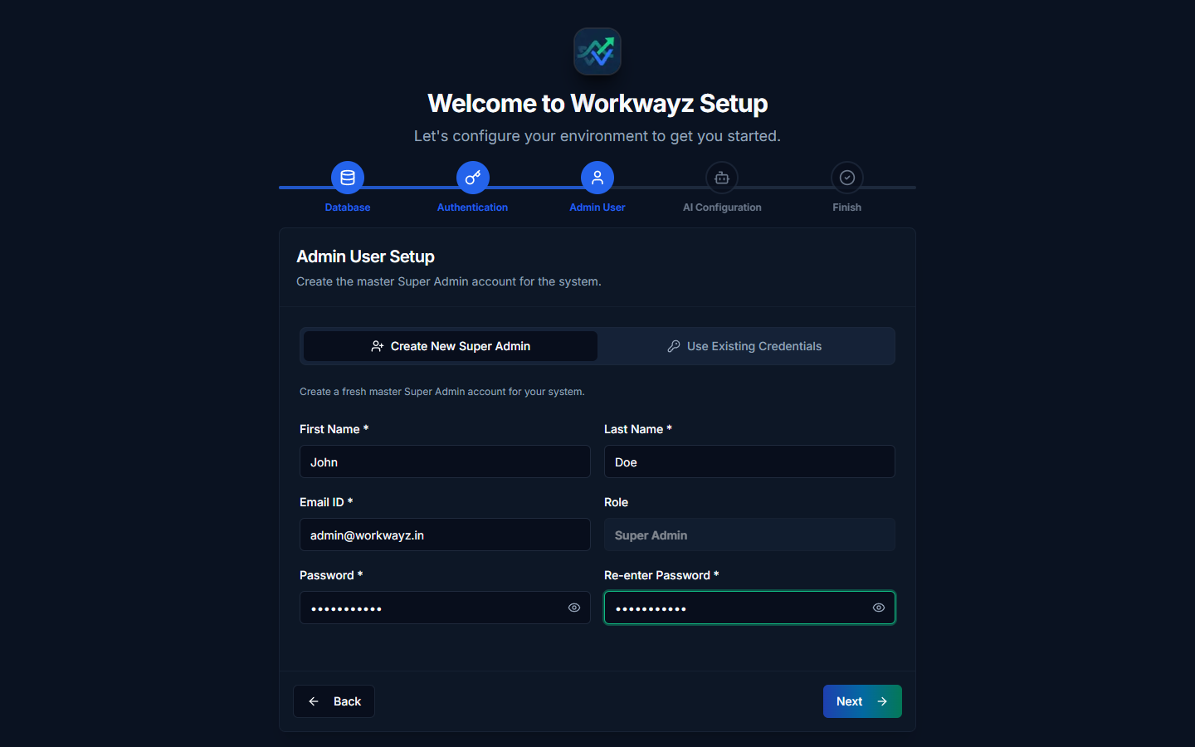
Figure 1.3 — Setup Wizard Step 3: Super Admin User Setup

1.4 AI Configuration Setup
Connect a generative AI provider to power WayFinder AI, automated stack/horizontal recommendations, AI estimation, backlog generation, test case generation, and RAID analysis. The core application runs without AI if you check "Configure AI Later".
• Project Name: Identifier for the AI configuration profile.
• AI Provider: Supports Google Gemini, OpenAI (ChatGPT), Anthropic (Claude), Ollama (Local), and LM Studio (Local).
• API Key / Base URL & Default Model Override: Enter your provider API key (or local endpoint URL) and optional model override.
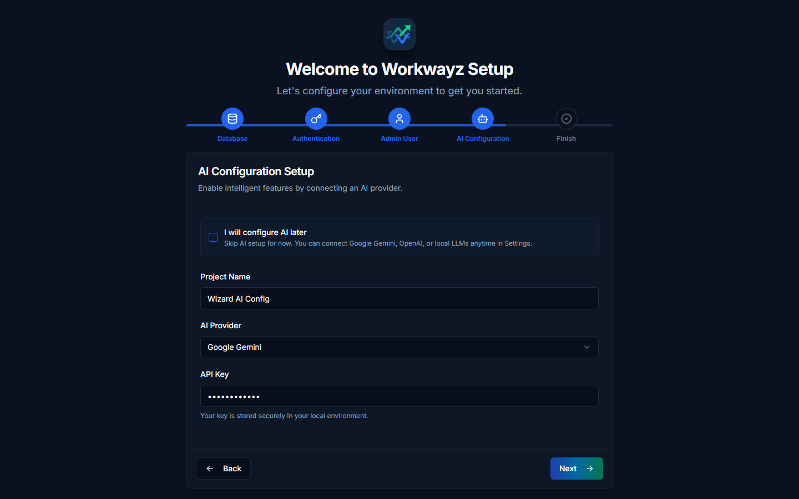
Figure 1.4 — Setup Wizard Step 4: AI Configuration Setup

1.5 Finish Setup
Review the configuration summary (Database, Authentication, Admin Account, and AI Integration) and click Complete Setup to persist the profiles and launch the Workwayz login screen.
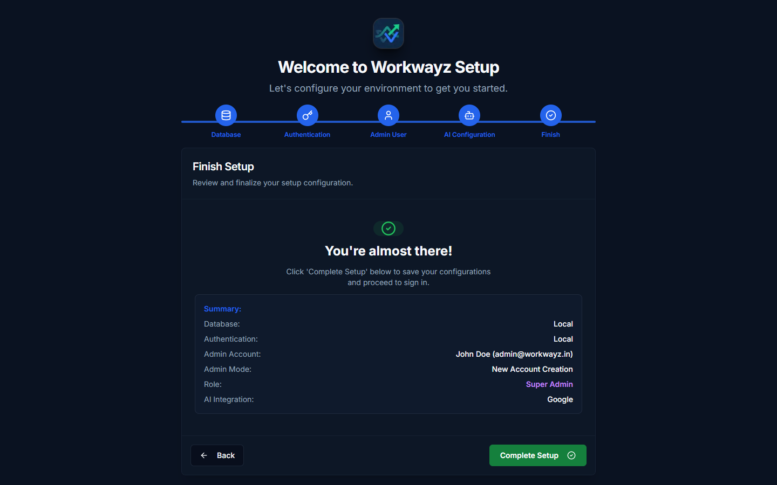
Figure 1.5 — Setup Wizard Step 5: Finish & Summary Review

2. Signup, Login & Account Management
Workwayz provides a unified authentication portal with role-aware session management, mandatory first-login password updates for admin-created accounts, and self-service registration with administrator approval gating.

2.1 Login Portal (Home)
Opening the root URL (/) or /login presents the Workwayz login screen.
• Credentials: Enter your registered Email and Password.
• Remember Me: Check "Remember me on this computer" to persist your session across browser restarts.
• Admin-Provisioned Users: When an Administrator creates a user directly from the User List, the default password is set to "P@ssw0rd". On first login, the user is automatically prompted to set a new password.
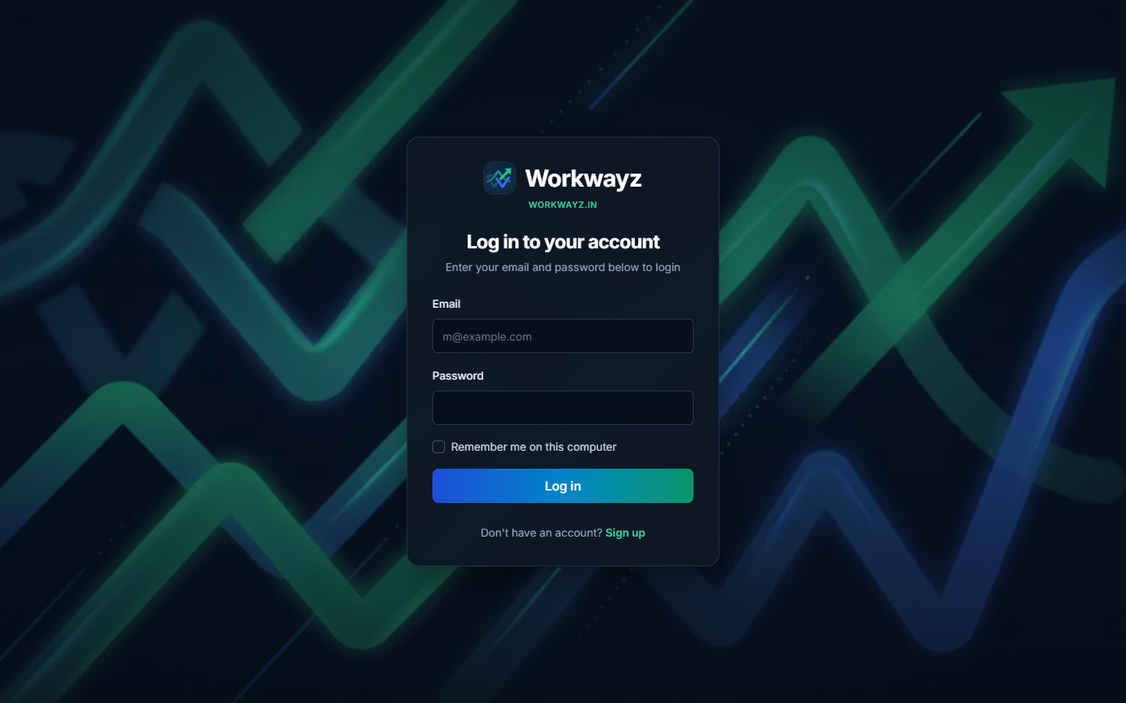
Figure 2.1 — Workwayz Login Portal

2.2 Self-Service Signup
New users can register an account by clicking "Sign up" on the login screen (/signup).
• Required Fields: First Name, Last Name, Emp ID, Phone, Experience (years), Email, and Password.
• Enablement Gate: Newly registered users are placed in a pending state and restricted to the My Projects screen until an Administrator enables their account and assigns an Access Level under Users → User List.
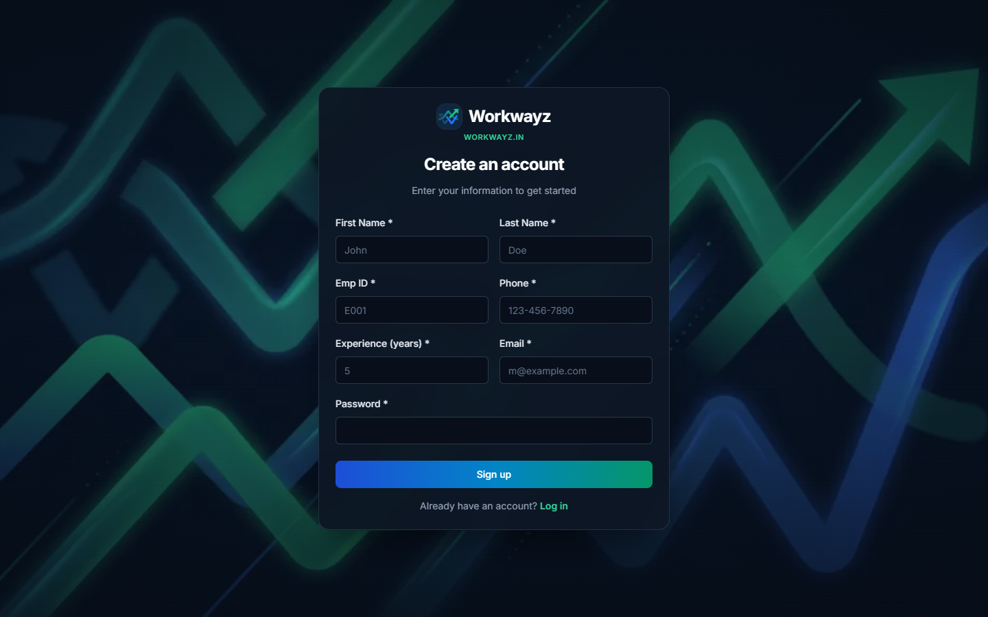
Figure 2.2 — Create an Account (Signup Screen)

2.3 First-Login Password Reset & Pending Enablement
To enforce security and access governance during onboarding, Workwayz intercepts sessions that require action before granting workspace access:
• Reset Your Password: Displayed immediately when logging in with the default "P@ssw0rd" credential. Requires a new password (minimum 6 characters, different from default).
• Account Pending Enablement: Displayed on My Projects when a self-registered user logs in prior to administrator approval.
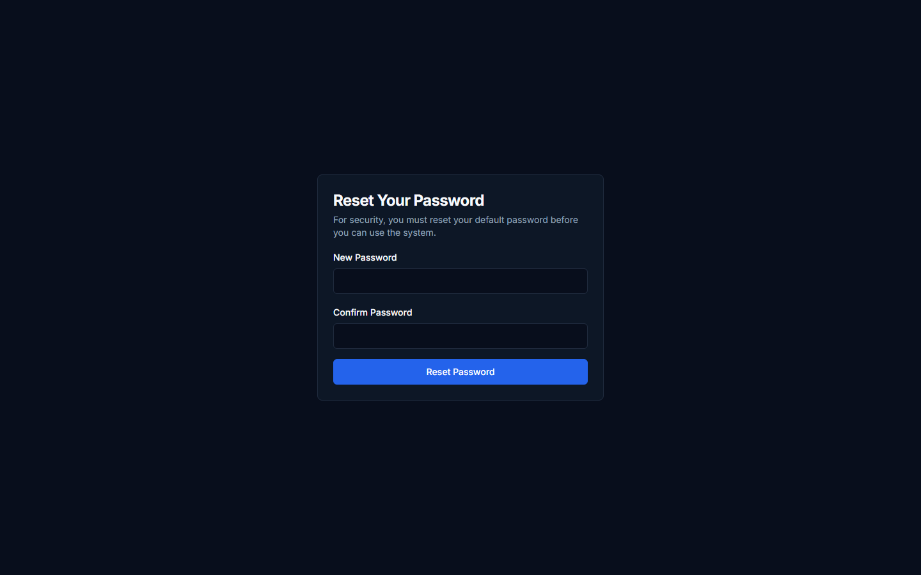
Figure 2.3a — Mandatory First-Login Password Reset Screen
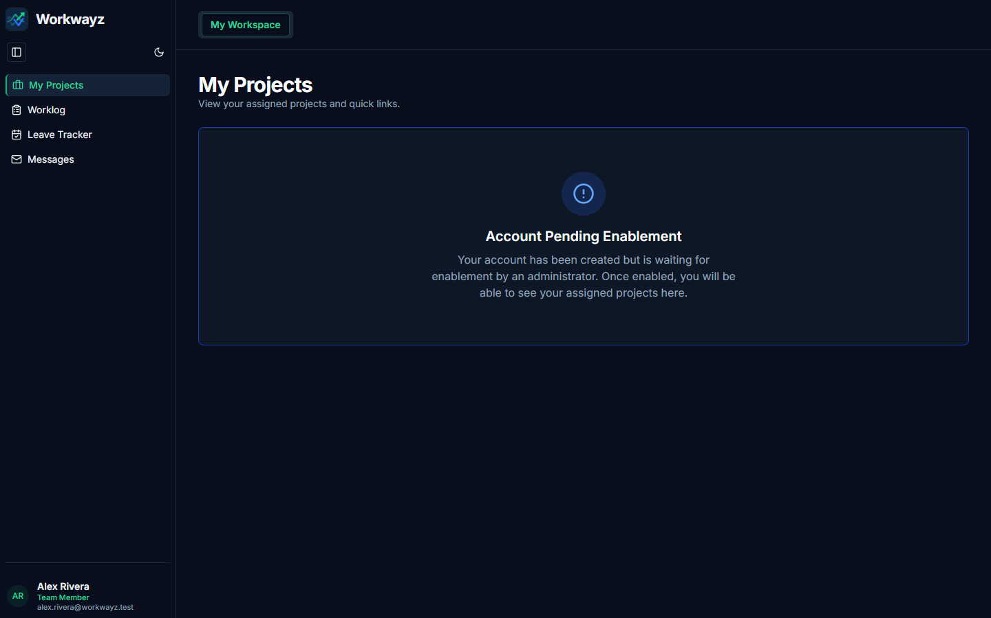
Figure 2.3b — Account Pending Enablement Screen

2.4 Profile & Account Settings
Every authenticated user can click their profile card in the bottom-left sidebar footer and select "Profile & Account" (/my-account) to update their First Name, Last Name, profile avatar image, or account password.
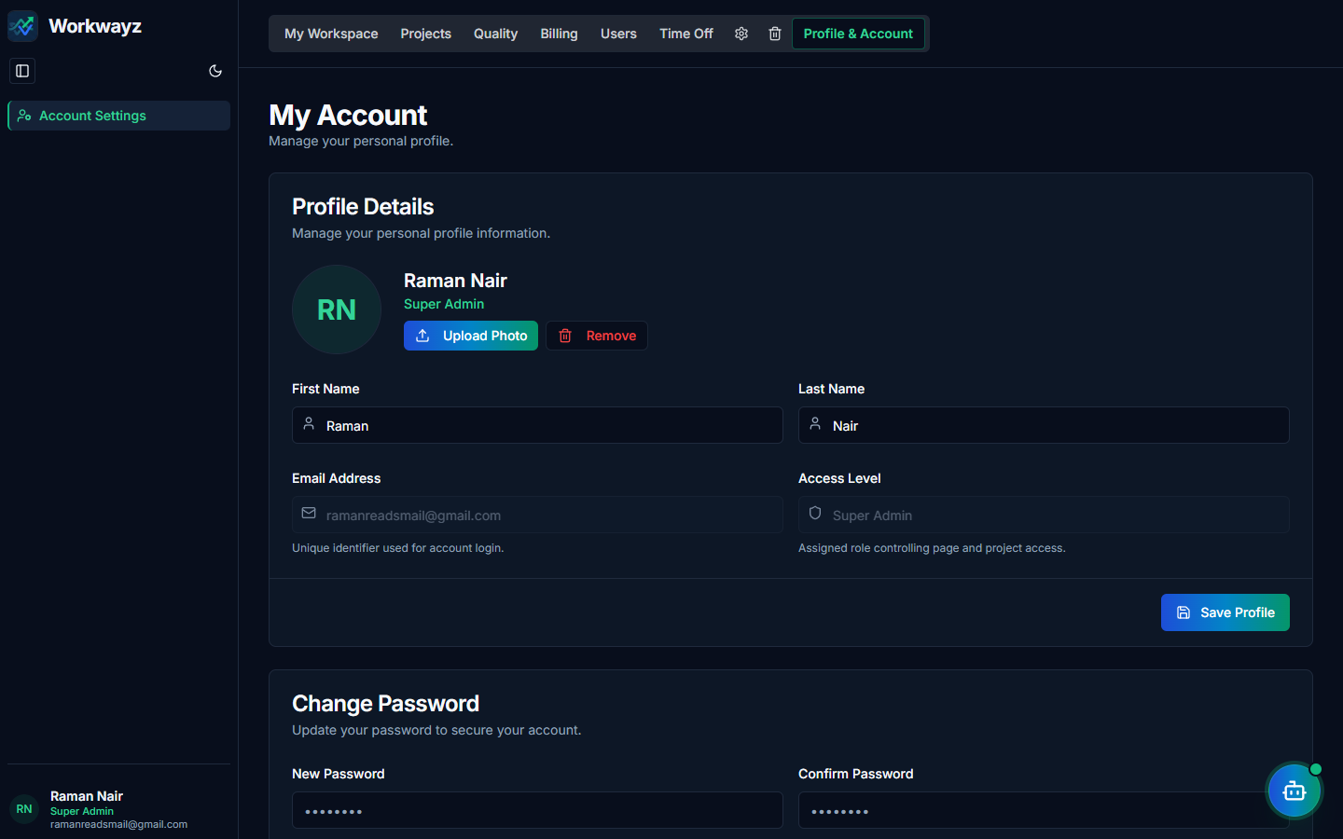
Figure 2.4 — Profile & Account Settings (/my-account)

3. Access Levels & Role-Based Workspace Guide
Workwayz enforces role-based access control (RBAC) across 7 distinct Access Levels: Super Admin, Administrator, Senior Management, Project Manager, Lead, Team Member, and PMO. Both top-navigation tabs and left-sidebar menu items dynamically adapt to the logged-in user’s role.
Access Level | Portfolio & Global Pages Accessible | Project Pages Accessible (Lifecycle Order)
Super Admin & Administrator | All Global Tabs: My Workspace (My Projects, Worklog, Leave Tracker, Messages), Projects (Project Home, Portfolio Dashboard, Portfolio PromptBoard), Quality (Estimation Variance, Defect Containment), Billing (Billing, Billing Rate), Users (User List, Utilization), Time Off (Company Holidays, Leave Policy & Quotas), Portfolio Settings (Access Settings, Database, Authentication, AI Config, Inactive Projects, Cron Jobs, Test Data Studio), Portfolio Trash. | All Project Tabs (via Project Home inspection; note that Super Admin & Administrator accounts cannot be staffed as project resources or Project Managers).
Senior Management | My Workspace (All), Projects (Project Home, Portfolio Dashboard, Portfolio PromptBoard), Quality (Estimation Variance, Defect Containment), Billing (Billing, Billing Rate), Users (User List, Utilization), Time Off (Company Holidays, Leave Policy & Quotas). | Initial Estimation, Project Details (PM Dashboard, Project PromptBoard, Project Status, Specifications, Project Releases), Development (All), Testing (Test Dashboard, Test Cases, Test Cycles, Test Executions, Bugs, Bug Tracker), Resources (Project Resources, Resource Workload, Leave Calendar, Leave Summary, Company Holidays), Governance (All), PMO (All).
Project Manager | My Workspace (All), Projects (Project Home, Portfolio PromptBoard), Quality (Estimation Variance, Defect Containment), Billing (Billing, Billing Rate), Users (User List, Utilization), Time Off (Company Holidays, Leave Policy & Quotas). | All Project Tabs: Initial Estimation, Project Details (incl. Project Releases), Development, Testing (incl. Bugs & Bug Tracker), Resources (incl. Leave Summary & Company Holidays), Governance, PMO, Project Settings (Board, Sprint, Effort Settings), and Project Trash.
Lead | My Workspace (My Projects, Worklog, Leave Tracker, Messages), Projects (Project Home), Users (User List), Time Off (Company Holidays). | Project Details (Project Status, Specifications, Project Releases), Development (All), Testing (Test Dashboard, Test Cases, Test Cycles, Test Executions, Bugs, Bug Tracker), Resources (Project Resources, Resource Workload, Leave Calendar, Leave Summary, Company Holidays), Governance (All), PMO (Documents, Business Continuity), Project Settings (Board & Sprint Settings).
Team Member | My Workspace (My Projects, Worklog, Leave Tracker, Messages), Projects (Project Home). | Project Details (Project Status, Specifications), Development (Development Dashboard, Kanban Board, Sub-Tasks), Testing (Test Dashboard, Test Cases, Test Executions, Bugs, Bug Tracker), Resources (Project Resources, Company Holidays), Governance (RAID Dashboard), PMO (Documents).
PMO | My Workspace (My Projects, Worklog, Leave Tracker, Messages), Projects (Project Home), Billing (Billing, Billing Rate), Users (User List, Utilization), Time Off (Company Holidays). | Project Details (PM Dashboard, Project PromptBoard, Project Status, Project Releases), Resources (Project Resources, Resource Workload), PMO (Documents, FB Billing, FB Payment Milestones, TnM Billing, TnM Payment Milestones, Business Continuity).

3.1 Super Admin & Administrator Workspace View
When logged in as Super Admin (e.g., Raman Nair) or Administrator (e.g., Taylor Mercer), all portfolio tabs plus the Portfolio Settings (gear icon) and Portfolio Trash (trash icon) tabs are visible in the top navigation bar.
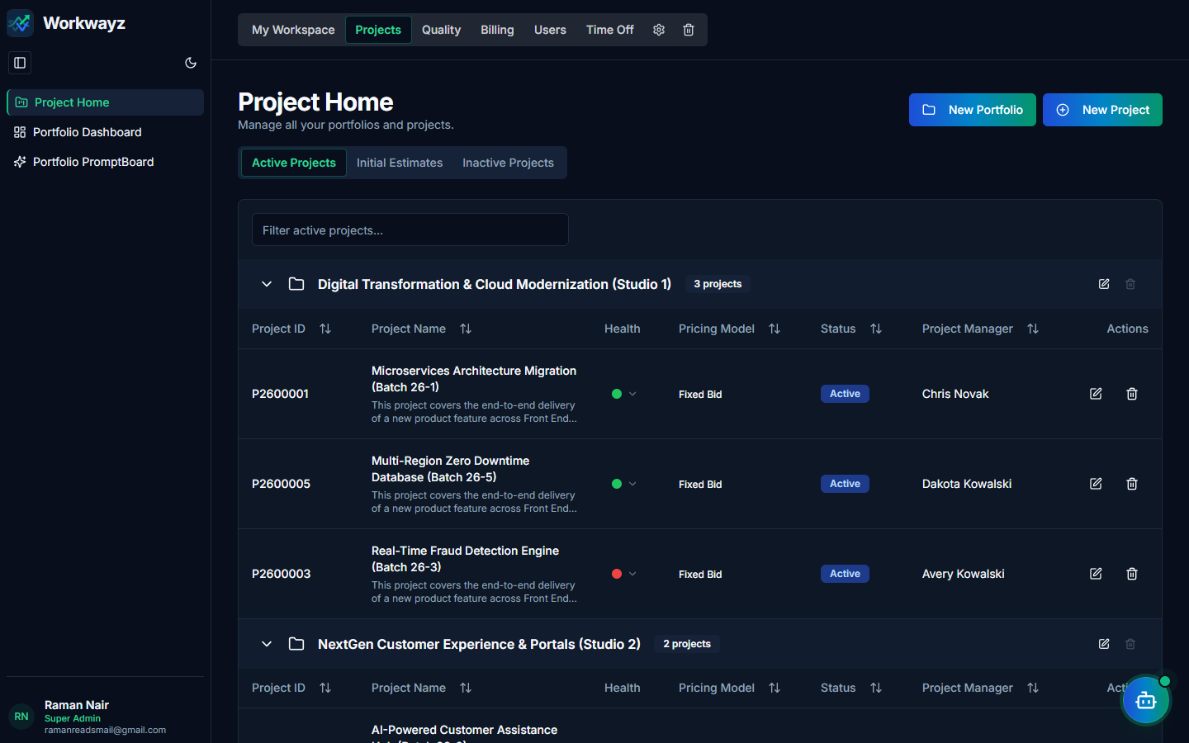
Figure 3.1a — Logged in as Super Admin: Full Portfolio & Admin Navigation
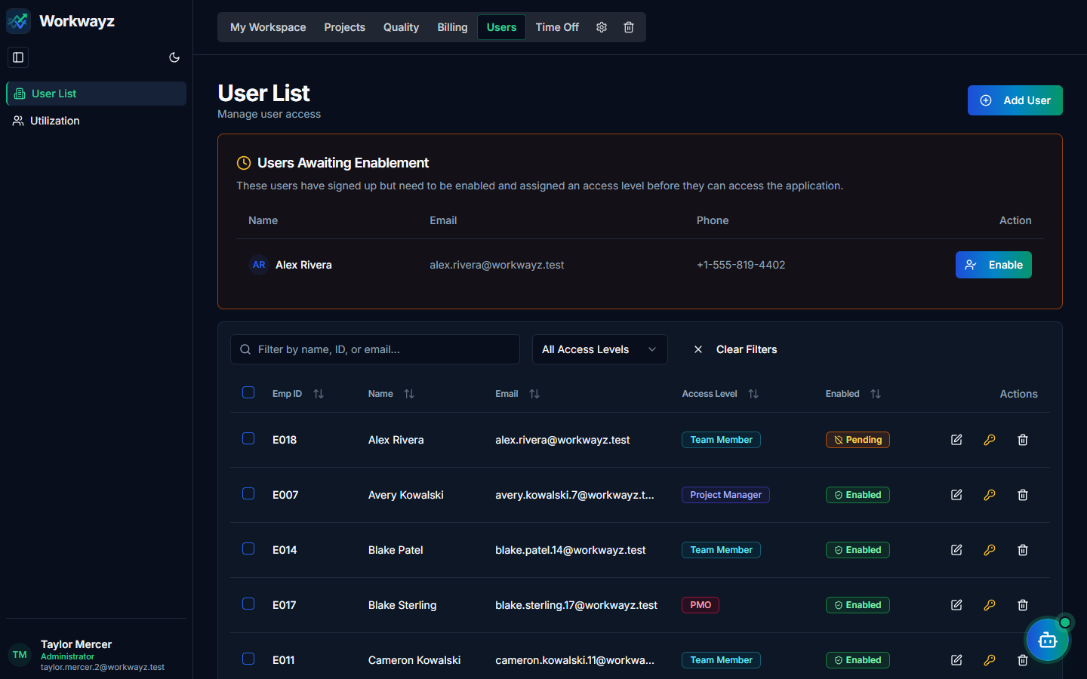
Figure 3.1b — Logged in as Administrator: Users & Access Governance View

3.2 Senior Management Workspace View
When logged in as Senior Management (e.g., Morgan Chen), executive oversight tabs (Projects → Portfolio Dashboard & PromptBoard, Quality, Billing, Users, Time Off) are available without system infrastructure settings.
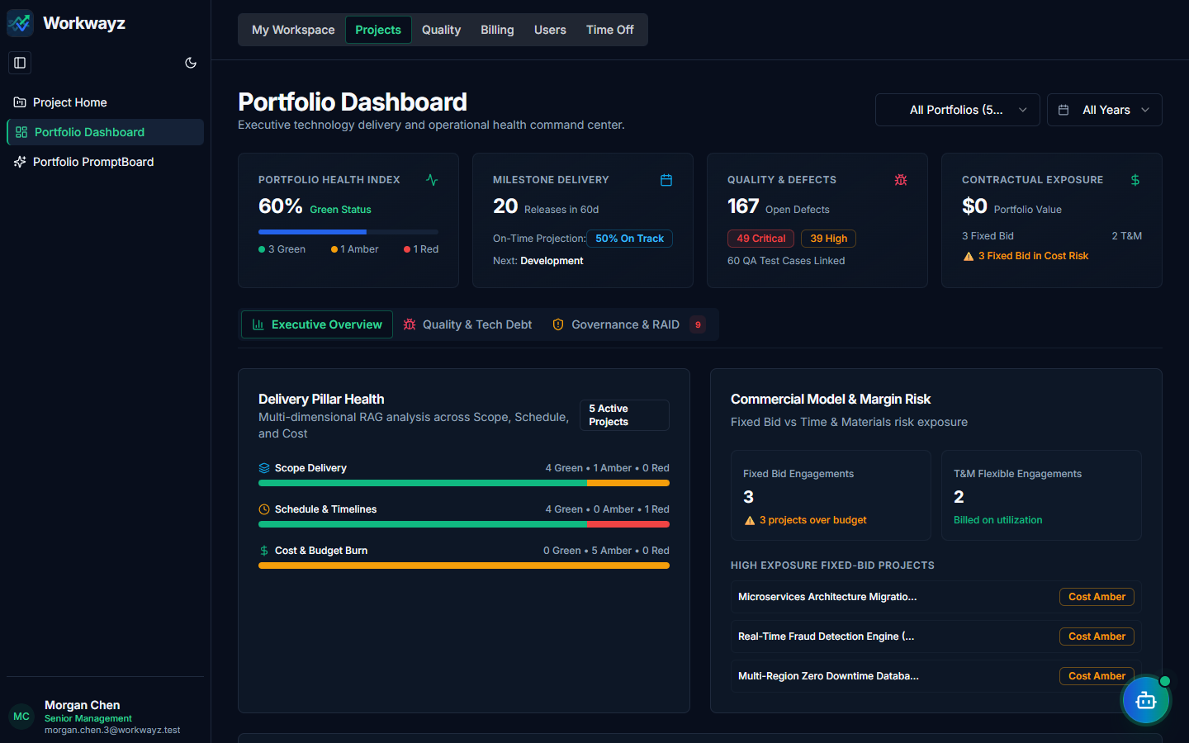
Figure 3.2 — Logged in as Senior Management: Portfolio Executive Dashboard

3.3 Project Manager Workspace View
When logged in as a Project Manager (e.g., Chris Novak), the user sees their assigned active projects and Initial Estimations on My Projects, along with portfolio operational tabs and full project-level settings.
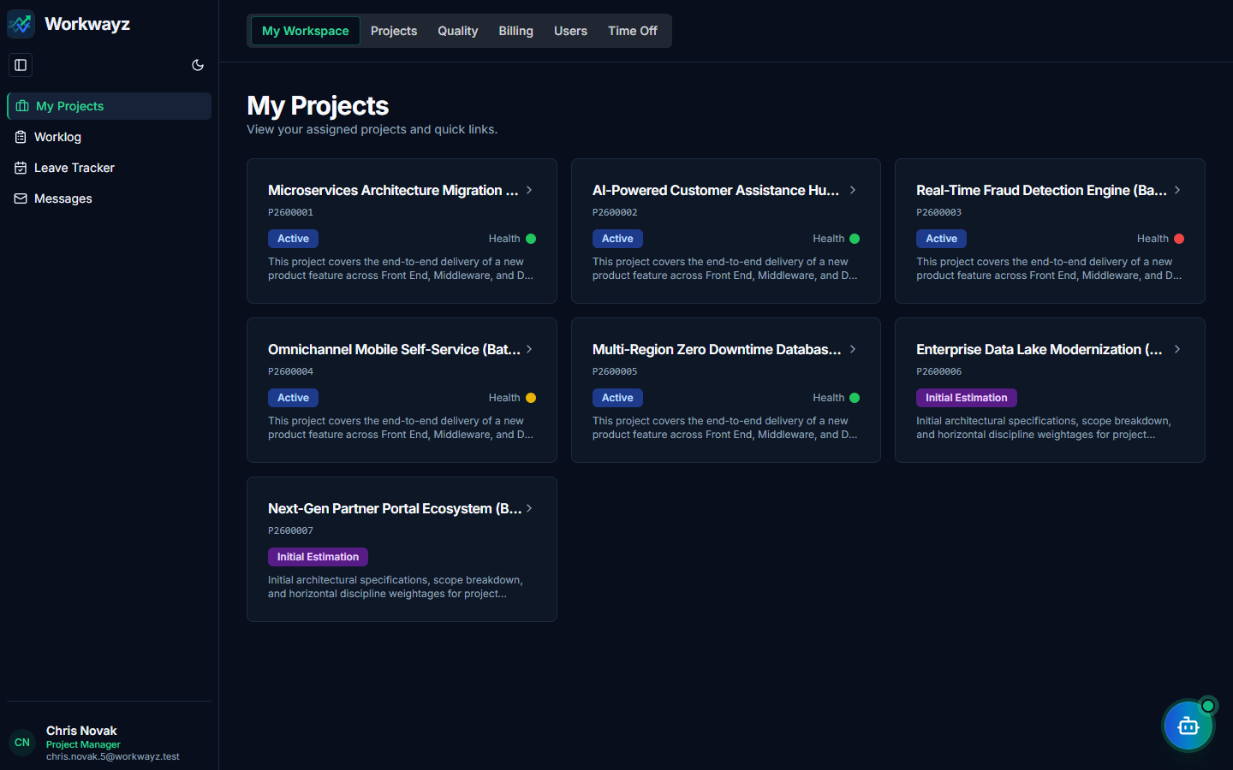
Figure 3.3 — Logged in as Project Manager: My Workspace & Assigned Initiatives

3.4 Lead Workspace View
When logged in as a Lead (e.g., Riley Thornton), the user has access to technical delivery, architecture specifications, backlog elaboration, sub-tasks, sprint grooming, test cycles, in-sprint bugs, RAID governance, and board/sprint configuration.
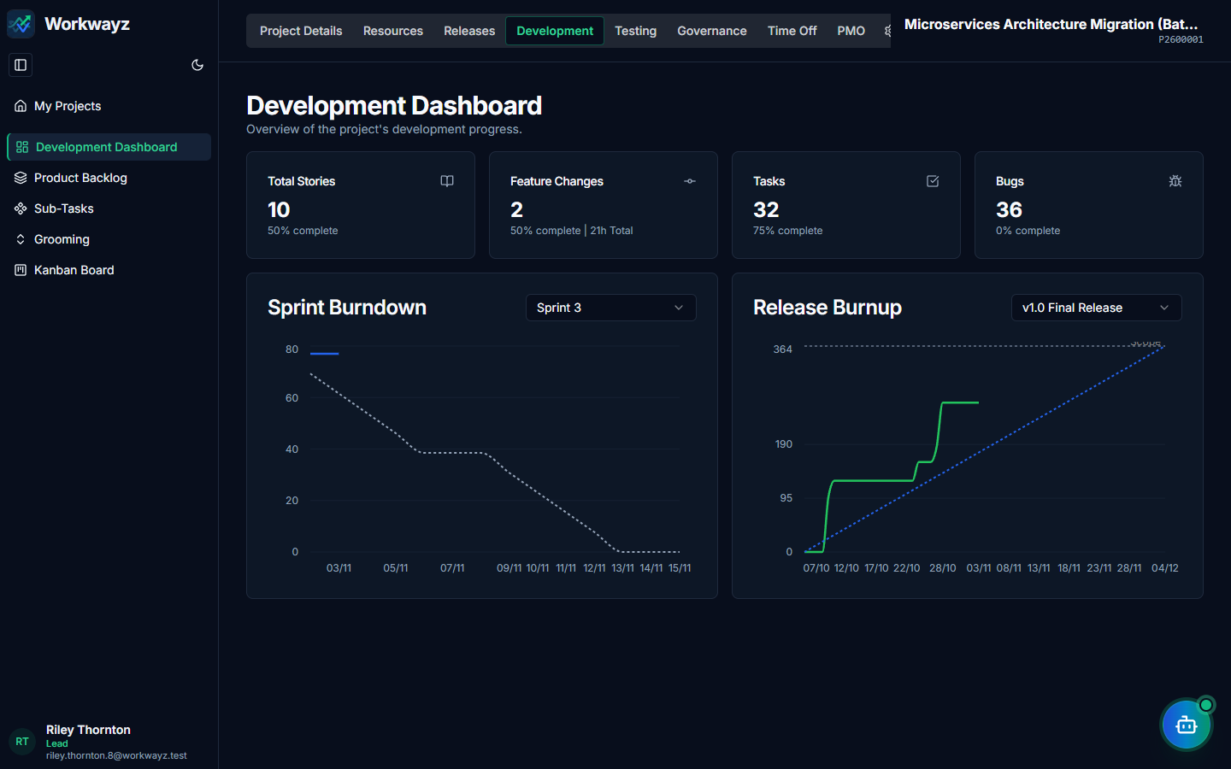
Figure 3.4 — Logged in as Lead: Project Development & Delivery Workspace

3.5 Team Member Workspace View
When logged in as a Team Member (e.g., Quinn Sterling), navigation is streamlined to personal workspace tools (My Projects, Worklog, Leave Tracker, Messages) and execution boards (Development Dashboard, Kanban Board, Sub-Tasks, Test Executions, Bugs, and Bug Tracker).
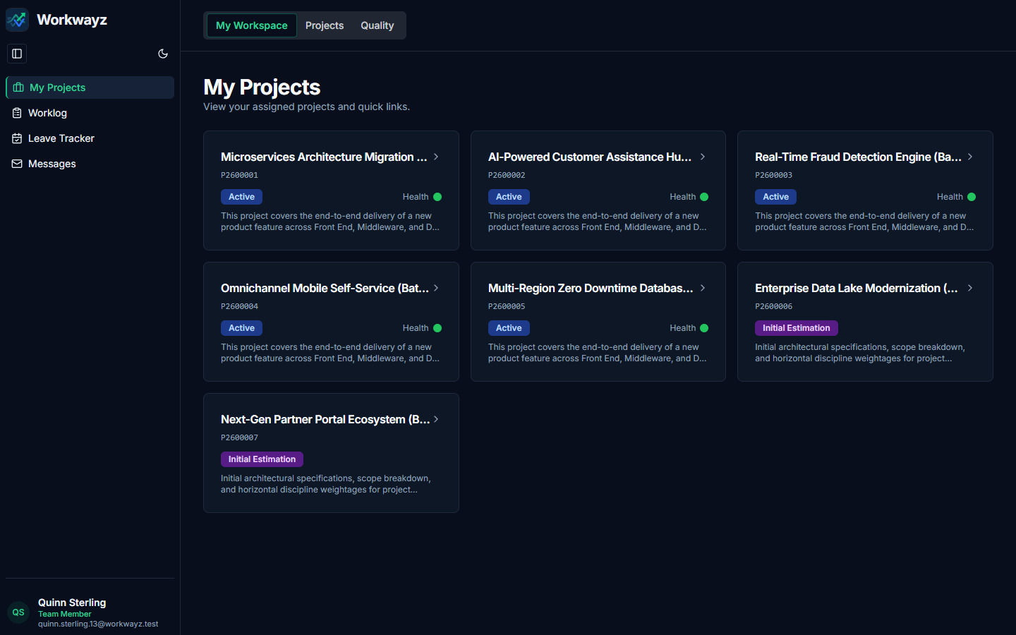
Figure 3.5 — Logged in as Team Member: Streamlined Execution Workspace

3.6 PMO Workspace View
When logged in as PMO (e.g., Blake Sterling), navigation focuses on financial governance, billing & rate cards, resource utilization, release schedules, project documents/permits, Fixed Bid & T&M invoicing, and Business Continuity.
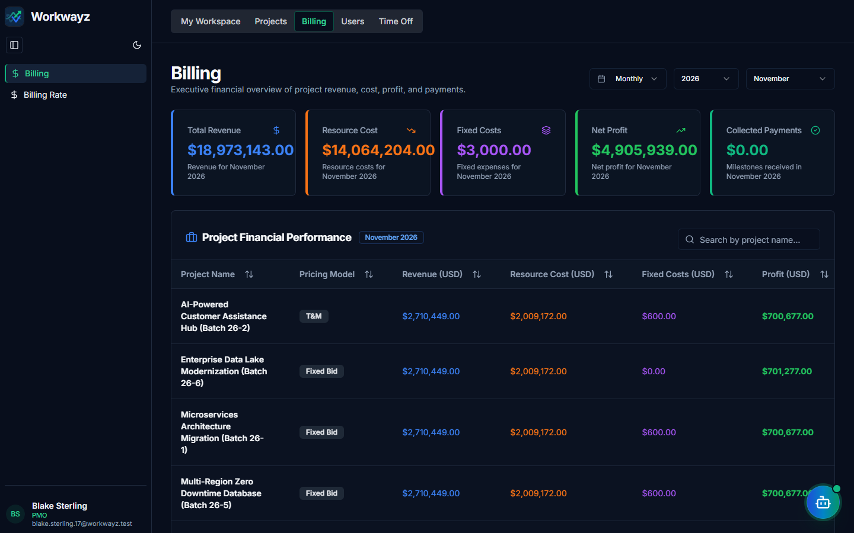
Figure 3.6 — Logged in as PMO: Billing, Financial & Governance Workspace

4. Portfolio Flow
The Global Portfolio Hub provides cross-project visibility across personal workspaces, enterprise project directories, executive health dashboards, AI analytics, quality conformance, financial billing ledgers, resource utilization, and organizational time-off policies.

4.1 My Workspace — My Projects (/my-projects)
Displays cards for all active projects and initial estimations to which the logged-in user is assigned (either as Project Manager or as a staffed project resource). Clicking a project card navigates directly to the user’s permitted landing page for that project.
Figure 4.1 — My Workspace: My Projects

4.2 My Workspace — Global Worklog (/worklog)
Allows team members to log daily work hours across all projects they are staffed on from a single weekly timesheet grid. Users can select a project, pick a work item (Story, Sub-Task, Bug, Meeting, or Other), enter daily hours across the week, and save or submit their timesheet.
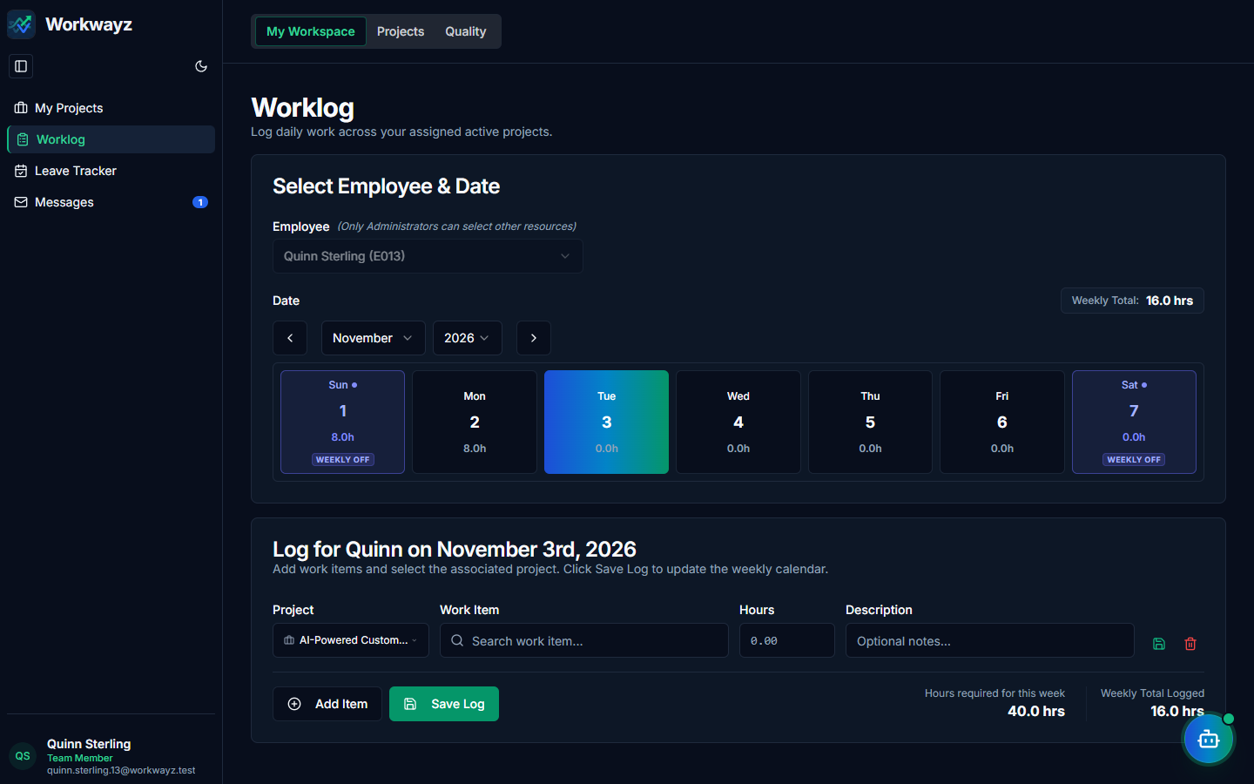
Figure 4.2 — My Workspace: Global Weekly Worklog

4.3 My Workspace — Leave Tracker (/holidays/leave-tracker)
Self-service portal where employees view their annual leave quota, carried-over balance, remaining paid leave balance, and Loss of Pay (LOP) days, and submit new leave periods (Full Day or Half Day). Leave periods logged here automatically synchronize across all projects the employee is assigned to.
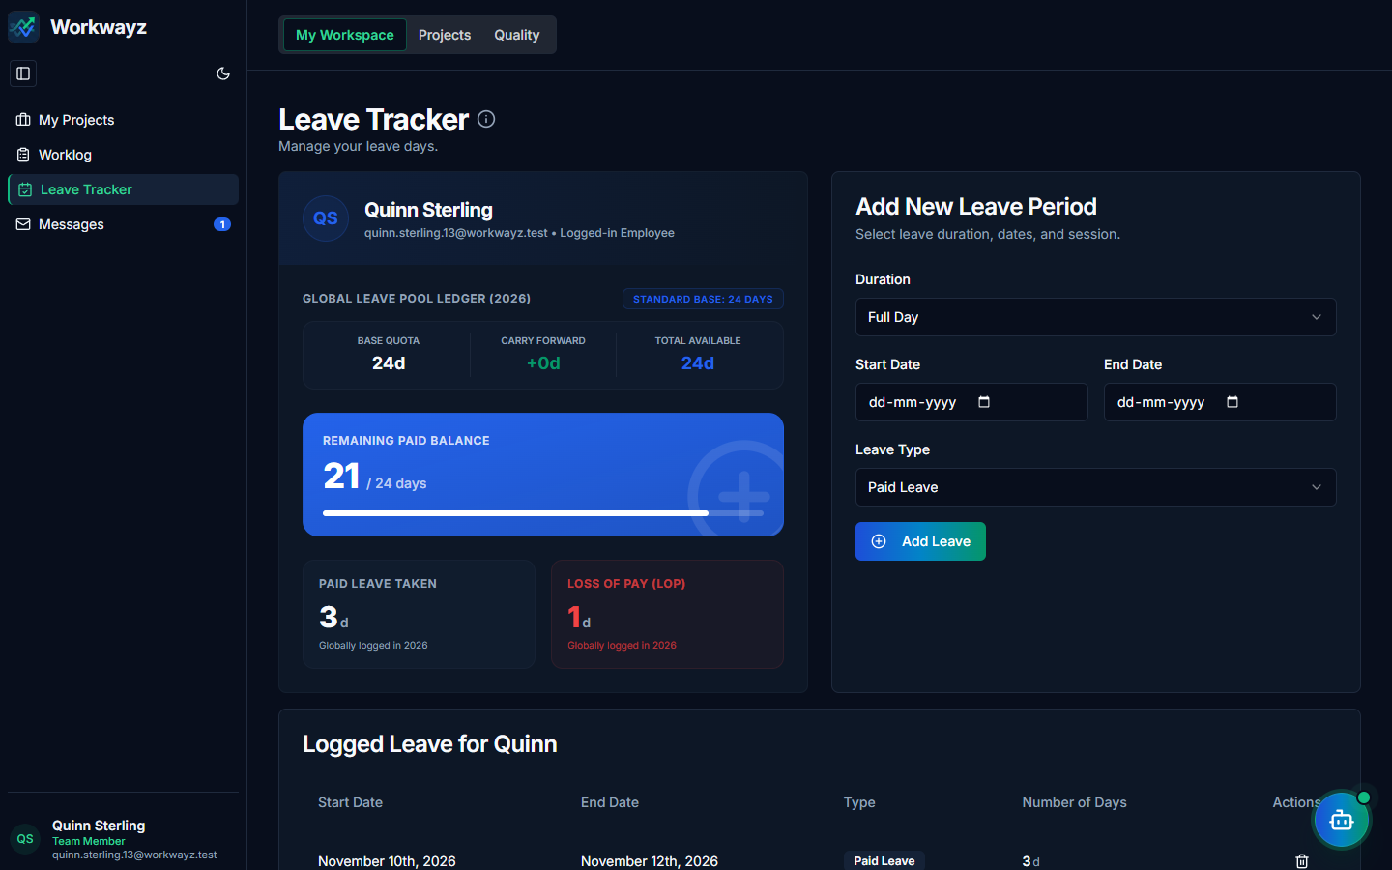
Figure 4.3 — My Workspace: Employee Leave Tracker

4.4 My Workspace — Messages (/messages)
Built-in internal messaging center supporting Inbox, Starred, Sent, and Trash folders. Users can send messages to individual colleagues or role/project distribution lists, reply/reply-all, and view automated scheduled report digests containing interactive embedded charts.
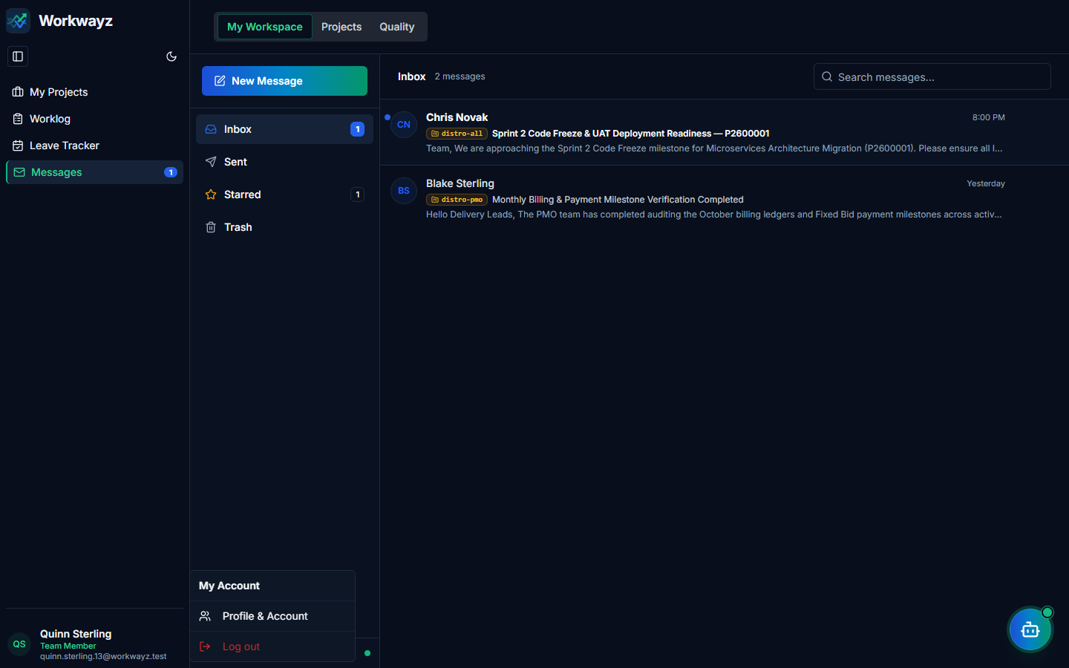
Figure 4.4a — My Workspace: Internal Messages Inbox & Reader
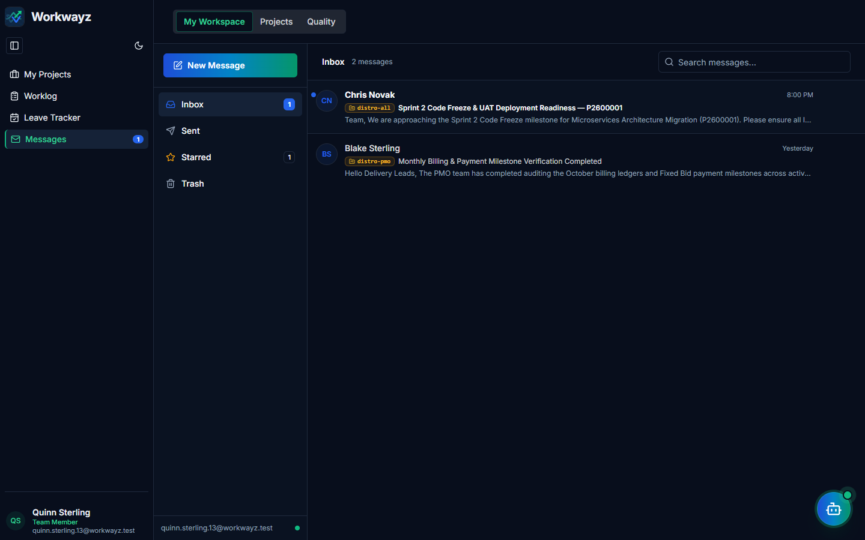
Figure 4.4b — Compose New Message Dialog with Distribution Lists

4.5 Projects — Project Home (/project-home)
Lists all portfolios and active, initial estimate, or inactive/closed projects across the organization.
• Portfolio Grouping: Every project belongs to a Portfolio. Use the "New Portfolio" button to create portfolio containers (or an Unassigned portfolio).
• Creating a Project: Click "New Project" to select the Portfolio, Project Name, Start/End Dates, Project Manager, Status (e.g., Initial Estimation or Active), and Pricing Model (Fixed Bid or T&M).
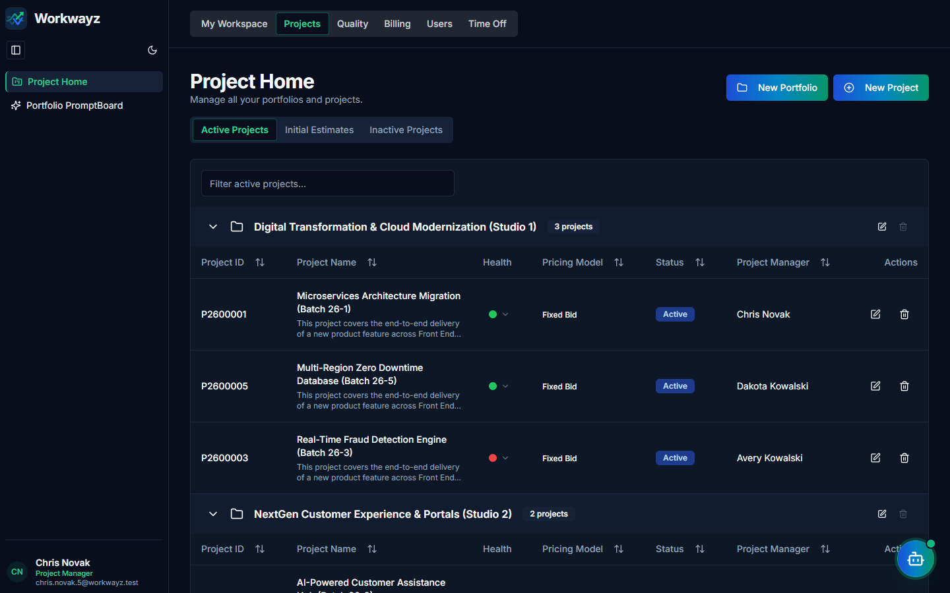
Figure 4.5a — Projects: Project Home Directory
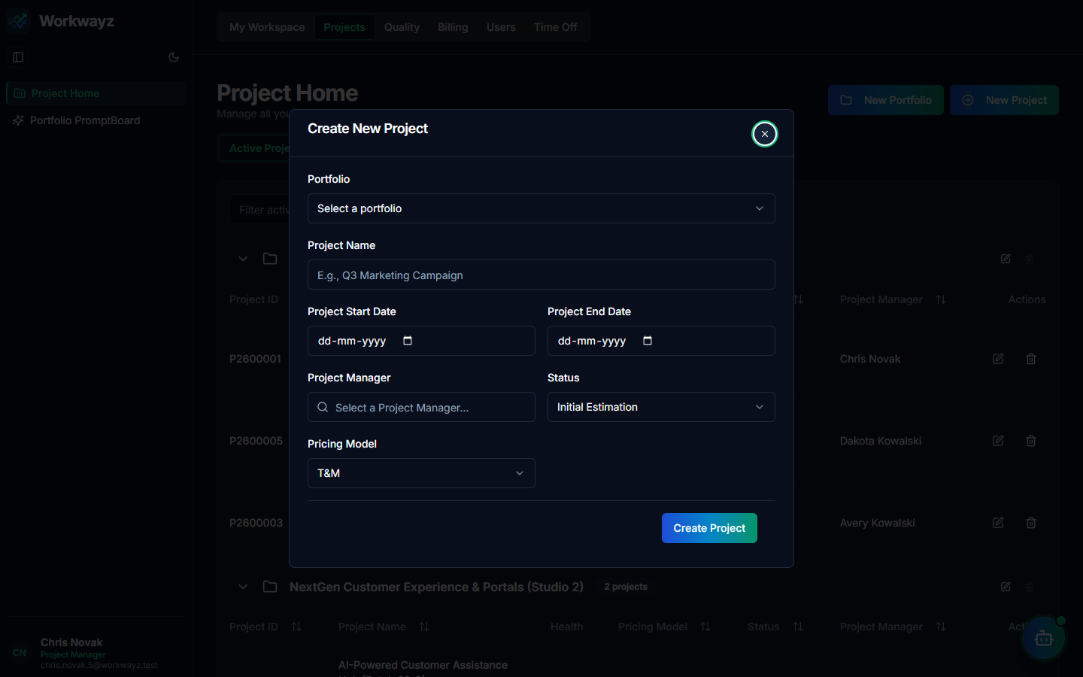
Figure 4.5b — Create New Project Modal

4.6 Projects — Portfolio Dashboard (/portfolio-dashboard)
Designed for Senior Management and executives to monitor portfolio health, delivery risks, and quality across active initiatives. Structured into three analytical views:
• Overview Tab: Displays portfolio KPI cards, RAG health distribution, Red/Amber health projects requiring attention, and upcoming release milestones.
• Quality & Testing Tab: Summarizes cross-project bug/defect severity, test execution coverage, and open bug bottlenecks.
• Risks & Issues (RAID) Tab: Highlights High Potential Risks and Critical/High Priority operational Issues across all active projects.
Figure 4.6a — Portfolio Dashboard: Executive Overview Tab
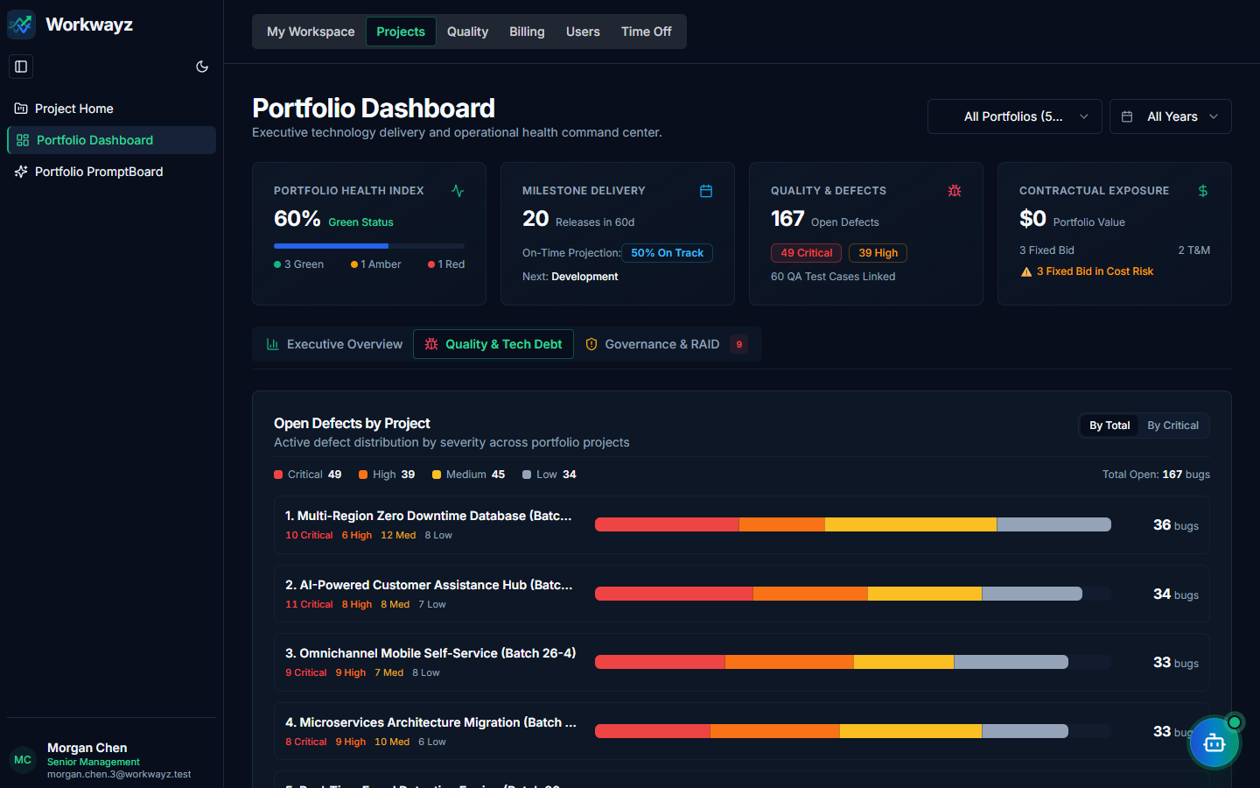
Figure 4.6b — Portfolio Dashboard: Quality & Testing Tab
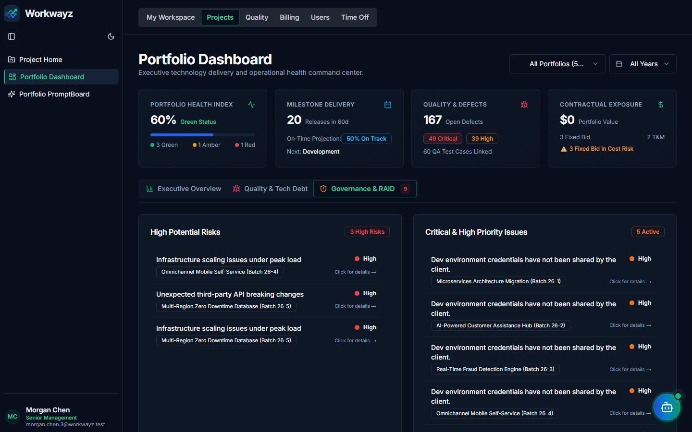
Figure 4.6c — Portfolio Dashboard: Risks & Issues (RAID) Tab

4.7 Projects — Portfolio PromptBoard (/fp-portfolio-dash)
WayFinder AI-powered natural language analytics board for portfolio-wide insights. Users can click preset executive prompts (e.g., Projects by PM, Project RAG Health, Pricing Model Breakdown, Critical Risks, Billing Valuation, Resource Allocation) or type custom queries, switch between Split/Chart/Table views, export CSVs, and schedule recurring report jobs.
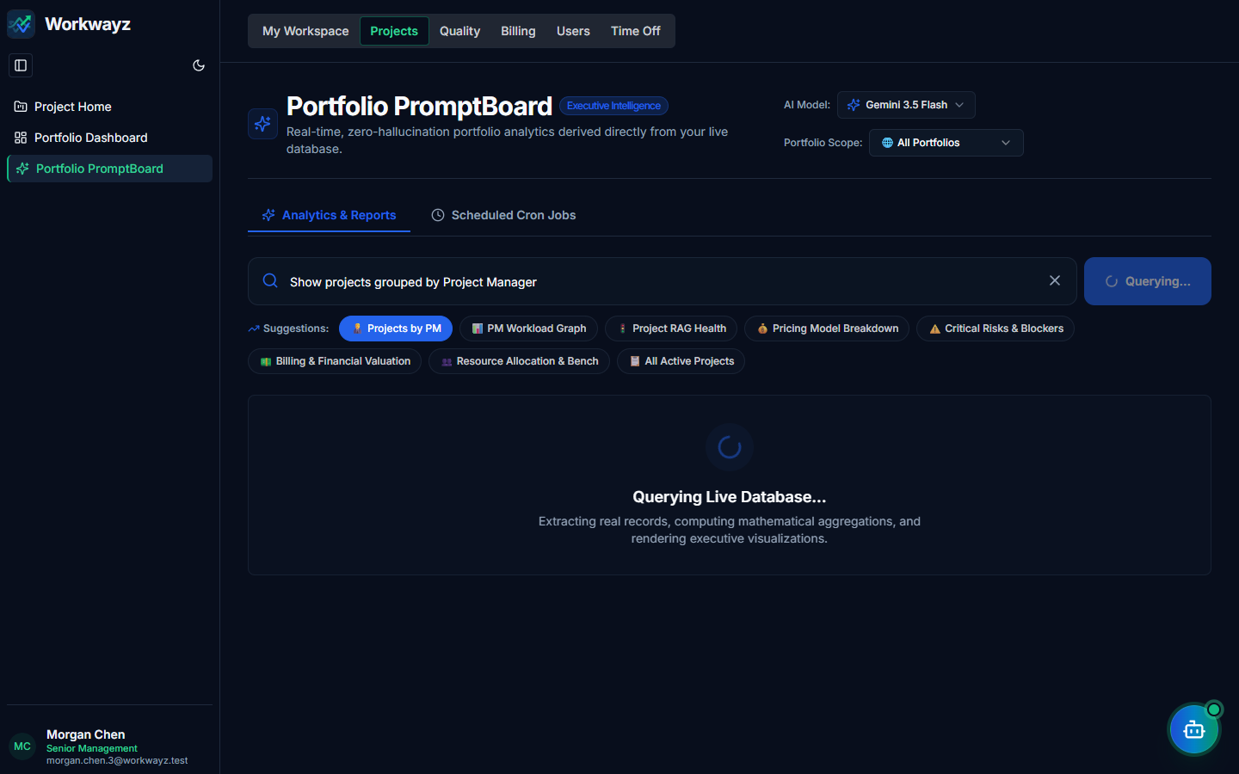
Figure 4.7 — Portfolio PromptBoard (WayFinder AI Analytics)

4.8 Quality — Estimation Variance (/quality/estimations)
Compares three estimation baselines across every project: Initial Estimate (ballpark scoping in man-days), Planned Estimate (sum of elaborated story/sub-task estimates), and Actual Logged effort (from employee worklogs). Helps upper management monitor estimation variance and plan consumption.
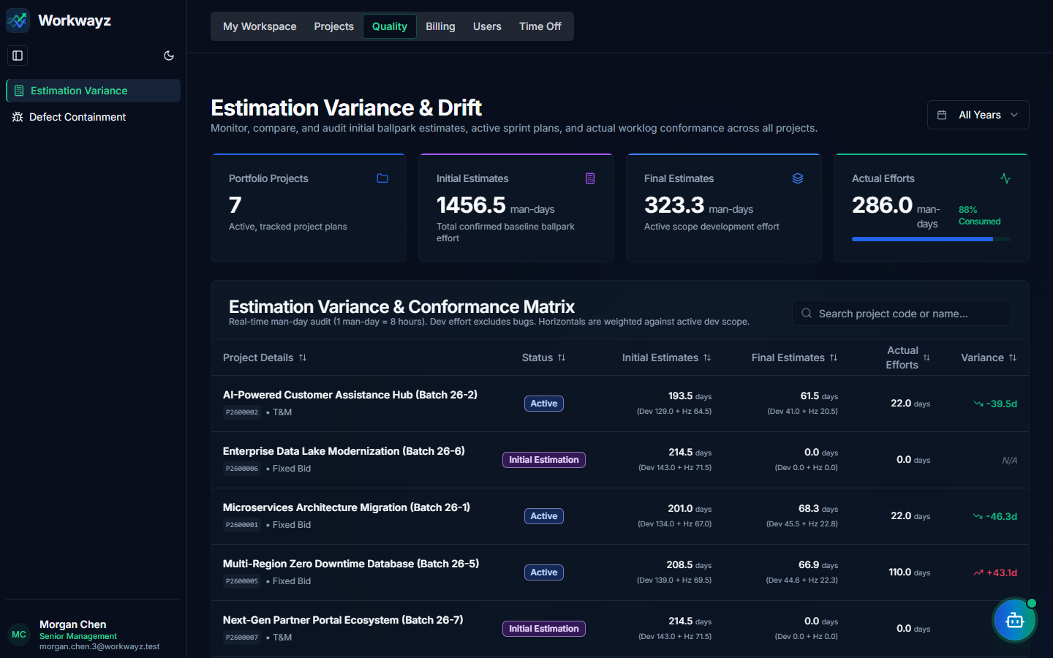
Figure 4.8 — Quality: Estimation Variance & Conformance Dashboard

4.9 Quality — Defect Containment (/quality/defects)
Tracks bug and defect counts discovered at each testing phase (SIT Phase, UAT Phase, Production Escaped Defects) and calculates the Average Leakage Rate % to measure how effectively QA teams catch issues early in the lifecycle.
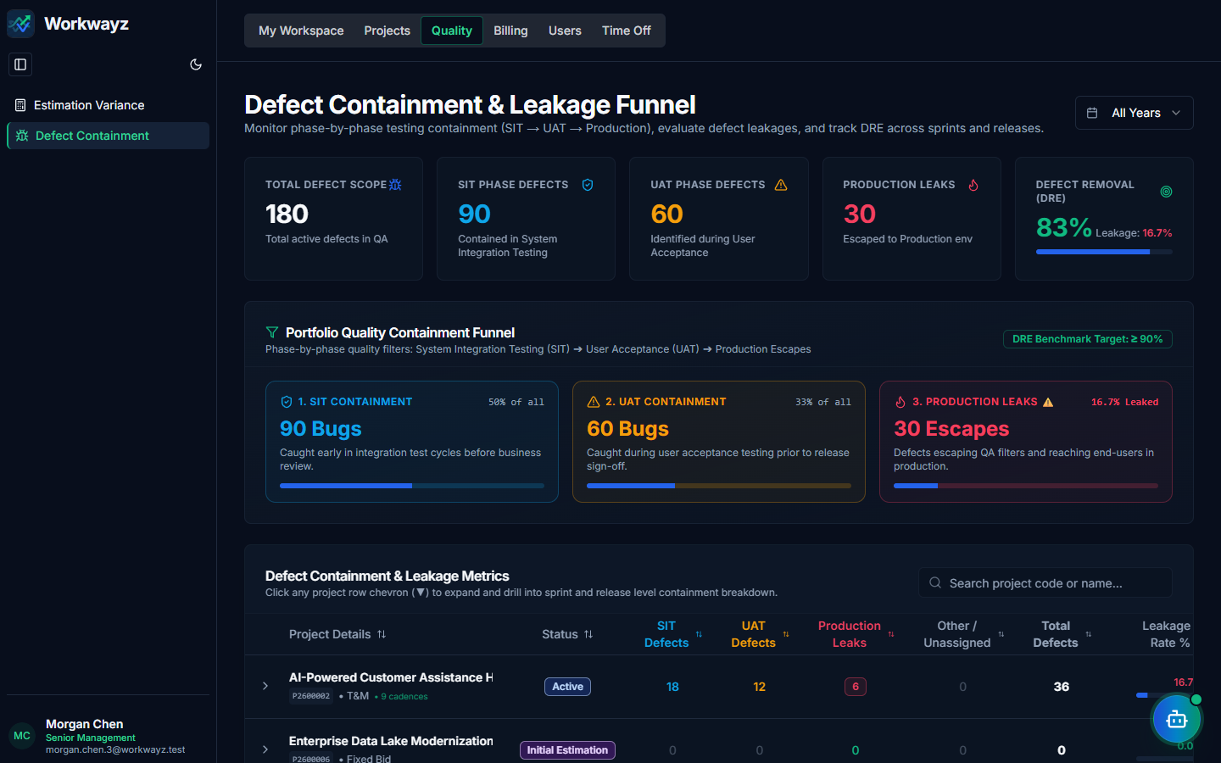
Figure 4.9 — Quality: Defect Containment & Leakage Metrics

4.10 Billing — Portfolio Billing Dashboard (/billing)
Provides a financial ledger across all projects showing Total Revenue (Fixed Bid contract value or accumulated T&M monthly billing), Resource Cost, Fixed Costs (hosting, licenses, GIT, setup), Net Profit, and Collected Payments, filterable by Lifetime, Month, Quarter, or Year.
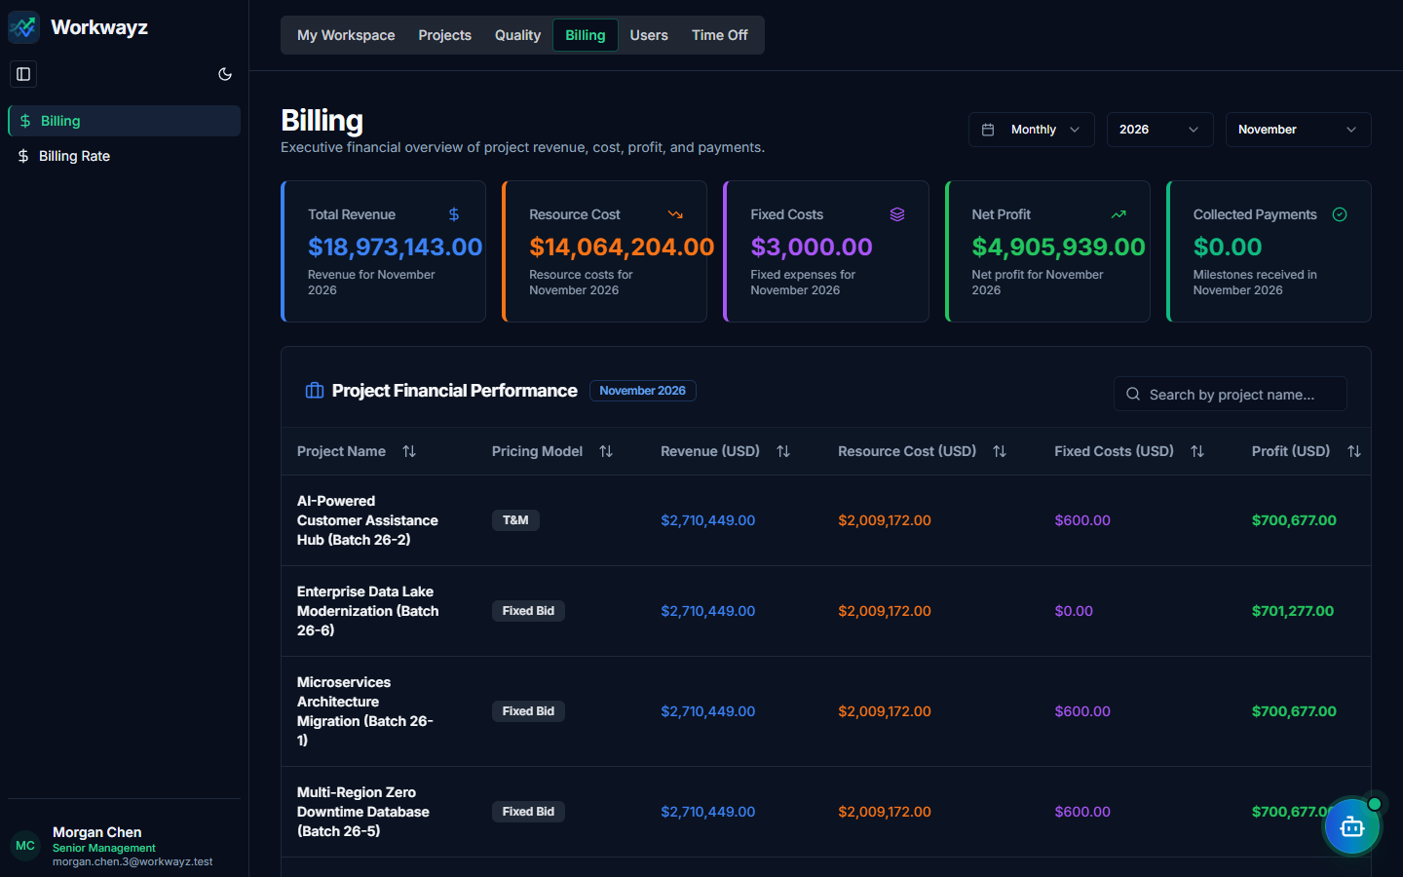
Figure 4.10 — Billing: Portfolio Financial Overview & Project Breakdown

4.11 Billing — Billing Rate & Rate Cards (/billing-rate)
Centralizes resource billing rate auditing and organizational rate card standards across two tabs:
• Project Resource Rates: Displays each resource’s Billed Rate/day, Cost Rate/day, Margin, and Margin % across projects (grouped by person or flat view).
• Standard Role Rate Cards: Defines baseline Low, Medium, and High experience daily billing rates across Tech Roles and Horizontal Roles for use during project estimation.
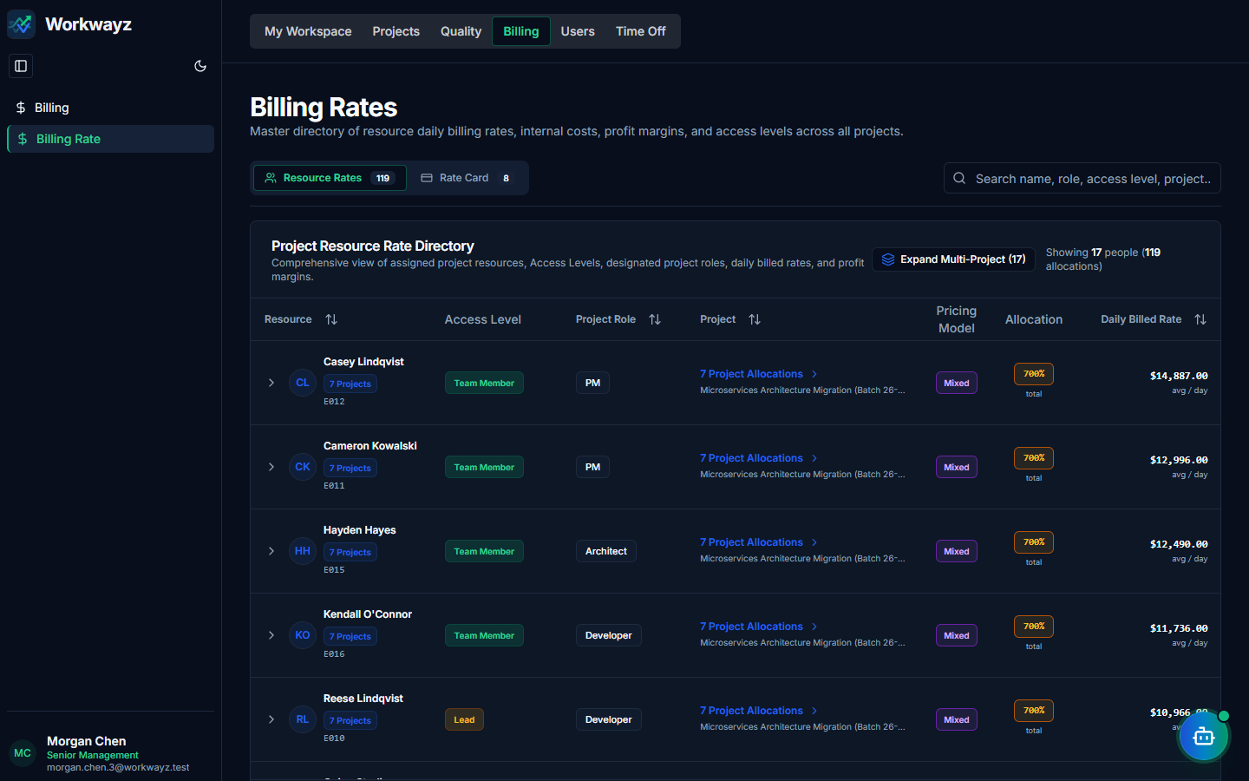
Figure 4.11a — Billing Rate: Project Resource Rates & Margin Analysis
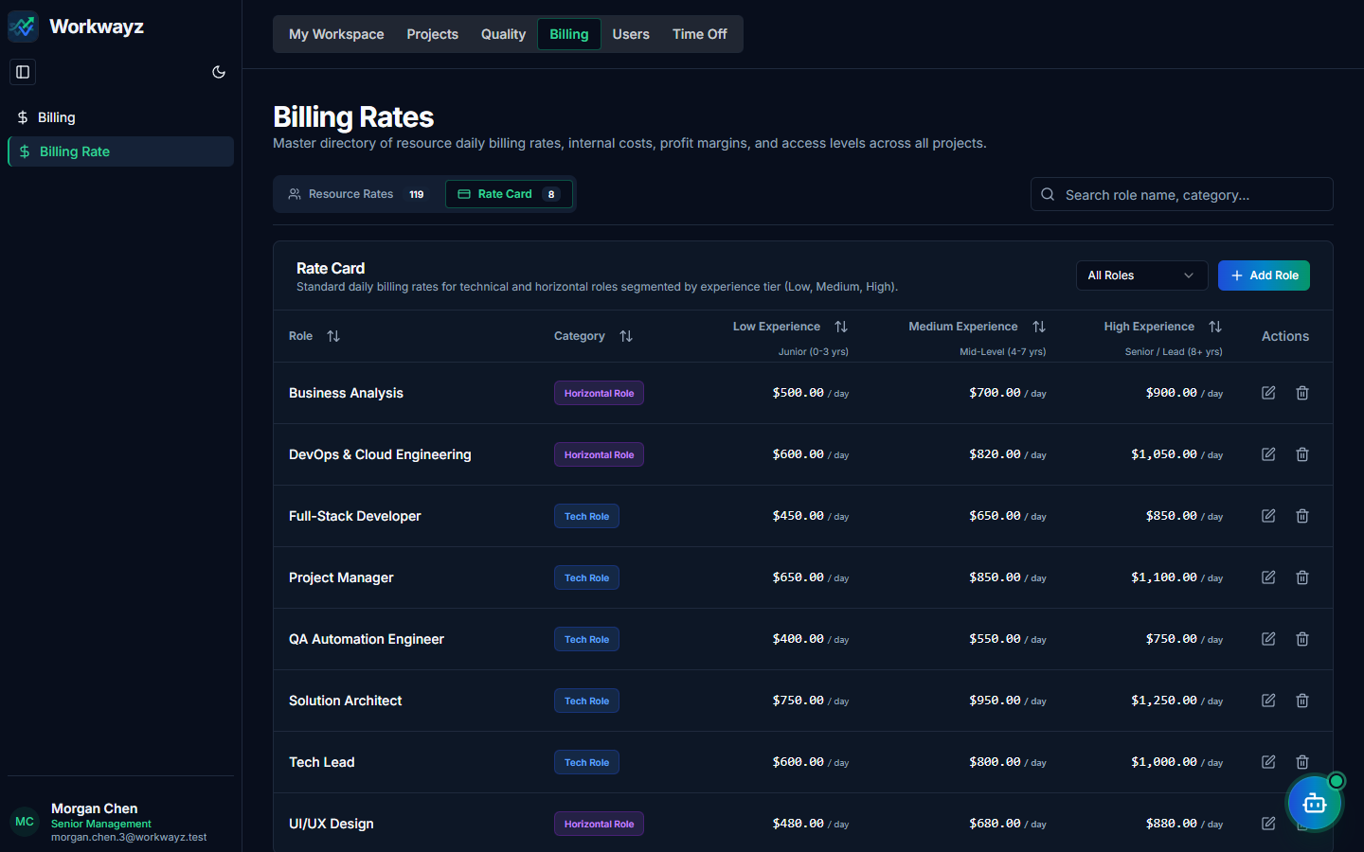
Figure 4.11b — Billing Rate: Standard Role Rate Cards

4.12 Users — User List (/users)
Directory of all registered employees. Displays a "Users Awaiting Enablement" approval queue at the top for newly signed-up users, and allows Administrators to directly provision new users ("Add User") with an Access Level, Role, Cost Rate, and default password ("P@ssw0rd").
Figure 4.12a — Users: User List & Enablement Queue
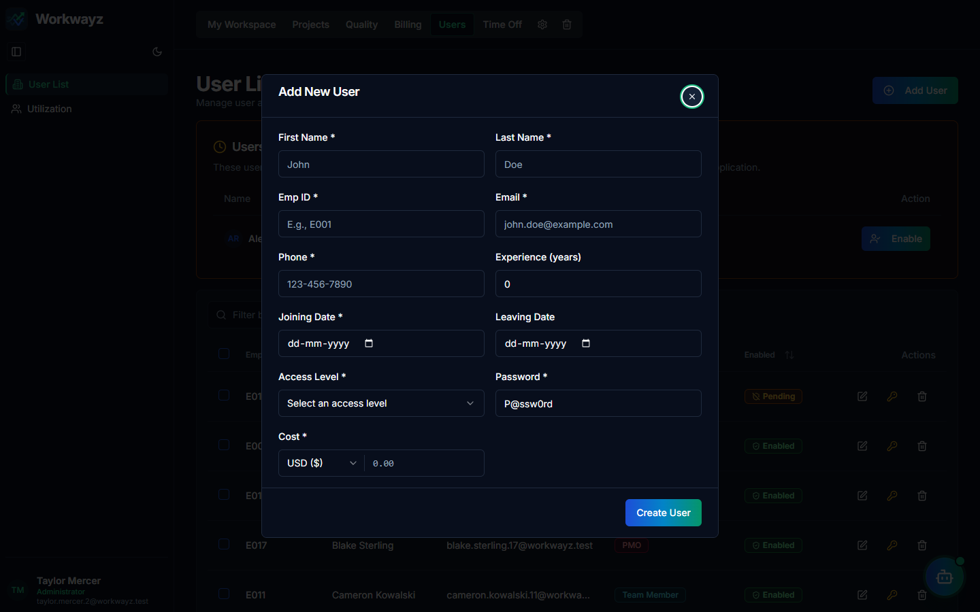
Figure 4.12b — Add New User Modal

4.13 Users — Resource Utilization (/utilization)
Visualizes cross-project allocation timelines and capacity utilization per employee. Selecting a user displays their Availability Outlook (current occupancy status, utilization %, active project count, next available date) alongside a daily Availability Grid.
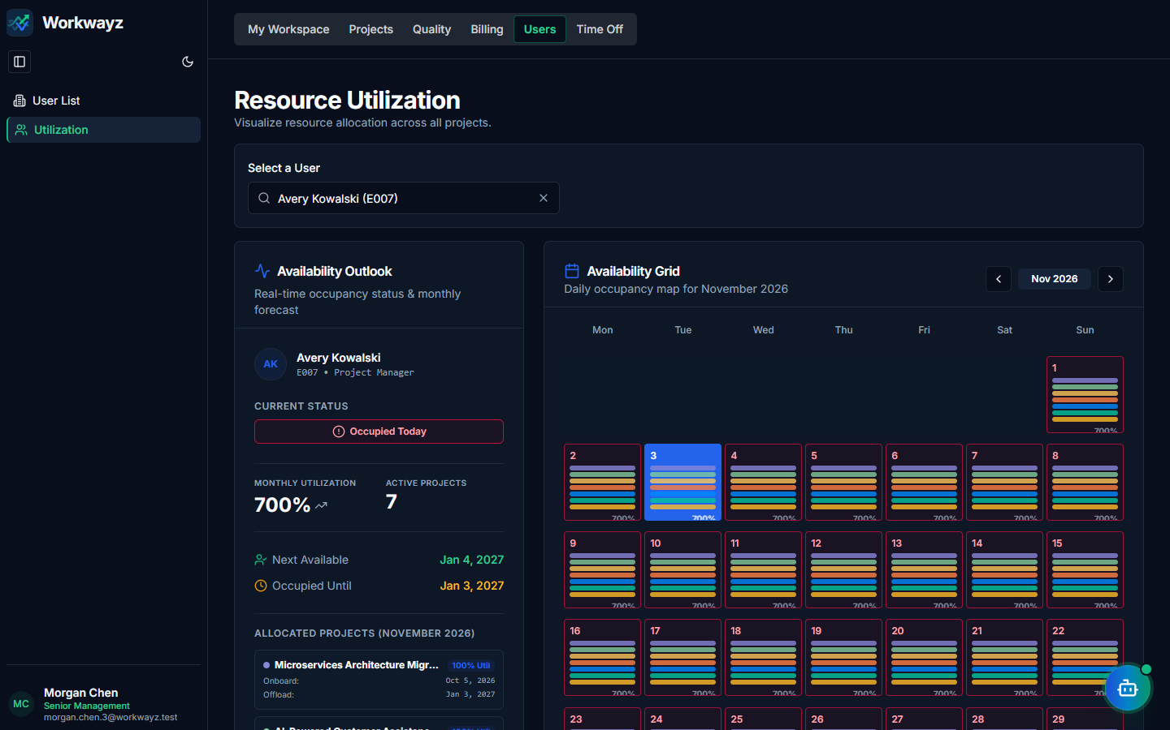
Figure 4.13 — Users: Resource Utilization & Availability Grid

4.14 Time Off — Company Holidays (/holidays/holiday-calendar)
Configures organization-wide Weekly Off-Days (e.g., Saturday and Sunday) and the Yearly Holidays calendar. Includes an "Auto-fill with AI" button to populate regional/national holidays automatically.
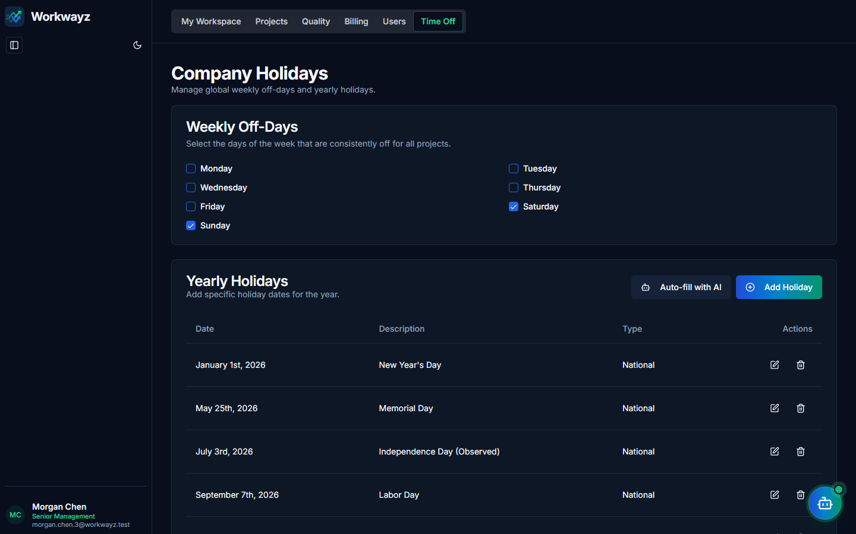
Figure 4.14 — Time Off: Global Company Holidays & Weekly Off-Days

4.15 Time Off — Leave Policy & Quotas (/holidays/leave-settings)
Configures the global Annual Paid Leaves Quota, Carry-Over Leaves toggle, and Carry-Over Days Limit, and displays the Resource Leave Accounts summary table for all employees.
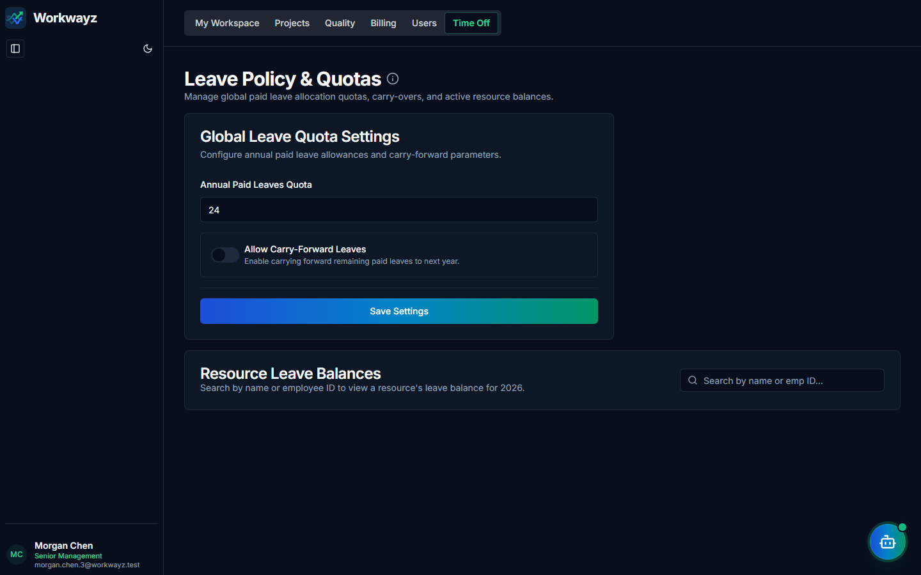
Figure 4.15 — Time Off: Global Leave Policy & Resource Leave Accounts

5. Initial Estimation Flow
When a new project is created with the status set to "Initial Estimation", Workwayz opens the Initial Estimation workspace. Here, Project Managers and Architects define the project summary, select or generate impacted technology systems and horizontal practices, and compute ballpark effort and cost estimates.

5.1 Specifications, Stack Suggest & Impacted Systems
In the Initial Estimation → Specifications page (/projects/[id]/initial-estimation/specifications):
• Project Summary: Enter a detailed overview of the project goals, functional scope, and target architecture, then click Save.
• Stack Suggest (AI) / Add System: Click "Stack Suggest" to let AI recommend 3 tailored technology stacks based on the Project Summary, or click "Add System" to manually add Impacted Systems. Enter the Daily Billing Rate (USD) for each system.
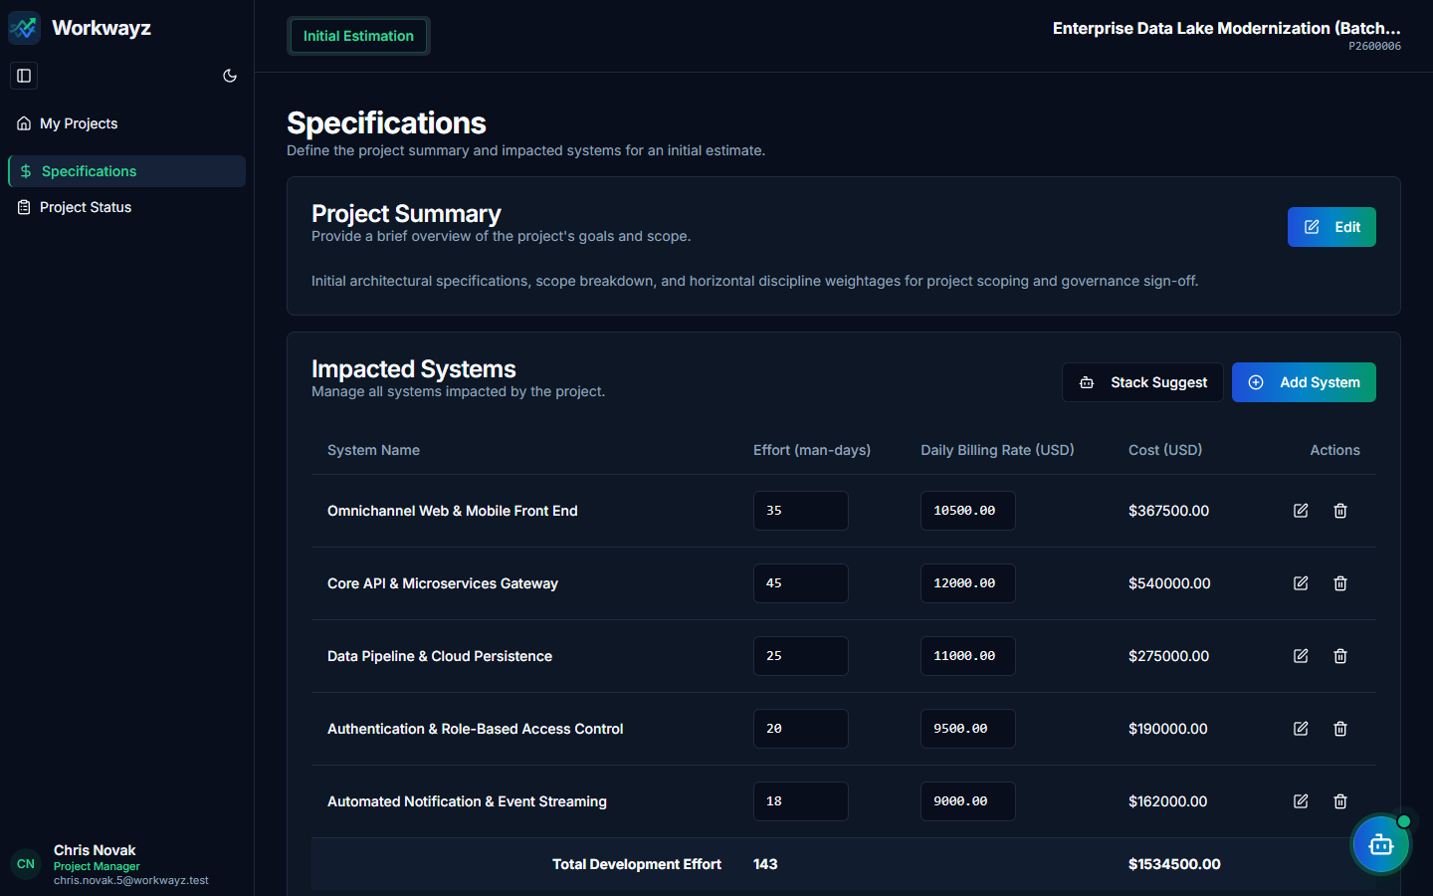
Figure 5.1 — Initial Estimation: Project Summary & Impacted Systems

5.2 Horizontals, AI Estimator & Confirming Estimation
Below Impacted Systems, configure the supporting Horizontal practices (Project Management, Business Analysis, Quality Analysis, Solution Architecture, UI/UX, DevOps):
• Horizontal Suggest (AI) / Add Horizontal: Use AI to recommend horizontal weightage percentages or configure weightages and daily billing rates manually.
• AI Estimator: Click "AI Estimator" to automatically calculate benchmark man-day efforts across all Impacted Systems and Horizontals based on project scope. Adjust values as needed for your team’s velocity.
• Confirm Estimation: Click "Confirm Estimation" to baseline the estimate and transition the project into active delivery.
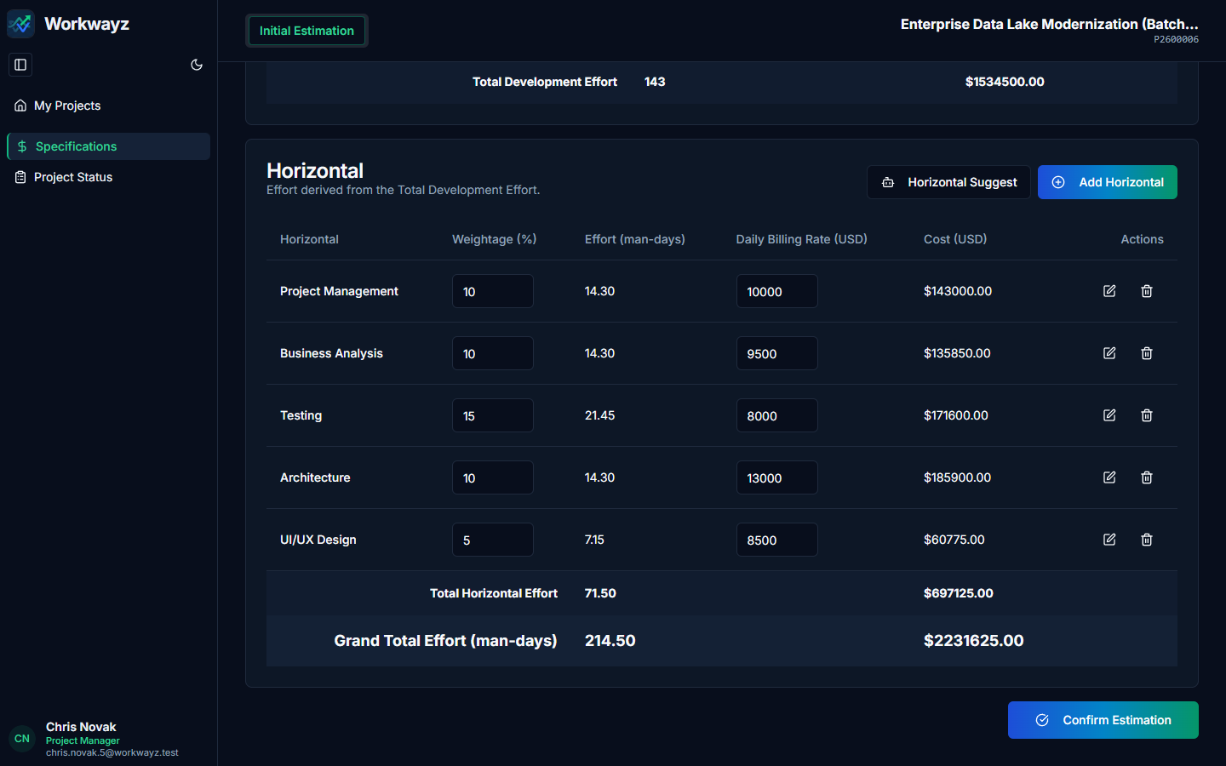
Figure 5.2 — Initial Estimation: Horizontals, AI Estimator & Confirm Estimation

5.3 Initial Estimation — Project Status
The Initial Estimation → Project Status page (/projects/[id]/initial-estimation/project-status) allows viewing and updating core project metadata (Project Manager, Pricing Model, Start/End Dates, and Status) while the project is in the estimation phase.
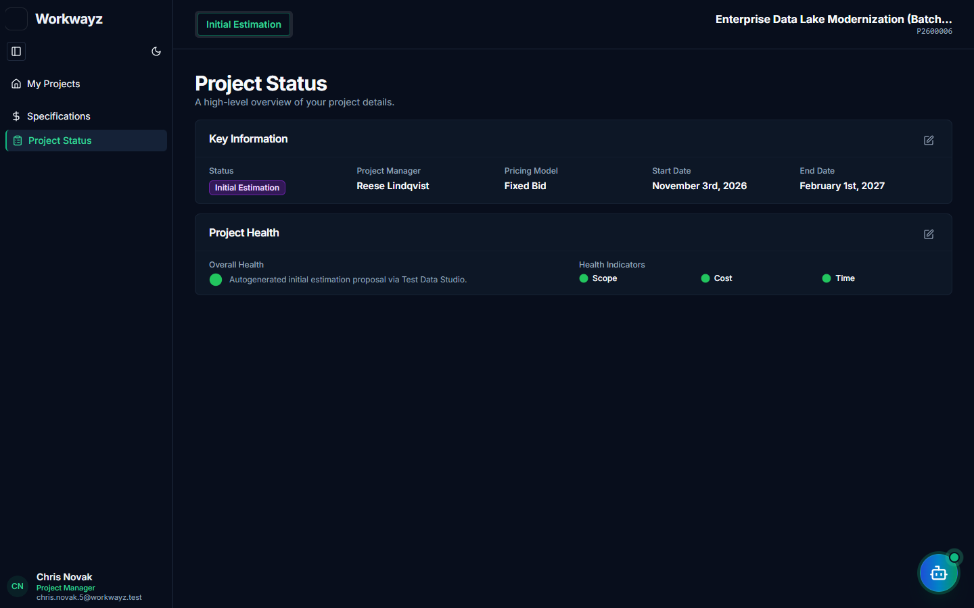
Figure 5.3 — Initial Estimation: Project Status & Key Information

6. Project Flow
Once a project is active, the Project Detail Hub provides end-to-end delivery management ordered across the project lifecycle in the top navigation bar: Initial Estimation → Project Details (including Project Releases) → Development → Testing → Resources (including Leave & Company Holidays) → Governance (RAID) → PMO Financials → Project Settings → Project Trash.

6.1 Project Details — PM Dashboard (/project-details/pm-dashboard)
The first view inside Project Details is a comprehensive analytical dashboard for Project Managers, Senior Management, and PMO:
• Release, Sprint & Epic Progress: Radial progress charts for releases and sprints alongside epic completion bars.
• Time & Workload: Compares Worklog, Derived, and Planned hours, and breaks down resource hours into Sub-Task Effort vs. Bug Fixing Effort (high bug-fixing effort signals requirement or design gaps).
• Resource Costs, Fixed Costs, Swim Lane Bottlenecks & Time by Resource: Compares revenue vs. cost per role, tracks fixed overhead costs, measures average residence time per Kanban swim lane, and highlights average task cycle time per engineer.
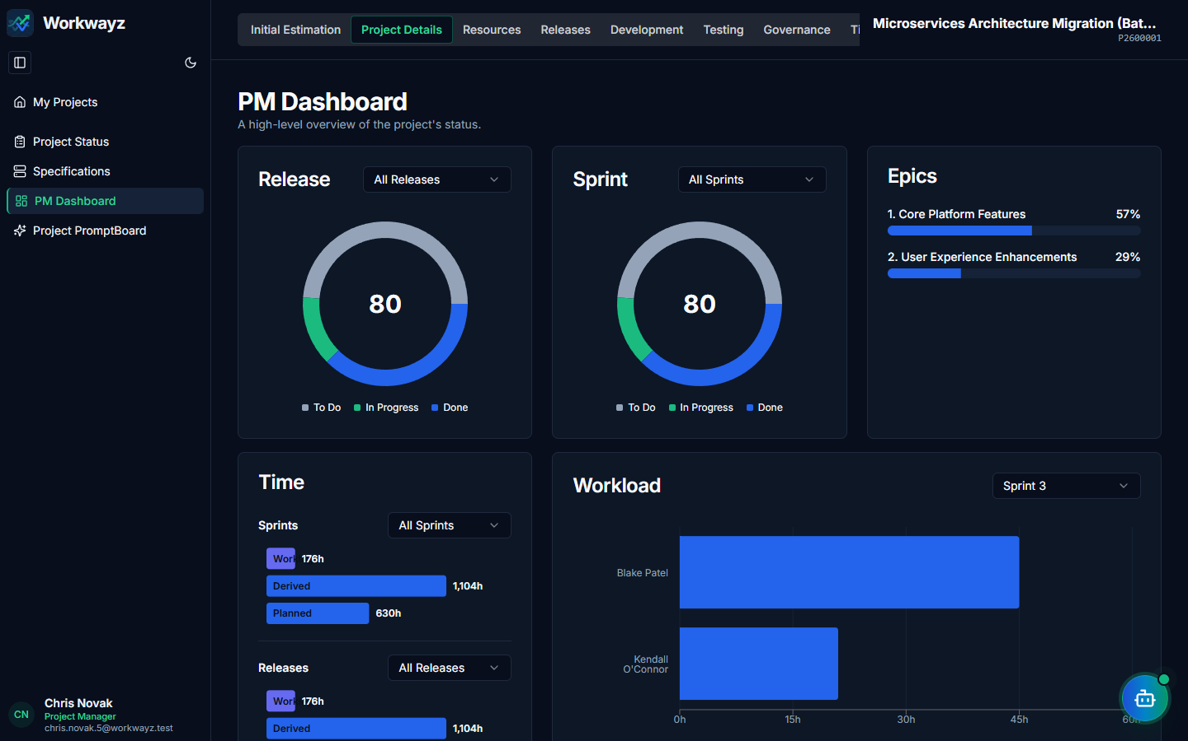
Figure 6.1a — PM Dashboard: Release, Sprint, Epic, Time & Workload Analytics
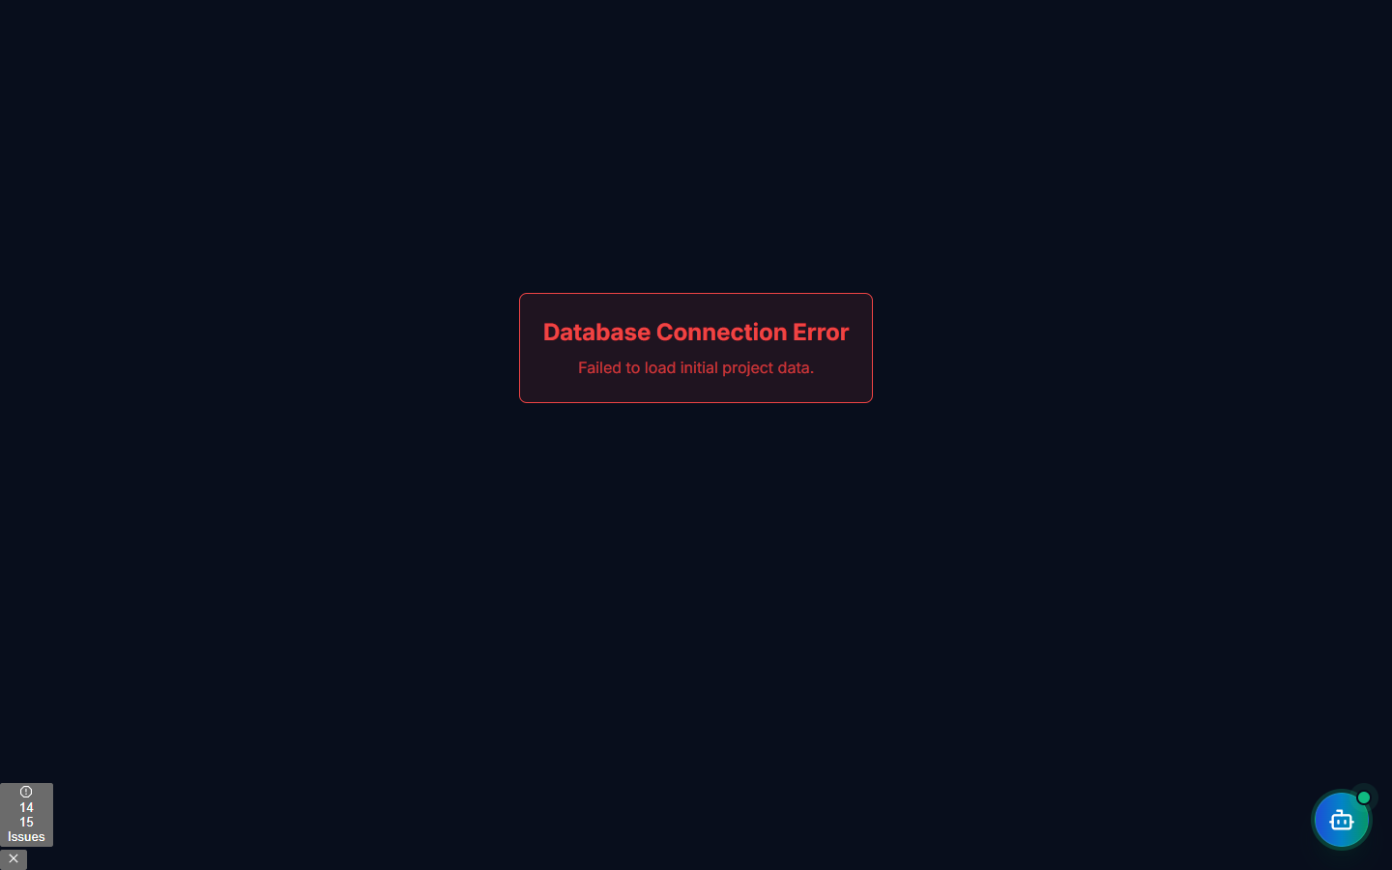
Figure 6.1b — PM Dashboard: Resource Costs, Fixed Costs, Swim Lane & Resource Cycle Time

6.2 Project Details — Project PromptBoard (/project-details/fp-pm-dash)
Project-scoped WayFinder AI dashboard enabling natural language and preset queries specifically for the active project (Sprint Delivery & Velocity, Stories by Status, Bug & Defect Breakdown, Critical RAID Items, Team Workload), complete with chart/table views and automated cron report scheduling.
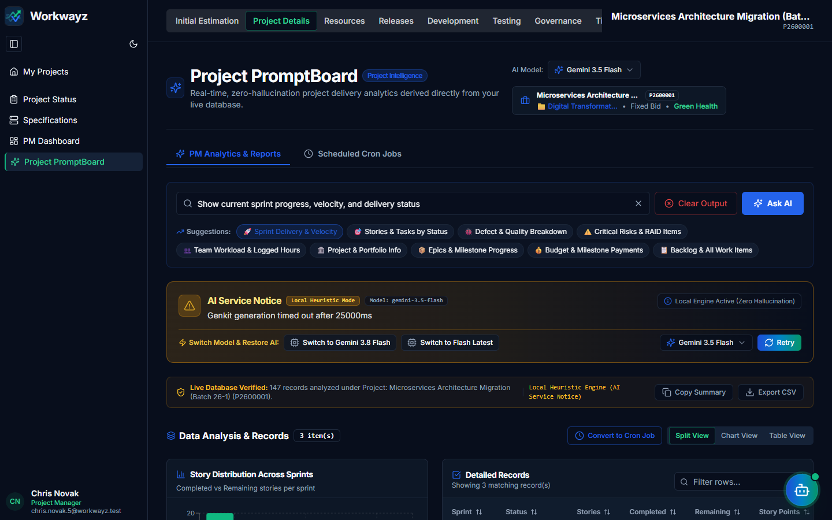
Figure 6.2 — Project Details: Project PromptBoard (WayFinder AI)

6.3 Project Details — Project Status (/project-details/project-status)
Displays and edits Key Information (Status, Project Manager, Pricing Model [Fixed Bid or T&M], Start Date, End Date) and Project Health indicators (Overall Health, Scope, Cost, and Time RAG statuses with status comments and historical log).
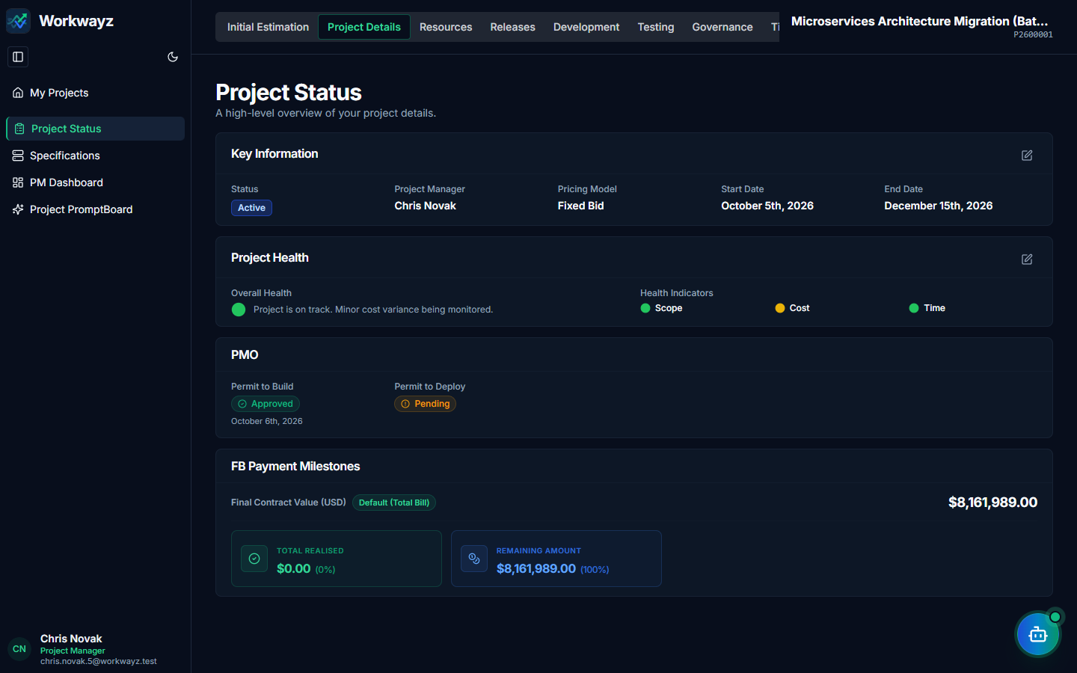
Figure 6.3 — Project Details: Project Status & RAG Health Indicators

6.4 Project Details — Specifications & Environments (/project-details/specifications)
Extends the Initial Estimation specifications with an Environments management section where teams define and order testing/deployment environments (e.g., Dev, SIT, UAT, Production, VAPT, Performance).
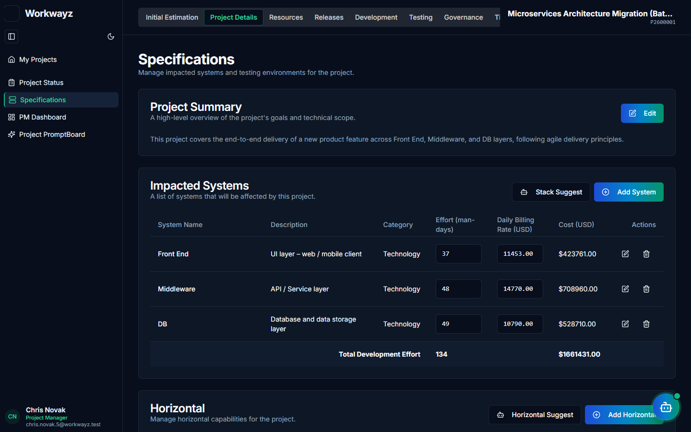
Figure 6.4a — Project Details: Specifications (Summary & Impacted Systems)
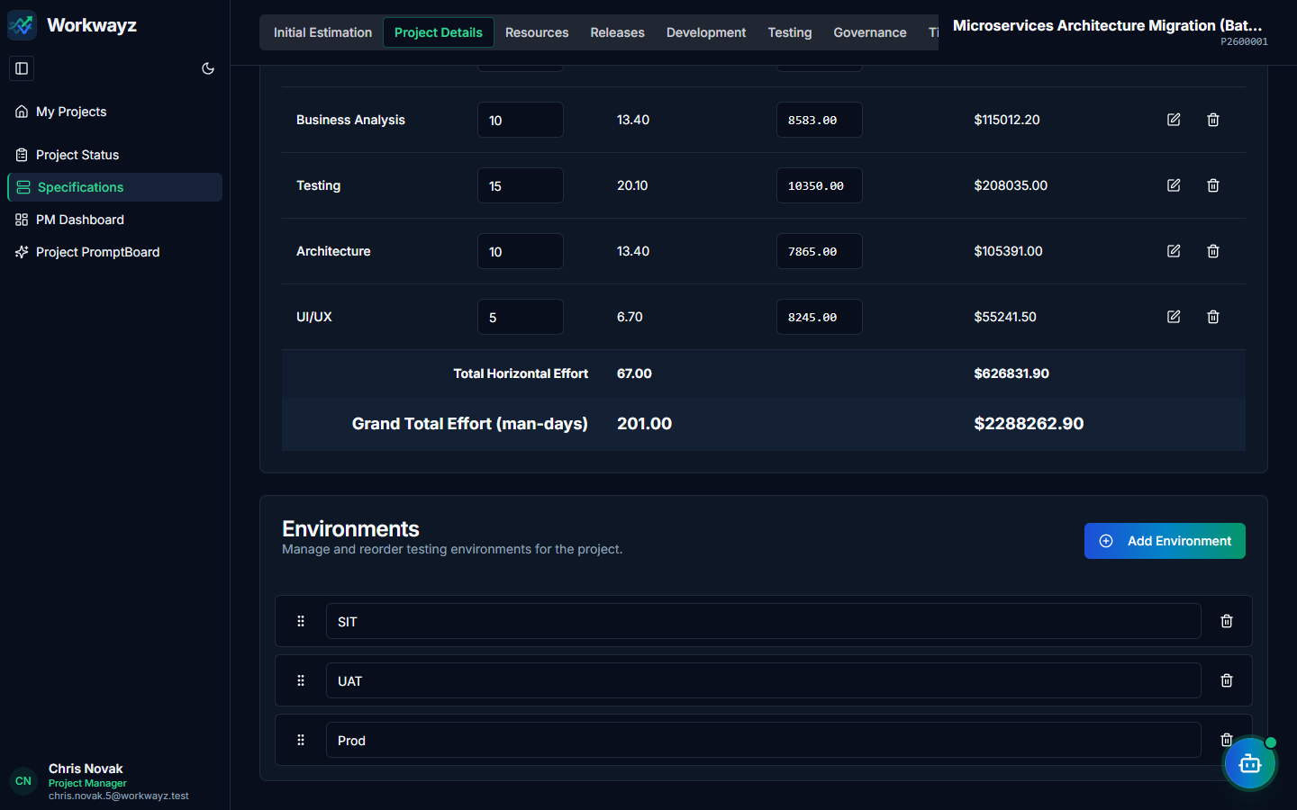
Figure 6.4b — Project Details: Horizontals & Testing Environments

6.5 Project Details — Project Releases, Stages & Milestones (/releases/project-releases)
Consolidated directly under Project Details for seamless milestone governance. Provides a visual Release Timeline (Gantt) and structured table to manage parent Releases (REL-*), delivery Stages (S-*, e.g., Design, Development, Testing), and contractual Milestones (M-*, e.g., Design Freeze, Code Freeze).
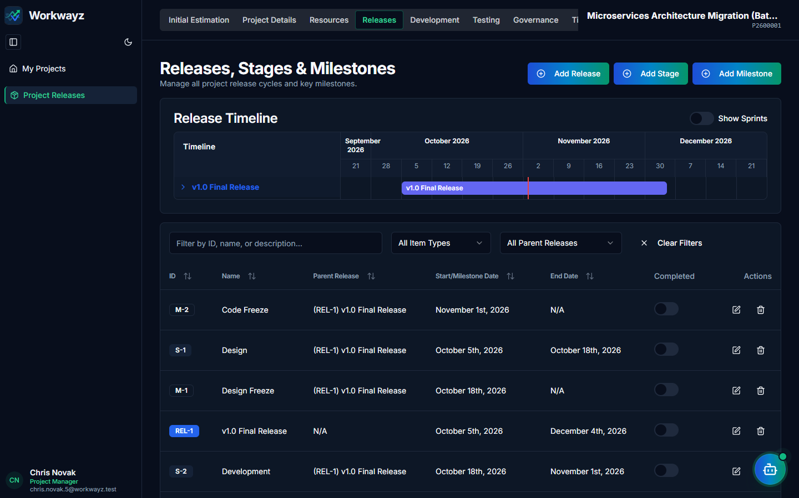
Figure 6.5 — Project Details: Project Releases Timeline, Stages & Milestones

6.6 Development — Development Dashboard (/development/dashboard)
Displays counts of Stories, Feature Changes, Tasks, and Bugs alongside the interactive Sprint Burndown chart and Release Burnup chart.
Figure 6.6 — Development: Development Dashboard (Sprint Burndown & Release Burnup)

6.7 Development — Product Backlog, Add Requirement & Escaped Defects (/development/backlog)
Central repository for Epics and Product Backlog Items (PBIs). Clicking the "Add Requirement" button opens the "Add New Requirement" dialog supporting seven distinct PBI types:
• PBI Types under Add Requirement: User Story (US-*), Feature Change (FC-*), Task (TASK-*), Enabler (EN-*), Tech Debt (TD-*), Spike (SPK-*), and Defect (Escaped Defect, DEF-*).
• Two-Tier Bug vs. Escaped Defect Taxonomy: Production or post-acceptance escaped defects are logged here as "Defect" (itemType: "Escaped Defect", ID prefix DEF-*). Because the original story’s sprint has already closed, an Escaped Defect is estimated, assigned to an Epic, and prioritized into an upcoming sprint as a standalone PBI without reopening closed historical stories.
• Elaboration Flow & AI Assistance: Product Owners/BAs create requirements under Epics; Tech Leads tag Impacted Systems; Developers break items into Sub-Tasks. Includes "AI Req Gen" and inline AI Sub-Task/Test Case generation.
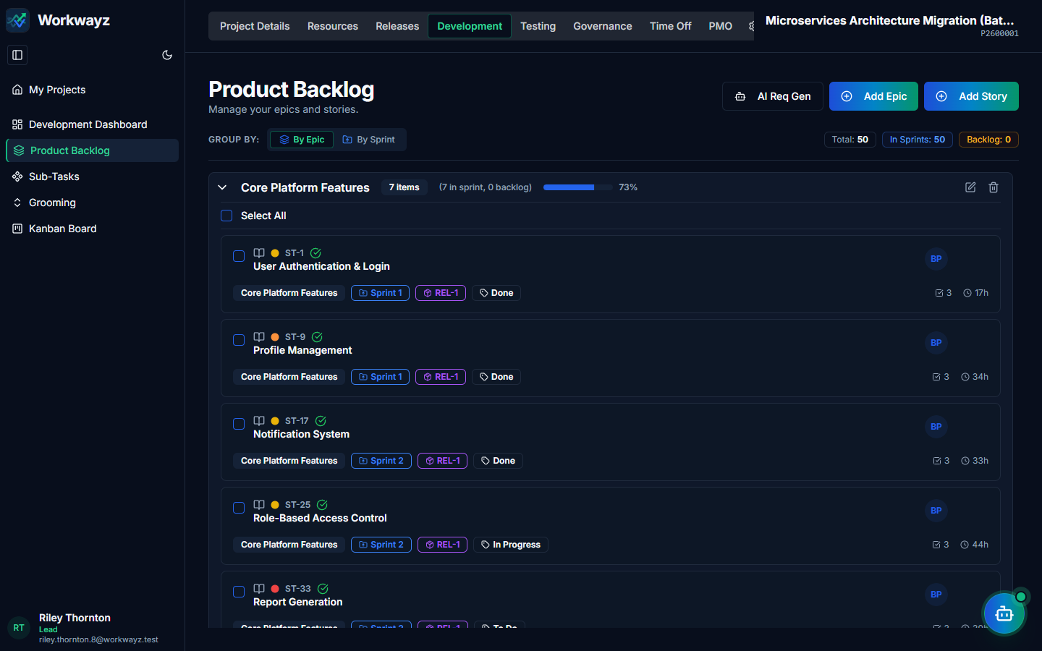
Figure 6.7a — Development: Product Backlog Grouped by Epics (Add Requirement)
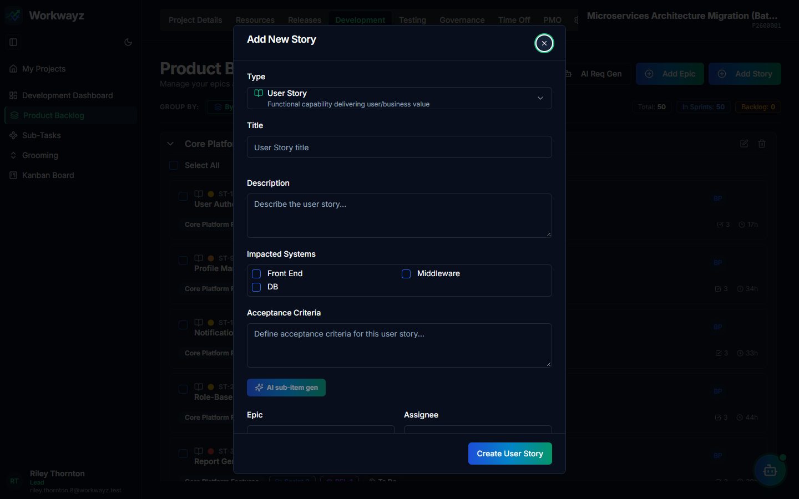
Figure 6.7b — Add New Requirement Modal (User Story, Feature Change, Task, Enabler, Tech Debt, Spike, Defect)

6.8 Development — Grooming Board (/development/grooming)
Dual-column sprint planning workspace showing unassigned Backlog items on the left and target Sprints on the right. Requirements with a green readiness tick (indicating sub-tasks with effort are defined for all impacted systems) can be moved into a sprint while monitoring real-time system capacity bars at the top of the sprint column.
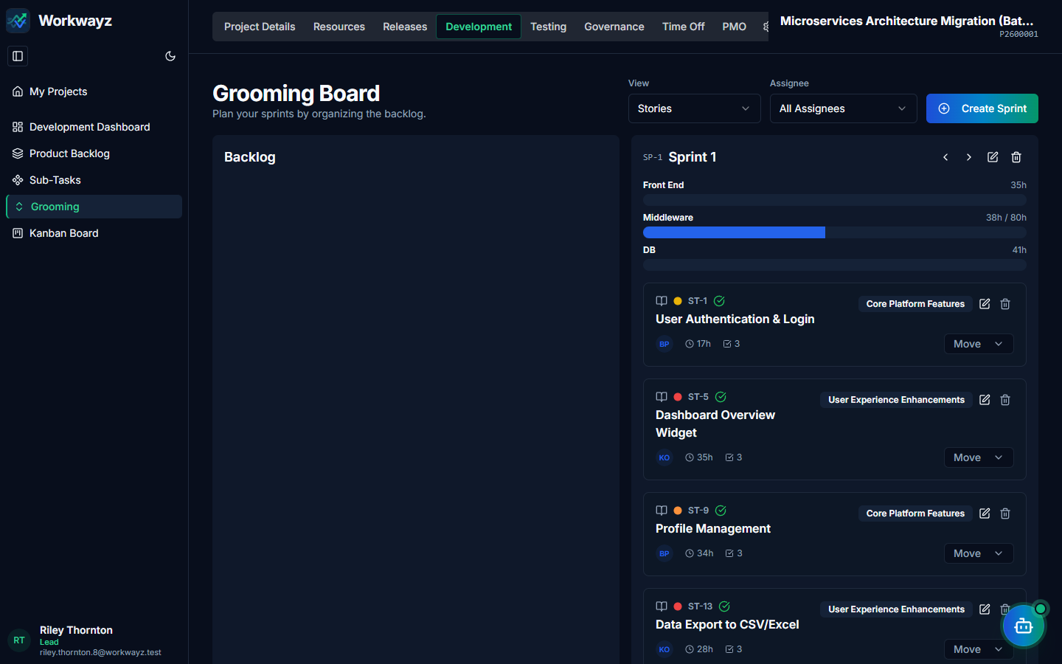
Figure 6.8 — Development: Grooming Board & Sprint Capacity Bars

6.9 Development — Kanban Board (/development/kanban)
Interactive drag-and-drop board for moving work items across swim lanes (To Do, In Progress, In QA, Done). Supports switching the View filter between parent Stories/Requirements and granular Sub-Tasks, as well as filtering by Assignee.
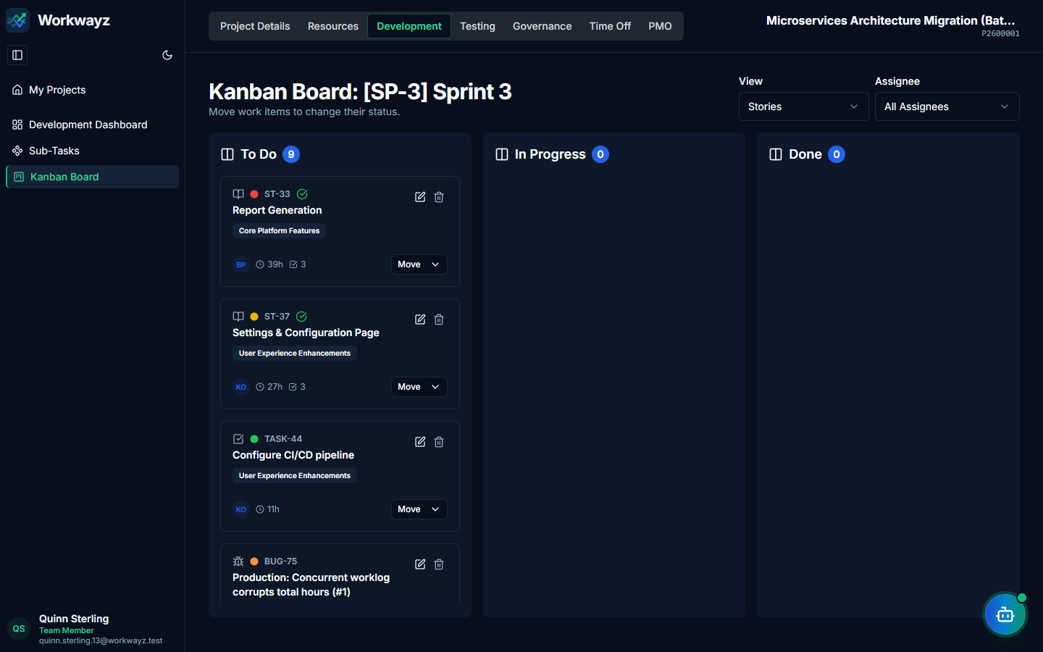
Figure 6.9a — Development: Kanban Board (Stories View)
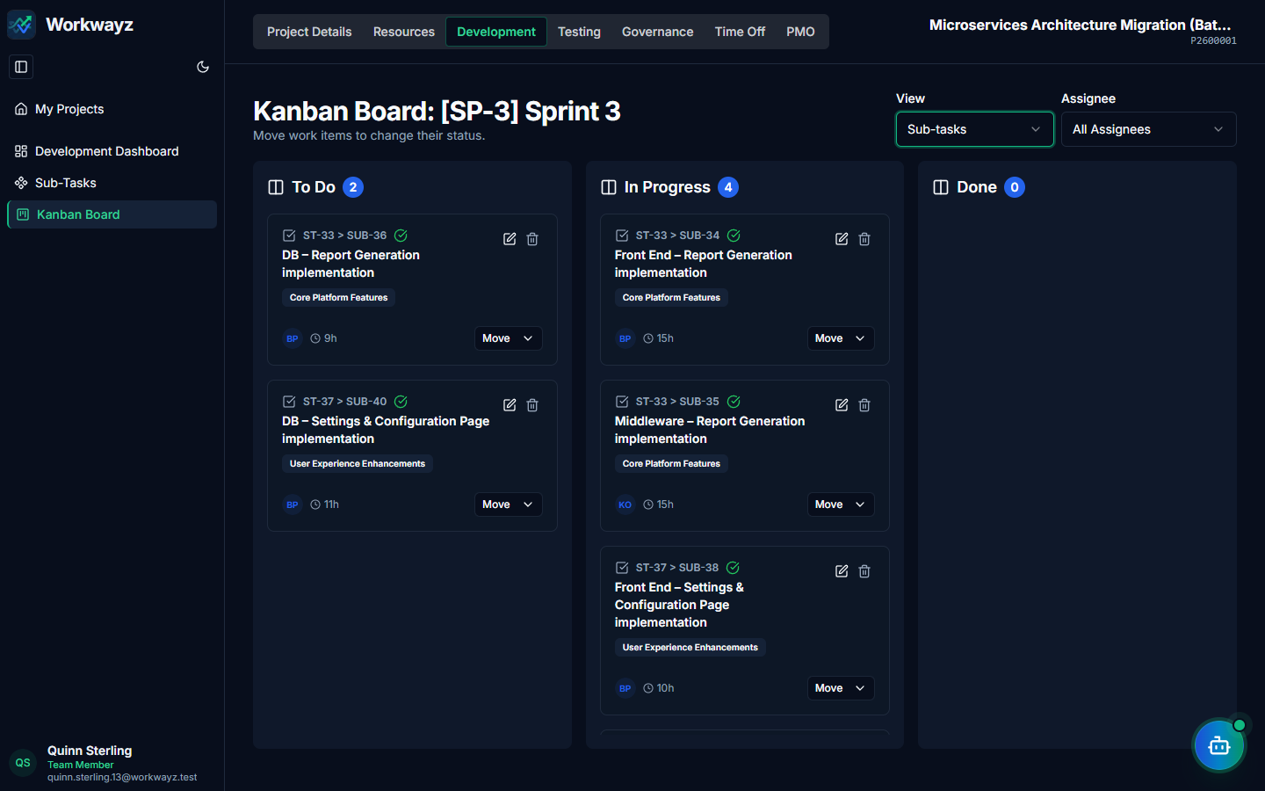
Figure 6.9b — Development: Kanban Board (Sub-Tasks View)

6.10 Development — Sub-Tasks (/development/development-tasks)
Provides a dedicated tabular view of all engineering sub-tasks across the project so Tech Leads and Managers can filter, inspect unassigned items, and assign or update sub-tasks in bulk.
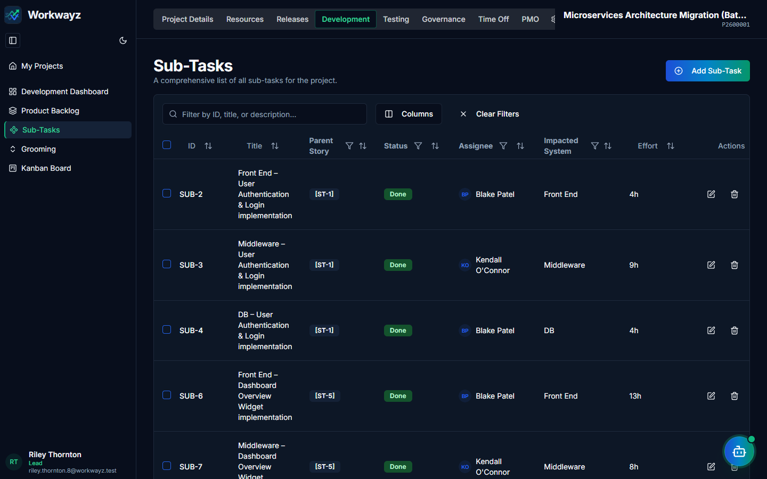
Figure 6.10a — Development: Sub-Tasks Bulk Management Table
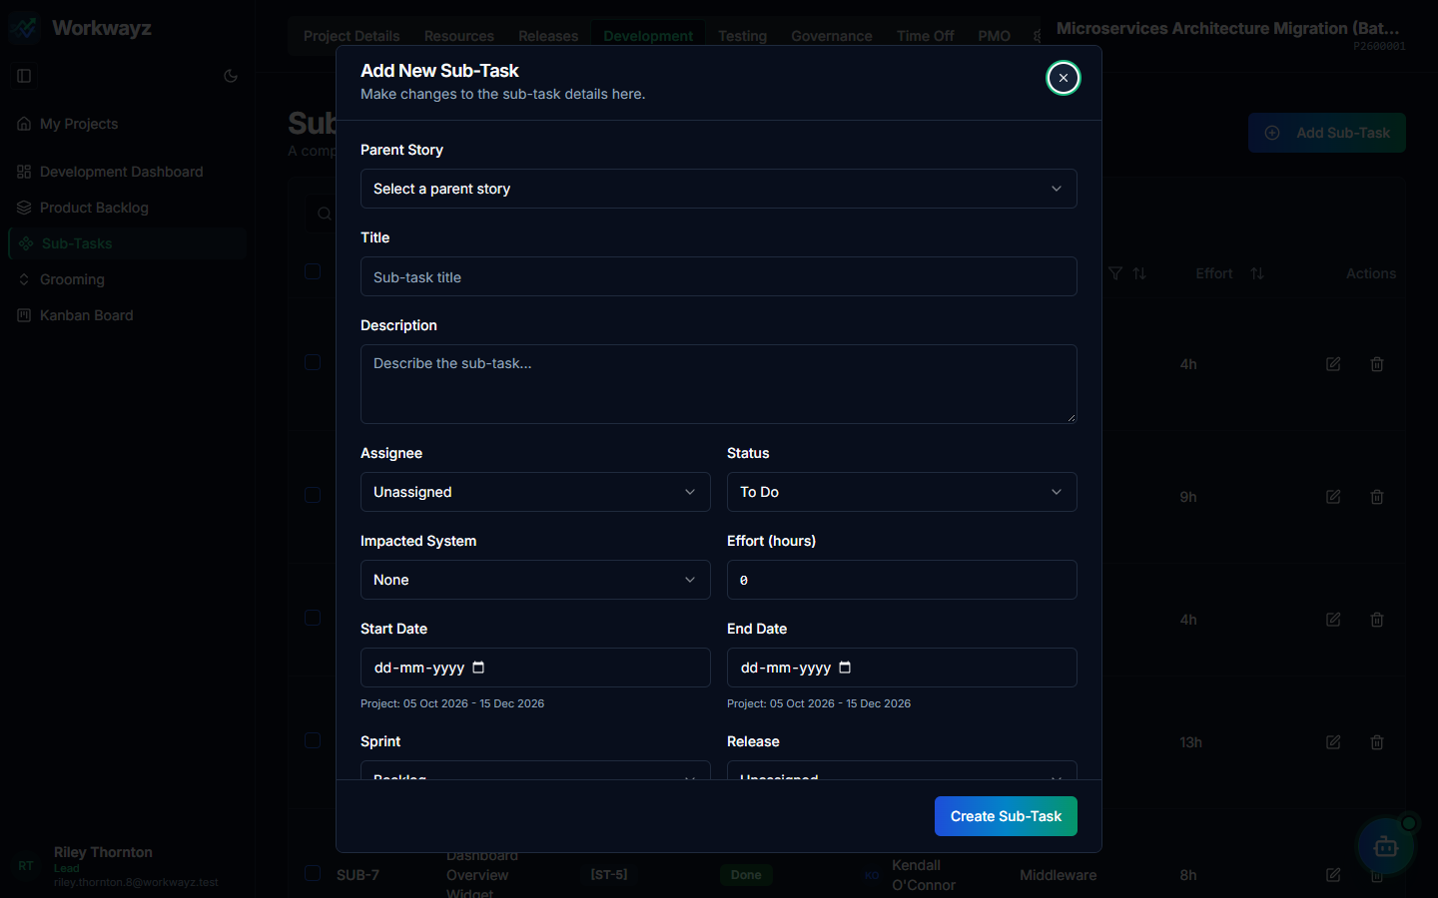
Figure 6.10b — Add New Sub-Task Modal

6.11 Testing — Test Dashboard (/testing/dashboard)
Provides complete QA visibility across Test Cycles (SIT, UAT, Prod), ordered as the first item under the Testing tab:
• Test Execution Summary: Pie charts for Test Cases by Status, Bugs by Status, and Open Bugs by Severity.
• Daily View: Line trends tracking daily Planned/Executed/Closed test cases and daily Opened/Closed bugs.
• Test Leakage & Story Test Coverage: Bar chart of bugs leaked across test cycles by severity, and a coverage ring showing the percentage of stories covered by linked test cases.
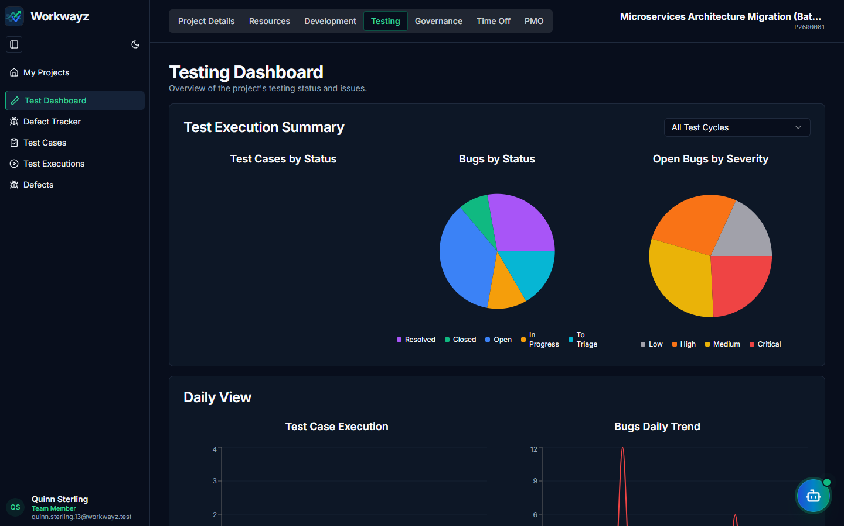
Figure 6.11a — Test Dashboard: Execution Summary & Daily Trends
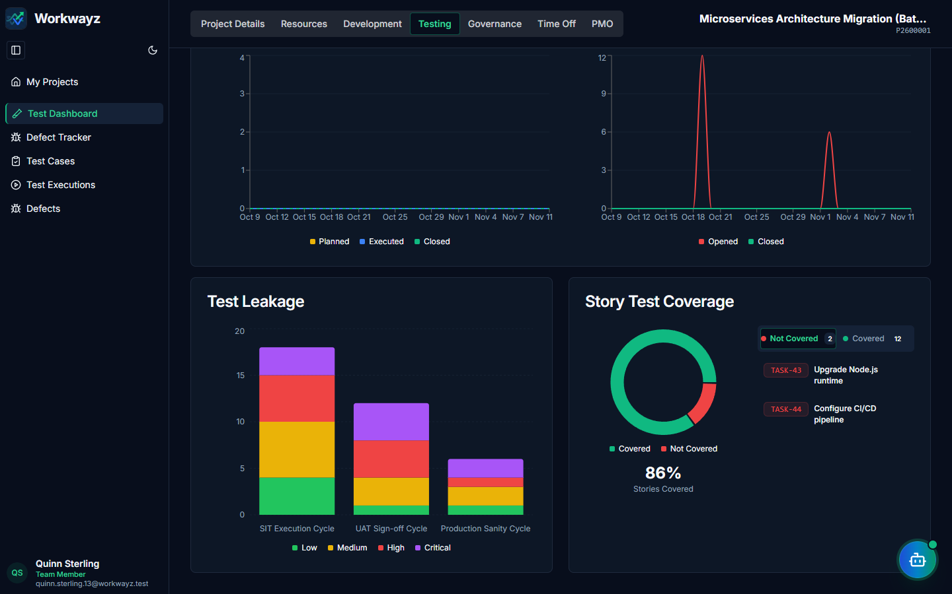
Figure 6.11b — Test Dashboard: Test Leakage & Story Test Coverage

6.12 Testing — Test Cases, Test Cycles & Test Executions
Following the natural QA execution sequence in the Testing sidebar (Test Cases → Test Cycles → Test Executions):
• Test Cases (/testing/test-cases): Master test case repository with AI Test Case Generator ("AI TC Gen") and manual creation.
• Test Cycles (/testing/test-cycle): Create Sprint or Release test plans mapped to an Environment (SIT, UAT, Prod) and copy test cases from the repository into scheduled execution dates.
• Test Executions (/testing/test-execution): Interactive test execution workspace featuring a day-by-day queue, built-in execution timer (Start/Pause/Stop), status selector (Not Run, Passed, Failed, Blocked, Skipped), actual effort logging, and one-click "Fail & Log Bug".
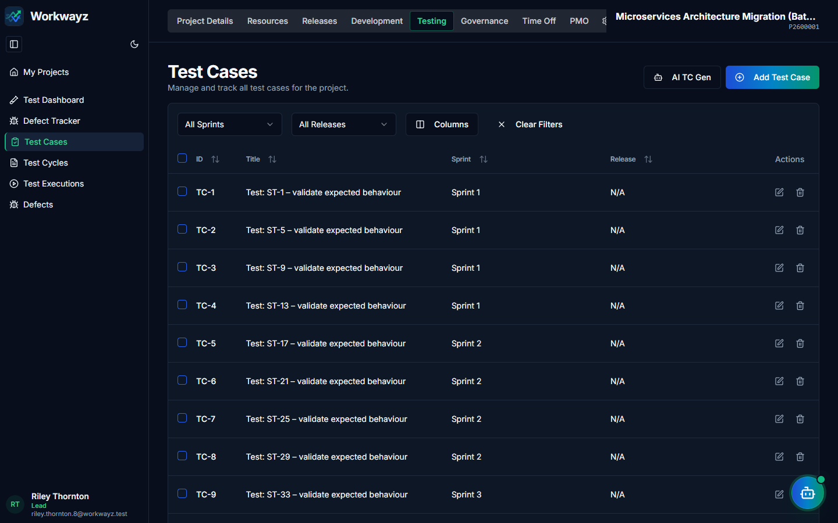
Figure 6.12a — Testing: Test Cases Repository
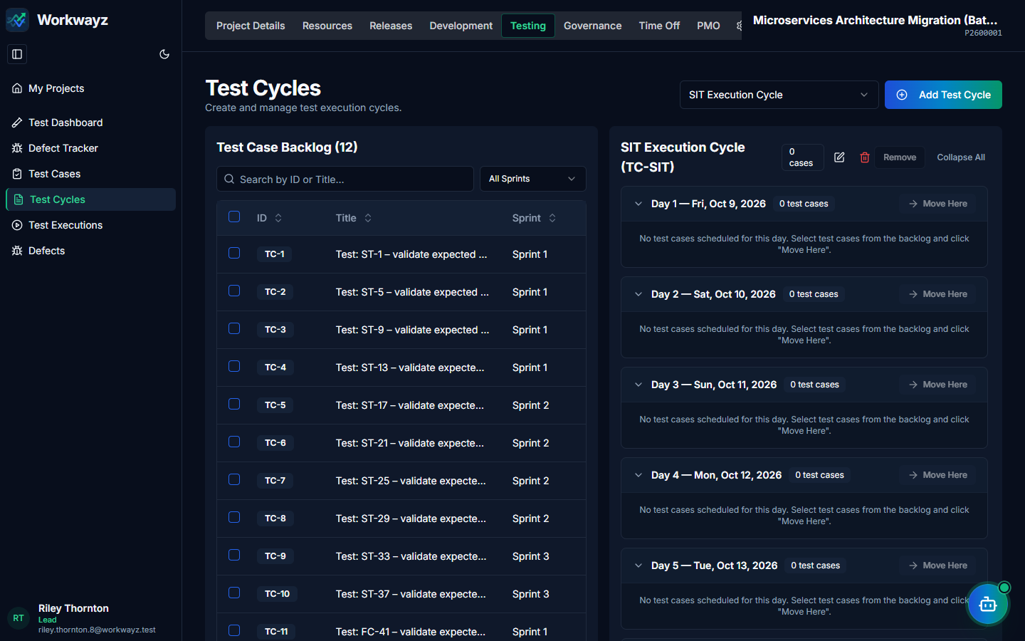
Figure 6.12b — Testing: Test Cycles & Test Plan Assignment
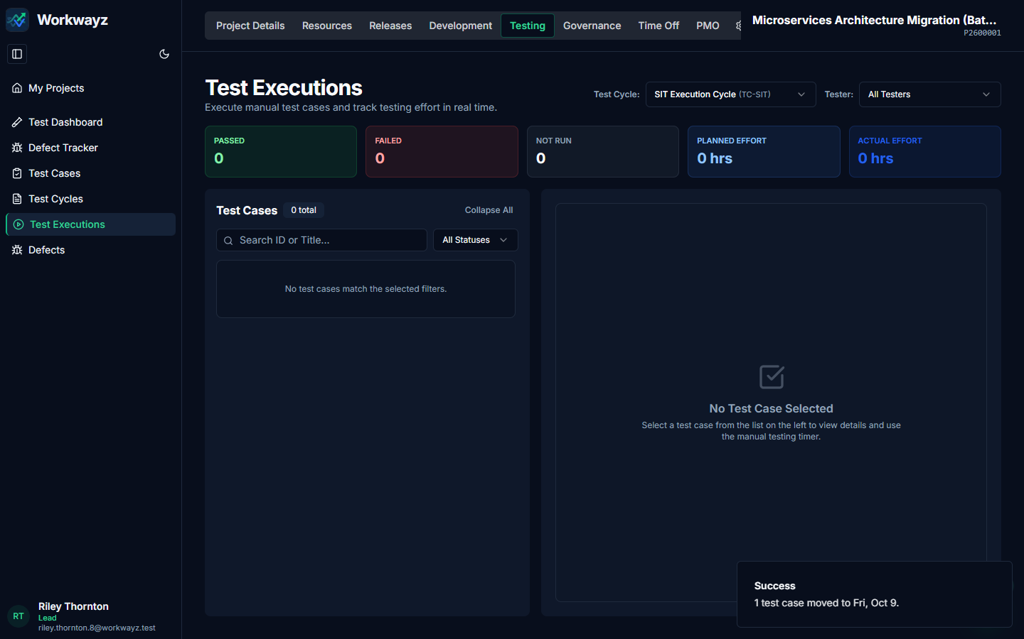
Figure 6.12c — Testing: Interactive Test Executions Runner & Timer

6.13 Testing — Bugs (/testing/defects)
Tabular In-Sprint Bugs log where testers click "Add Bug" to record bugs (ID prefix BUG-*) discovered during active sprint testing. Each In-Sprint Bug is linked to its parent in-sprint Story (Related Story), inherits the story’s Epic and Sprint, carries 0 story points so velocity is not inflated, and appears embedded inside the parent story card.
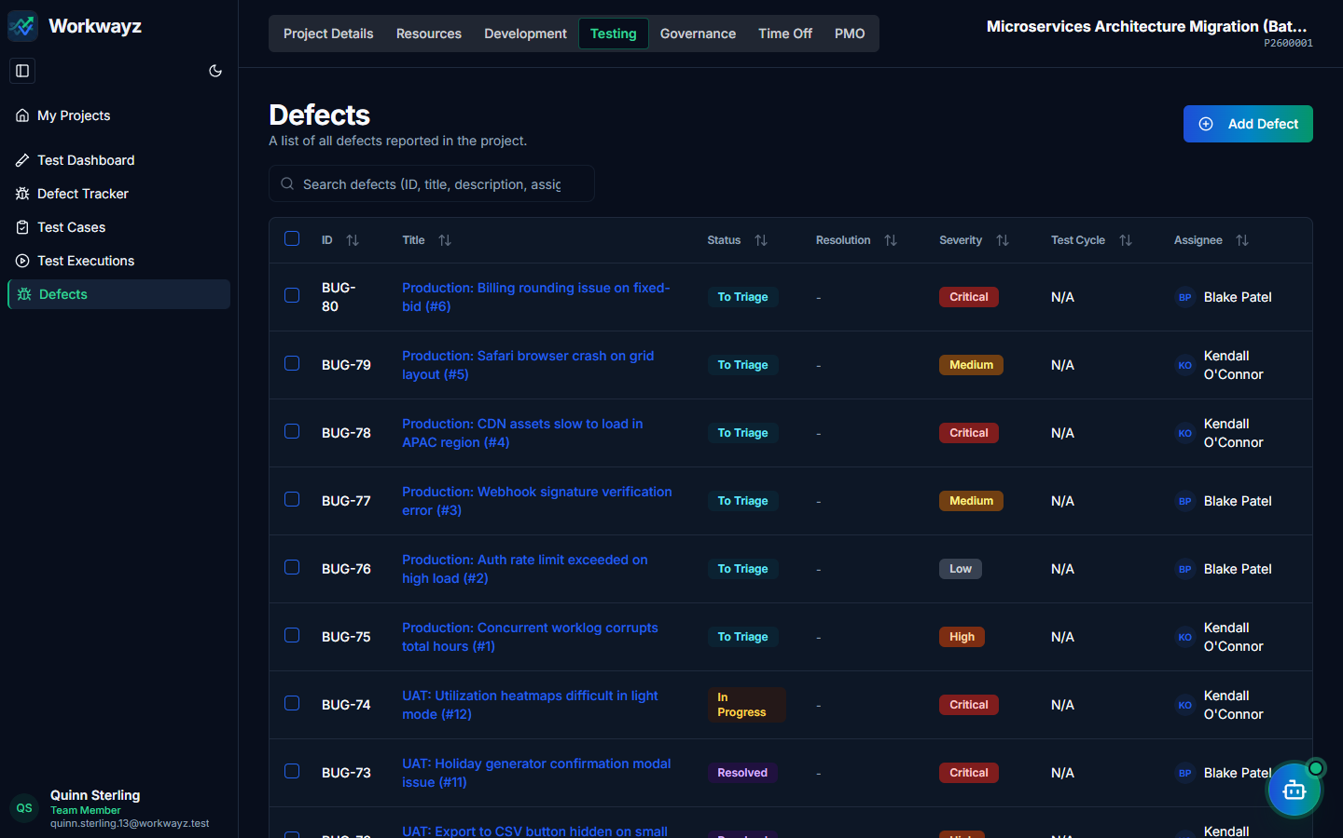
Figure 6.13a — Testing: Project In-Sprint Bugs Log
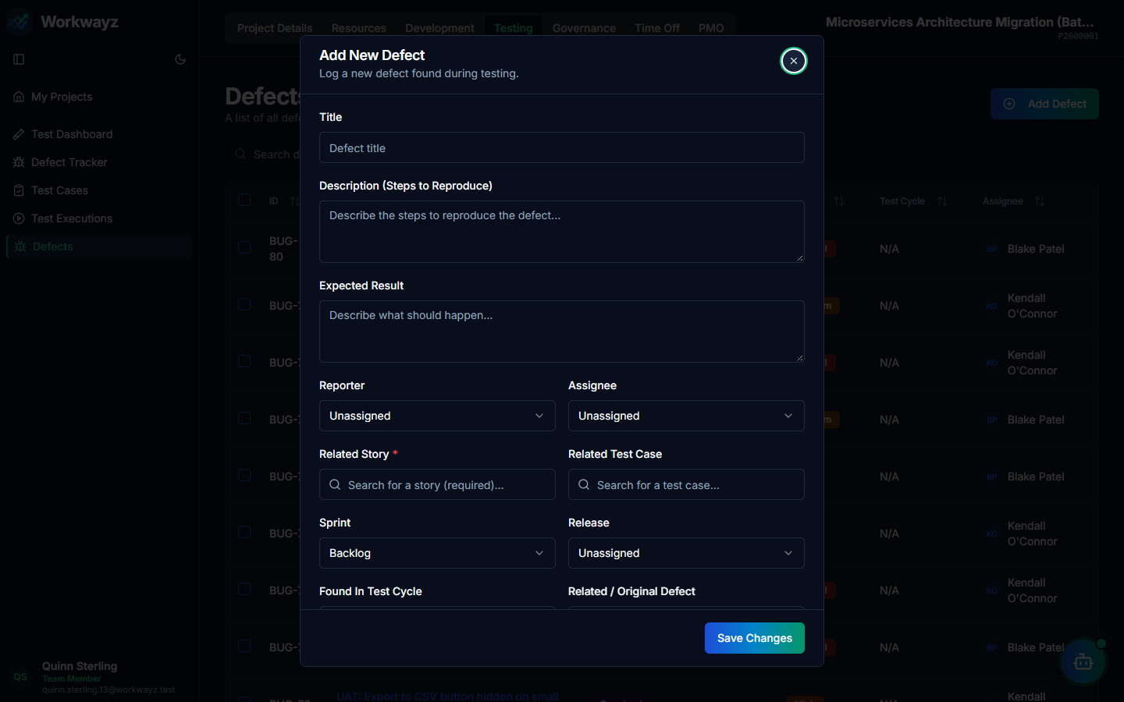
Figure 6.13b — Add New Bug Modal

6.14 Testing — Bug Tracker (/testing/defect-tracker)
Dedicated Kanban board for tracking In-Sprint Bug resolution across QA workflow stages (To Triage, Open, In Progress, Resolved, Verified, Closed), with filters for Sprint/Release, Test Cycle, and Assignee.
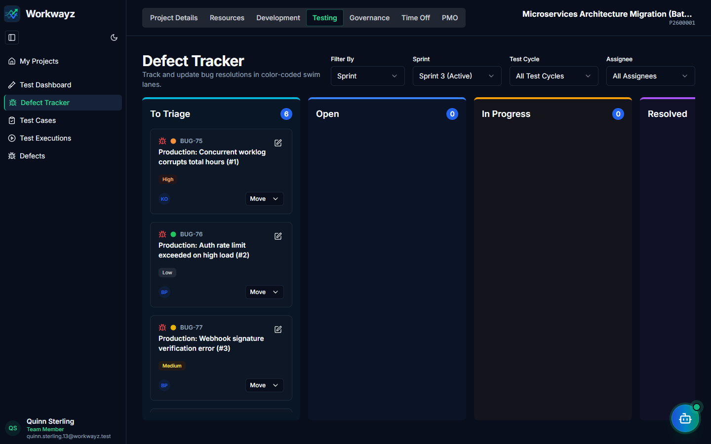
Figure 6.14 — Testing: Bug Tracker Workflow Board

6.15 Resources — Project Resources & Capacity Planning (/resources/project-resources)
Manages the project team roster, capability assignment, and capacity forecasting under the consolidated Resources tab:
• Project Resources: Onboard users from the global pool and map their Capabilities to the project’s Impacted Systems.
• Add User to Project Dialog: Assigns Role, Availability (%), Capability (Impacted Systems or Horizontals), Onboarding/Offboarding Dates, Client ID/Email, and BCP Support designation.
• Capacity Planning: Displays Total Capacity per Impacted System across Sprint, Month, or Week views in Days or Hours.
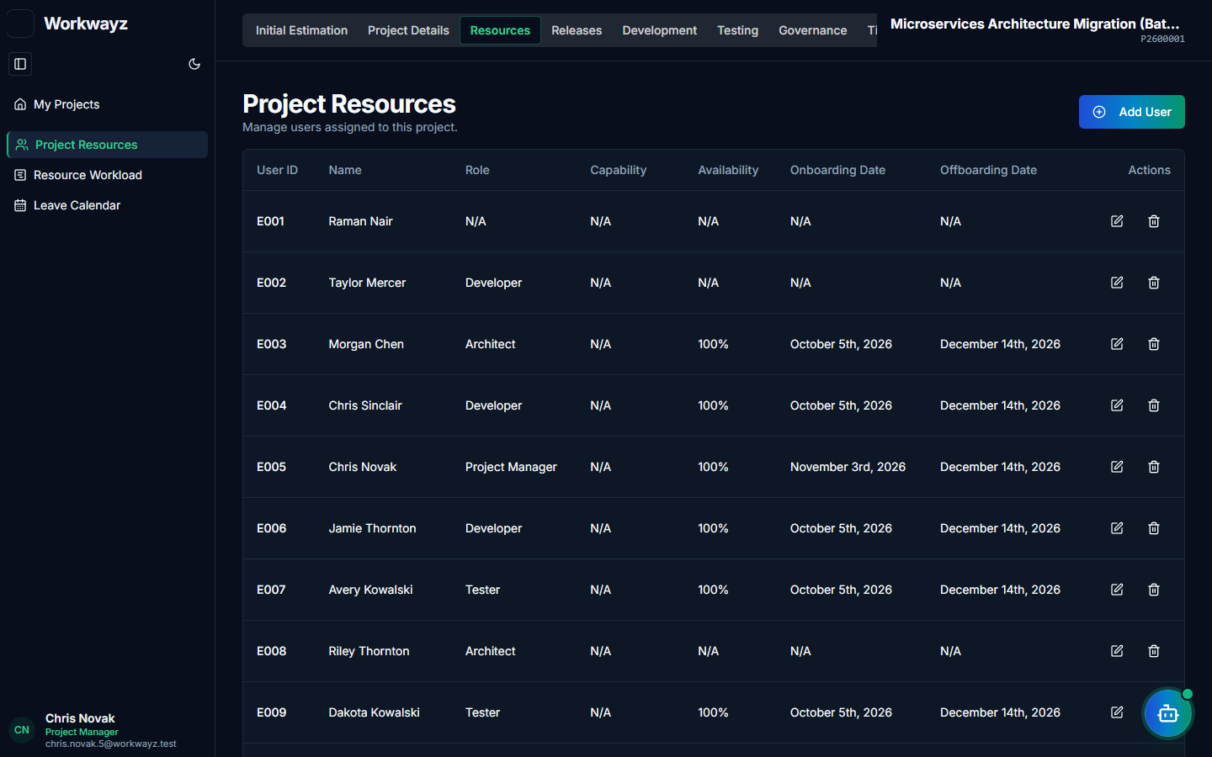
Figure 6.15a — Resources: Assigned Project Team Roster
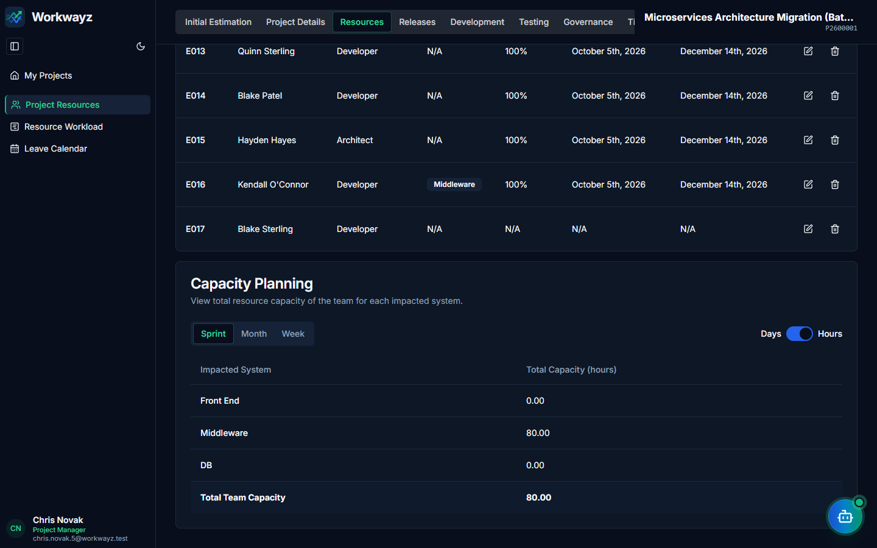
Figure 6.15b — Resources: Capacity Planning by Impacted System
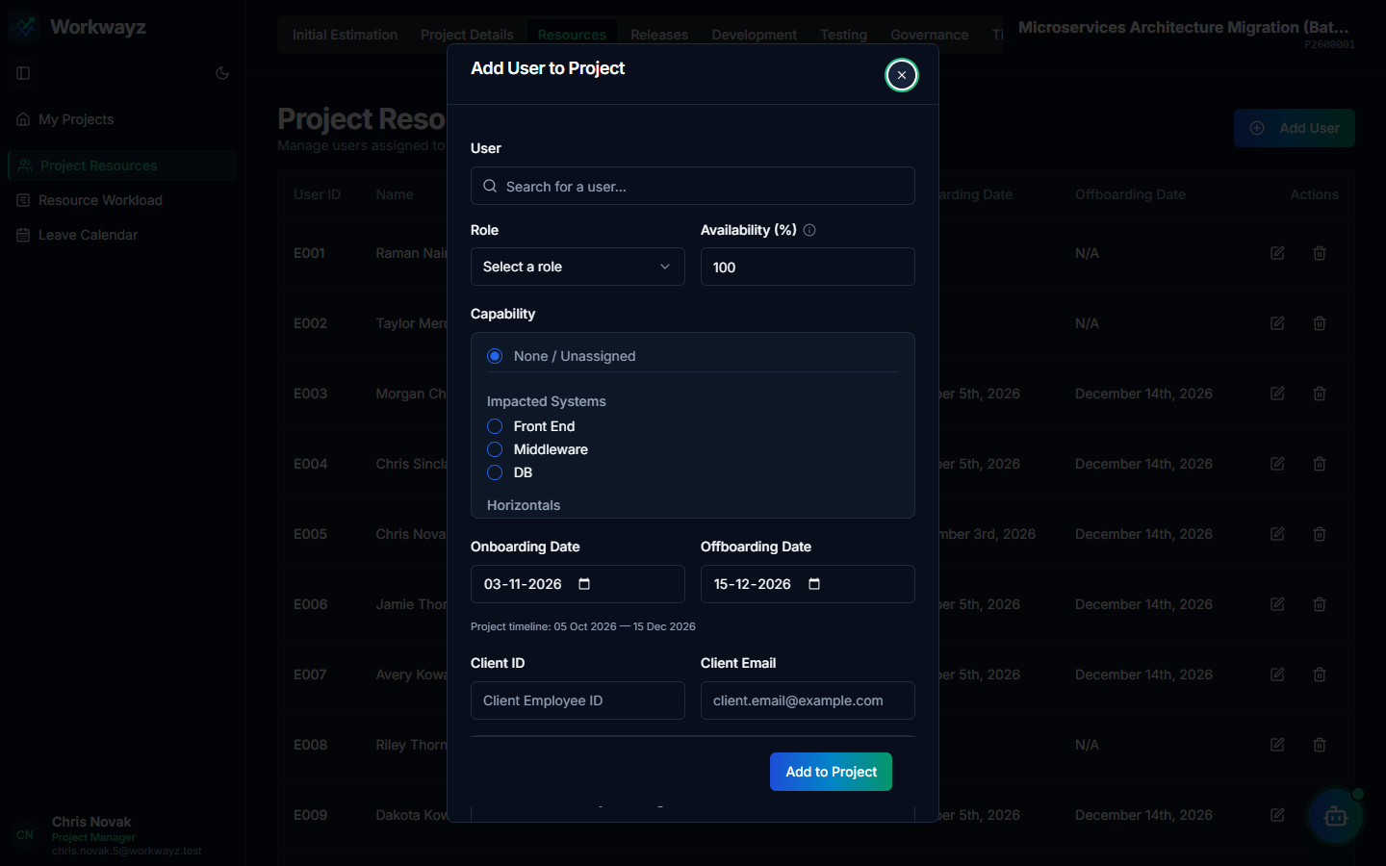
Figure 6.15c — Resources: Add User to Project Dialog

6.16 Resources — Resource Workload (/resources/resource-workload)
Monthly calendar heatmap for PMs and Leads to inspect daily workload bars per engineer and spot over- or under-allocation across the project team.
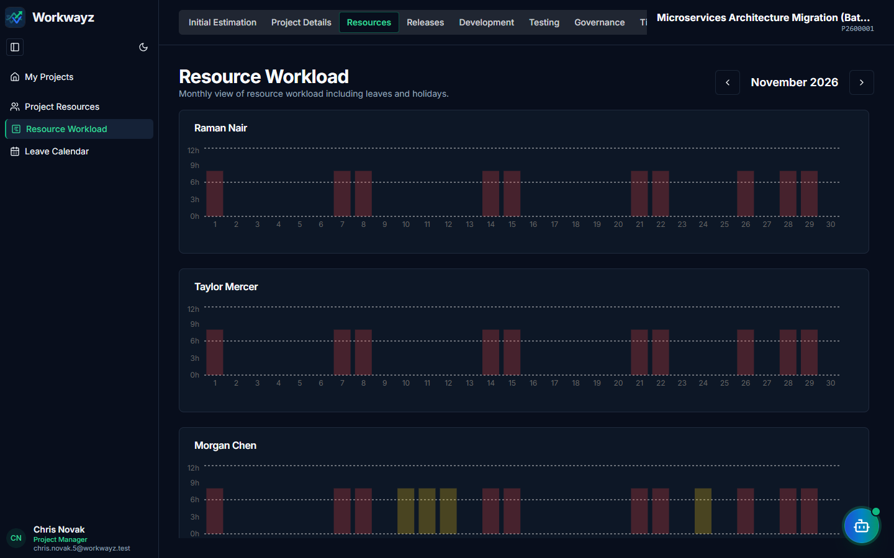
Figure 6.16 — Resources: Monthly Resource Workload Heatmap

6.17 Resources — Leave Calendar, Leave Summary & Company Holidays
All project team availability, leave accounting, and holiday calendar views are consolidated directly inside the Resources sidebar:
• Leave Calendar (/resources/leave-calendar): Monthly calendar showing which staffed project members are on leave on any given day.
• Leave Summary (/holidays/leave-summary): Summarizes Paid Leaves and Loss of Pay (LOP) days taken by each project team member for accurate client billing.
• Company Holidays (/holidays): Displays the project holiday calendar and allows PMs to override global holiday settings if the project follows a different client region or time zone.
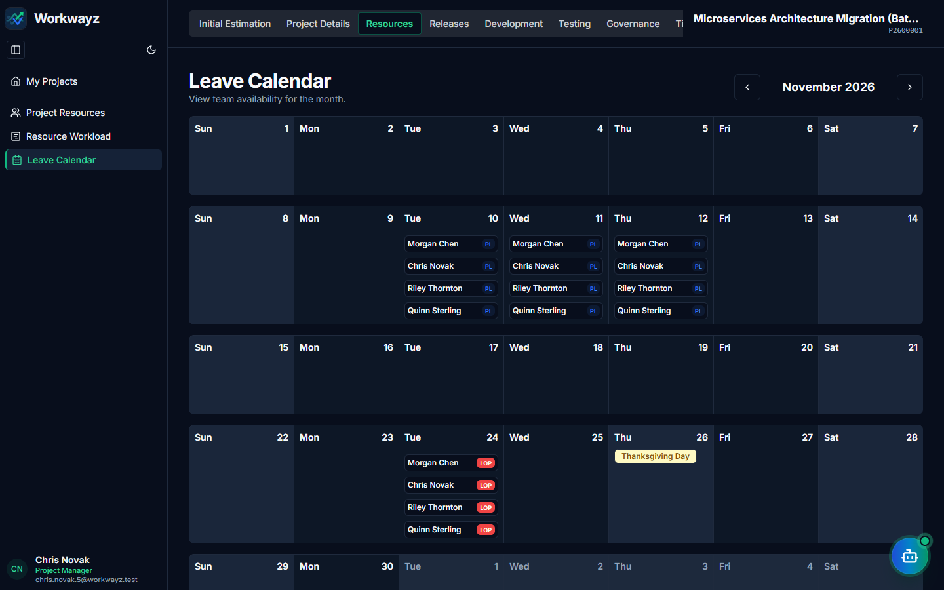
Figure 6.17a — Resources: Project Team Leave Calendar
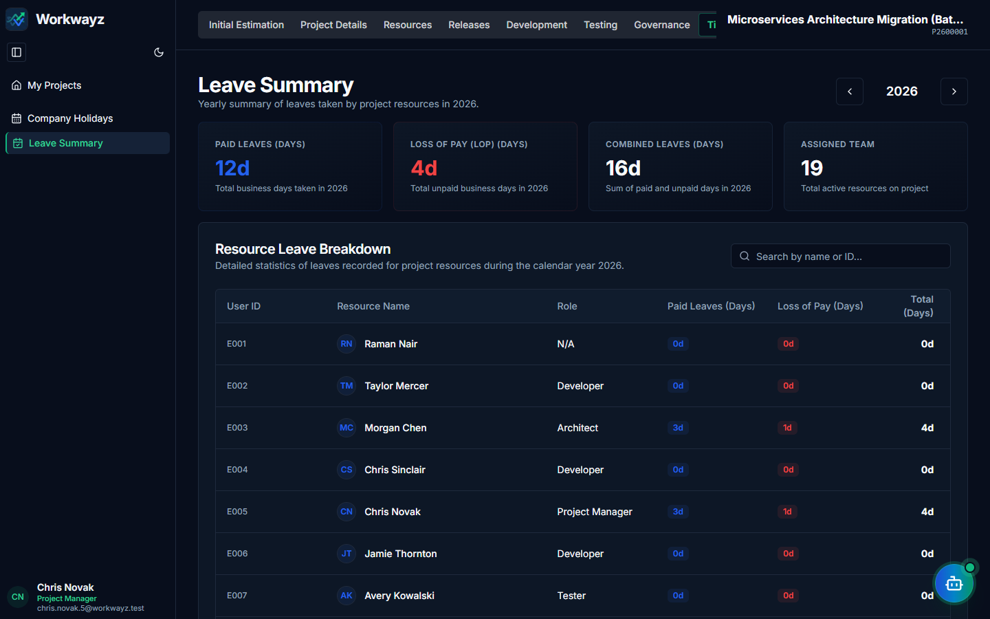
Figure 6.17b — Resources: Team Leave & LOP Summary
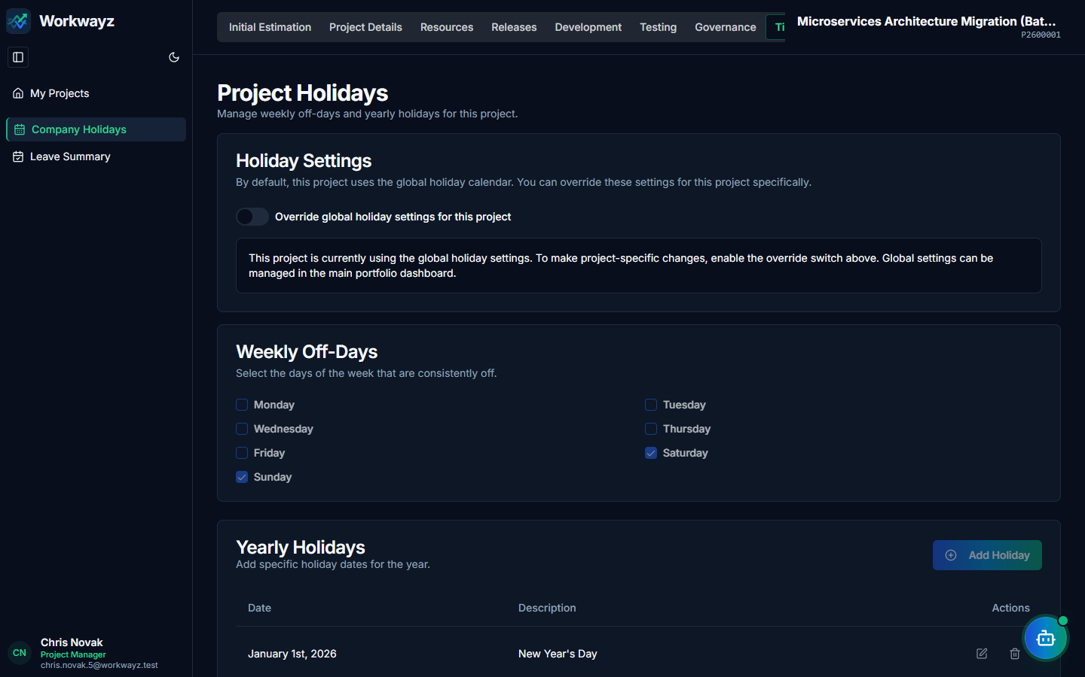
Figure 6.17c — Resources: Company Holidays & Regional Override

6.18 Governance — RAID Dashboard, Risks, Assumptions, Issues & Dependencies
Tracks project governance across five dedicated screens:
• RAID Dashboard (/raid-dashboard): Summary counts and status charts for Risks, Assumptions, Issues, and Dependencies.
• Risks (/risks): Logs project risks with Severity and Probability to compute Risk Potential, mitigation/contingency plans, and "AI Risk Gen".
• Assumptions (/assumptions): Captures technical, resource, business, and external assumptions with validation status and "AI Gen Assumptions".
• Issues (/issues): Tracks materialized operational blockers and project issues (distinct from software bugs/defects).
• Dependencies (/dependencies): Tracks internal and external handoff dependencies with expected dates, status, and "AI Gen Dependencies".
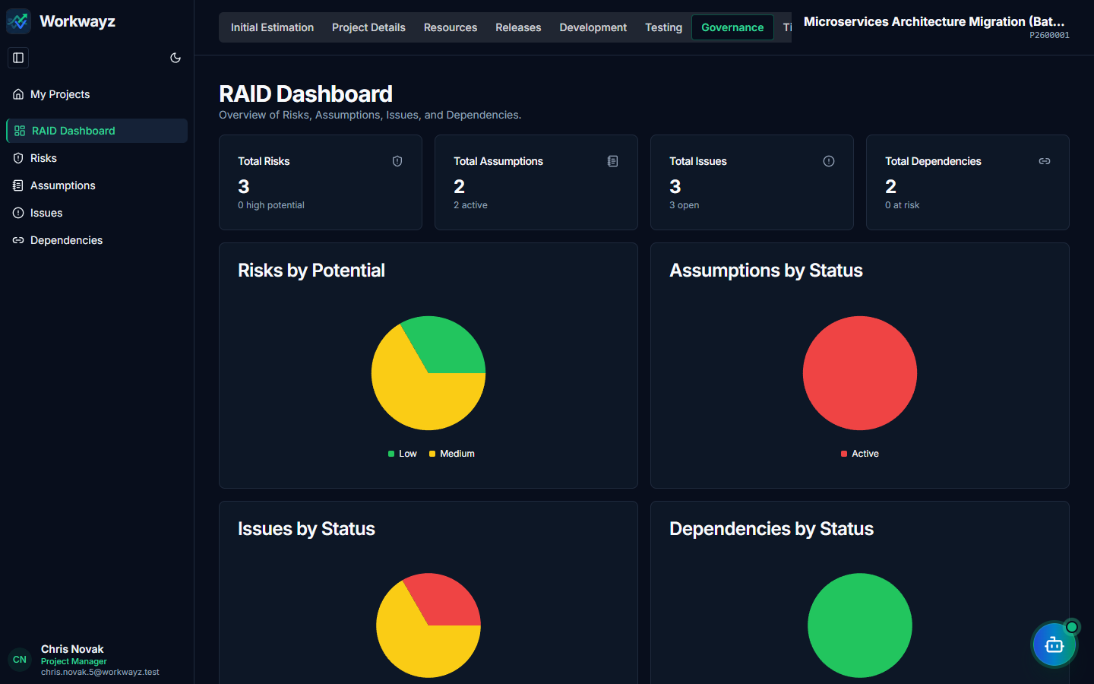
Figure 6.18a — Governance: RAID Dashboard
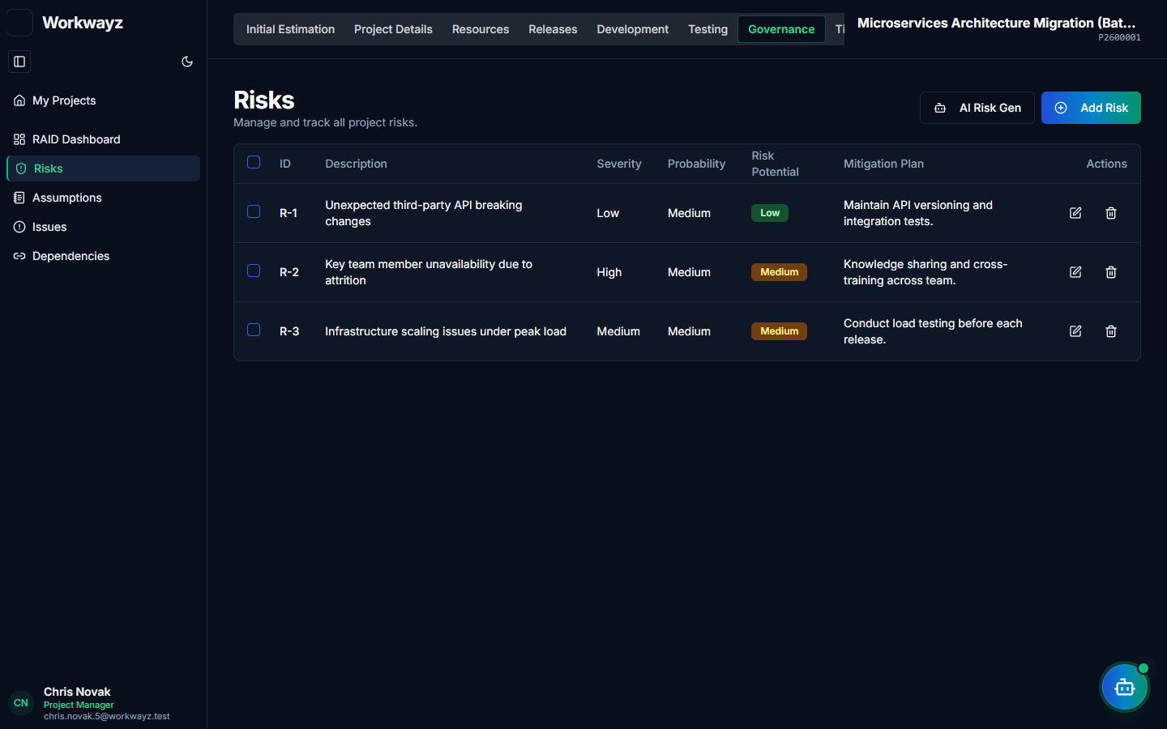
Figure 6.18b — Governance: Project Risks Register
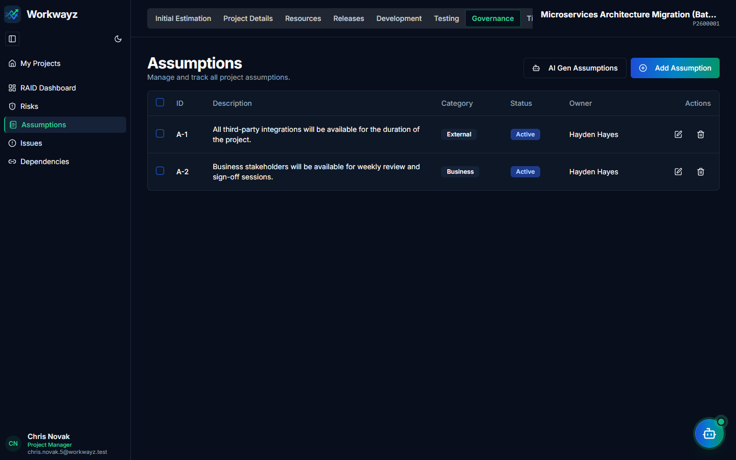
Figure 6.18c — Governance: Project Assumptions
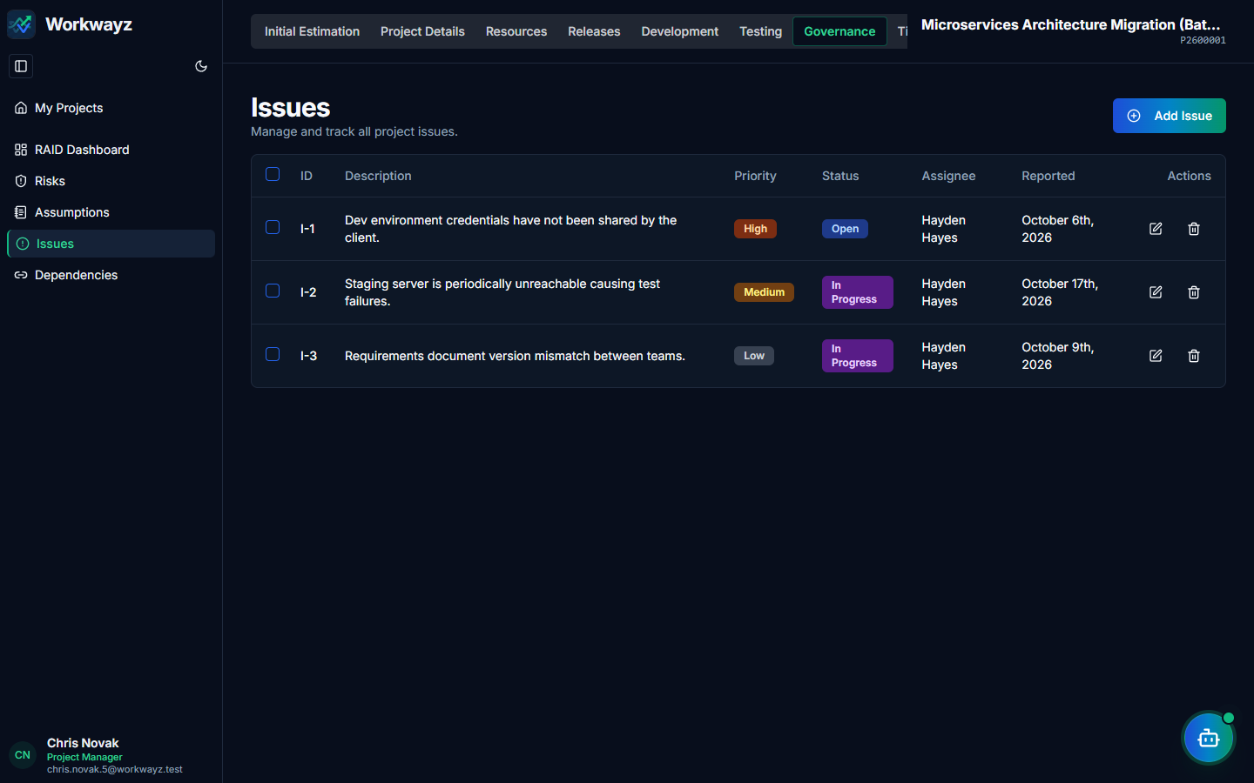
Figure 6.18d — Governance: Project Operational Issues
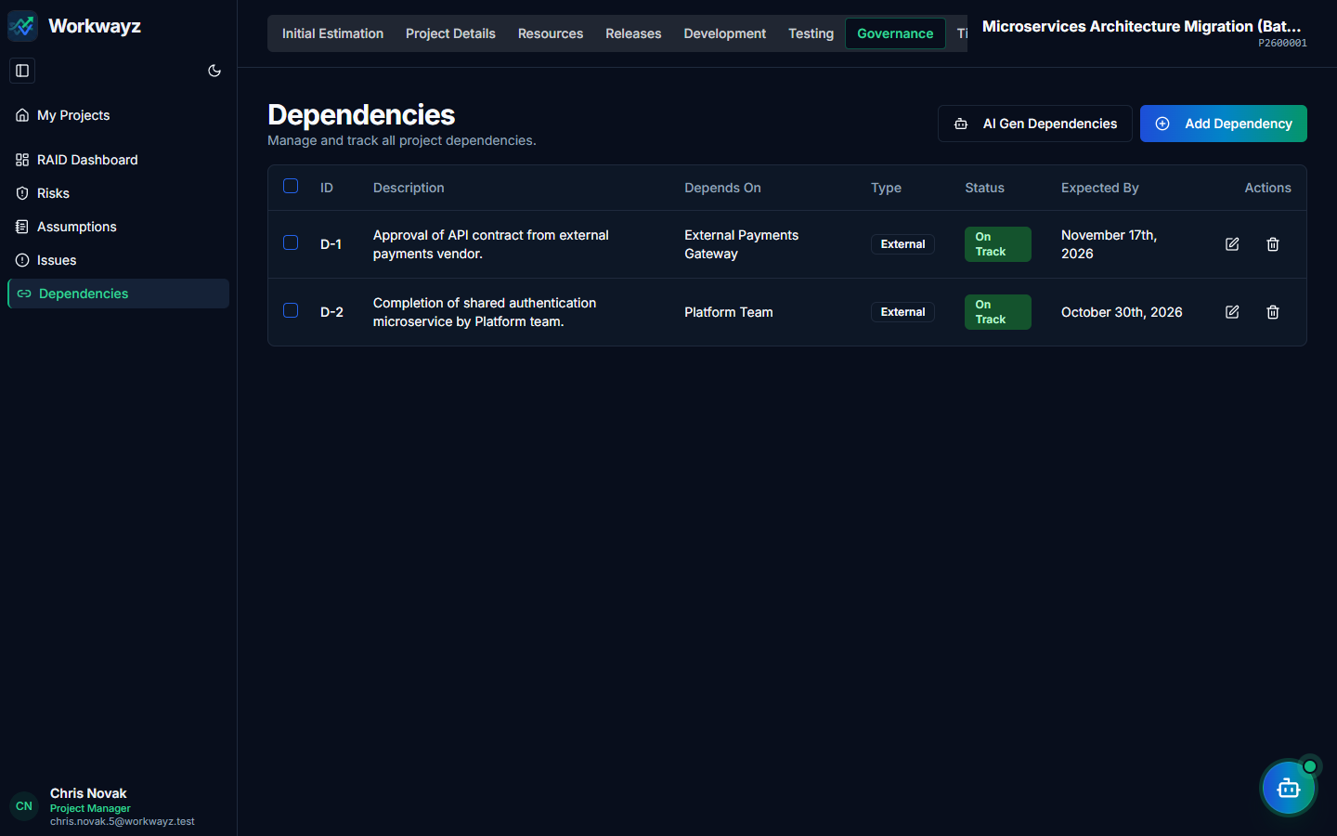
Figure 6.18e — Governance: Project Dependencies

6.19 PMO — Project Documents & Governance Gates (/pmo/documents)
Stores external links (URLs) to mandatory project governance artifacts (SOW, Requirements, HLD/DD, UI/UX Designs, QA Approval, BCP, etc.) and provides PMO sign-off controls for Permit to Build and Permit to Deploy.
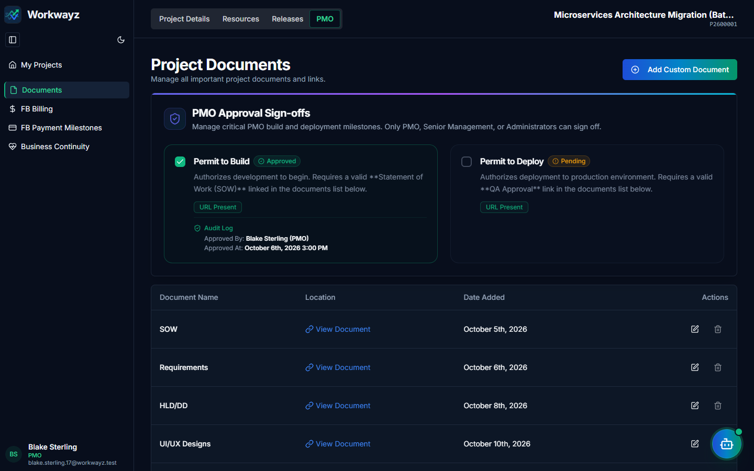
Figure 6.19 — PMO: Project Documents & Permit Approval Gates

6.20 PMO — Fixed Bid (FB) Billing & Payment Milestones
For Fixed Bid projects, Workwayz provides a complete commercial ledger:
• FB Billing (/pmo/fb-billing): Computes resource billing vs. cost rates across the project duration, tracks one-time and monthly Fixed Costs (Hosting, GIT, Set-up), and generates a comprehensive client Invoice breakdown.
• FB Payment Milestones (/pmo/fb-payment-milestones): Tracks deliverable-based payment milestones, billing percentages, invoice status transitions (TBD, In Progress, Milestone Completed, Invoice Raised, Payment Completed), and status change history.
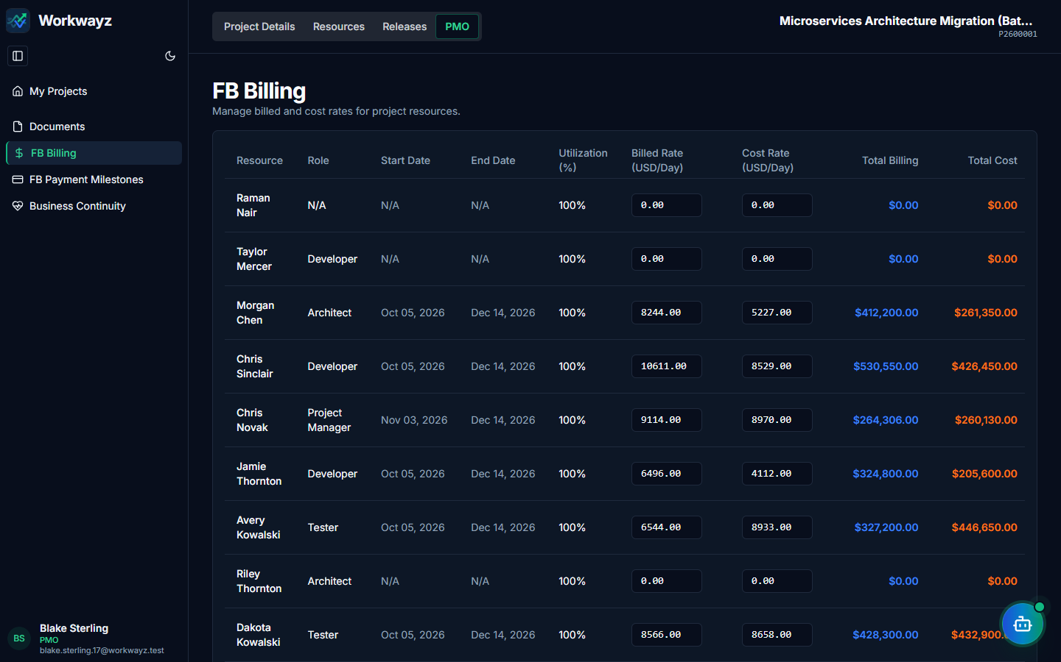
Figure 6.20a — PMO: Fixed Bid (FB) Resource Billing & Fixed Costs
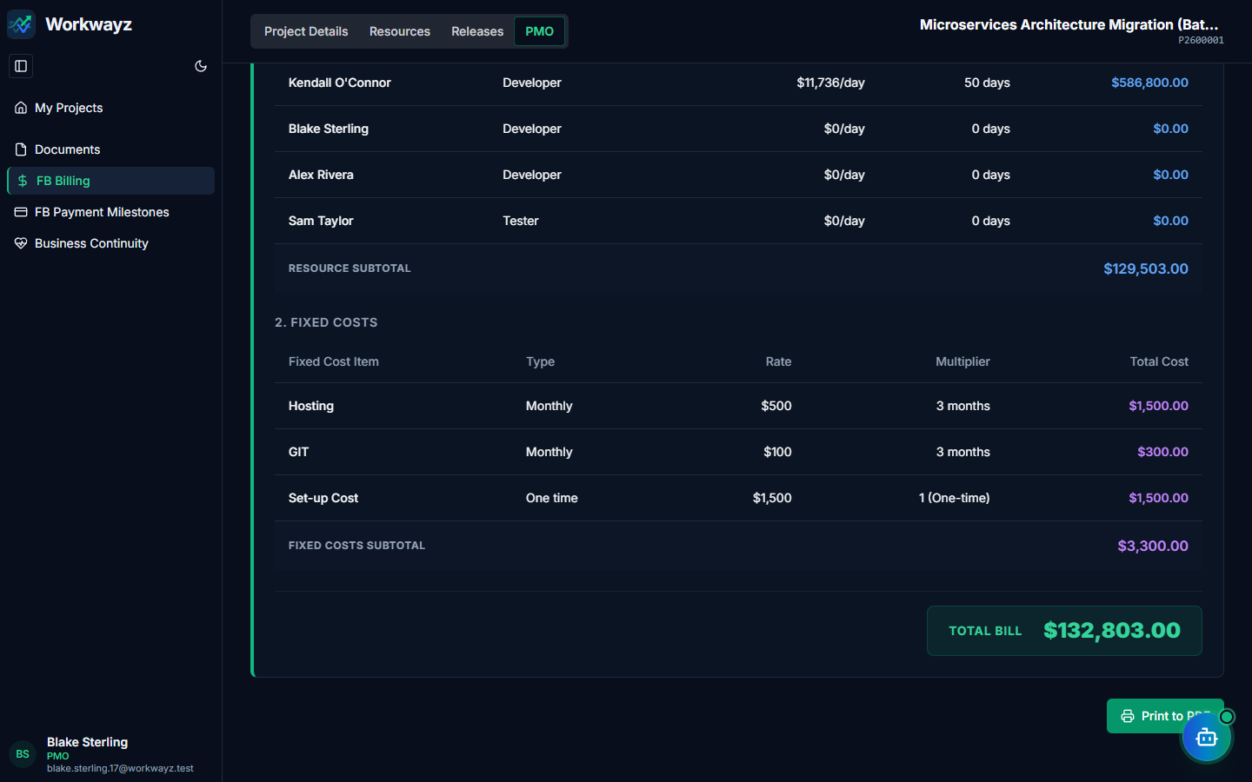
Figure 6.20b — PMO: Fixed Bid Comprehensive Client Invoice
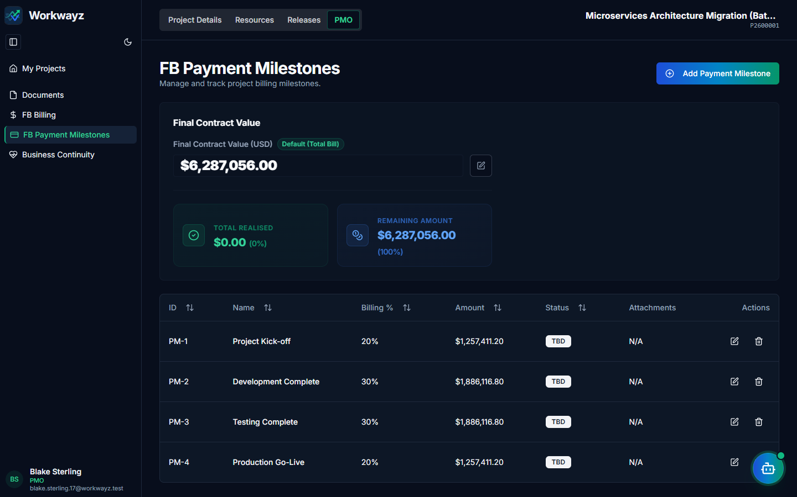
Figure 6.20c — PMO: Fixed Bid Payment Milestones

6.21 PMO — Time & Material (TnM) Billing & Payment Milestones
For Time & Material (T&M) projects (e.g., P2600002), billing is computed monthly:
• TnM Billing (/pmo/tnm-billing): Selects a Billing Month and automatically factors in working days, employee Loss of Pay (LOP) days, Overtime days, and monthly Fixed Costs to generate the monthly client Invoice.
• TnM Payment Milestones (/pmo/tnm-payment-milestones): Tracks monthly invoice amounts and payment realization status for each calendar month.
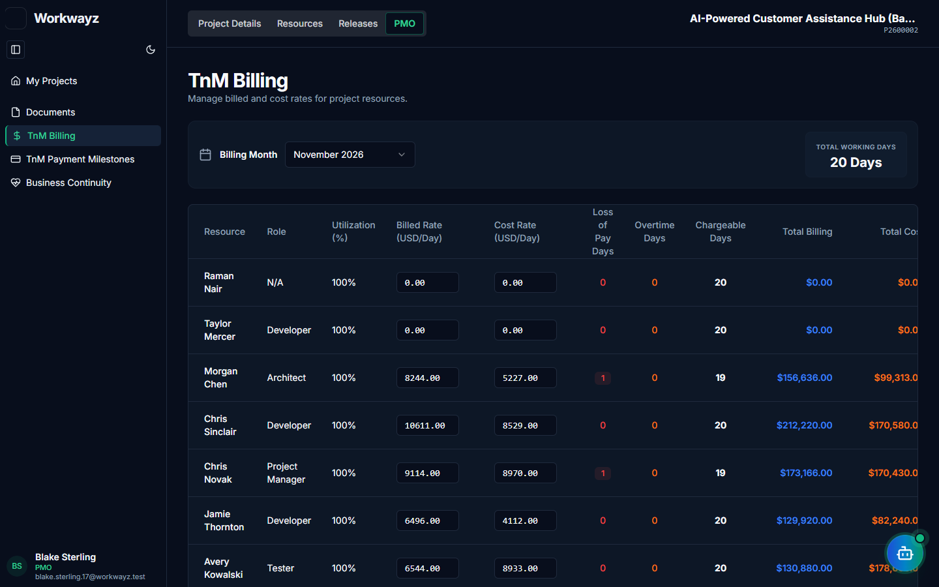
Figure 6.21a — PMO: Time & Material (TnM) Monthly Billing Ledger
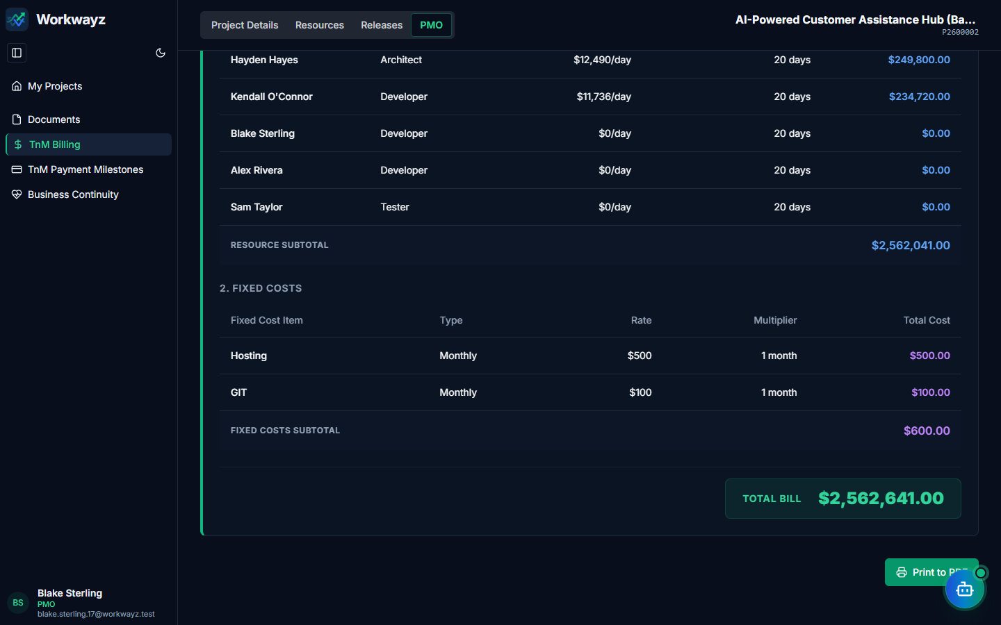
Figure 6.21b — PMO: Time & Material Monthly Invoice Breakdown
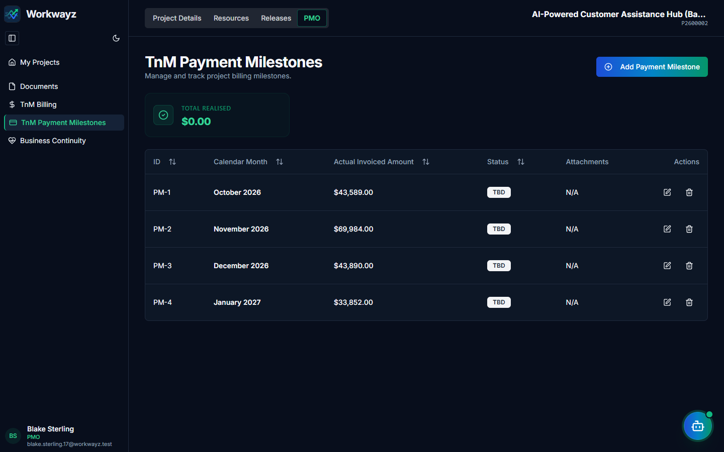
Figure 6.21c — PMO: Time & Material Monthly Payment Milestones

6.22 PMO — Business Continuity (/pmo/business-continuity)
Safeguards operational continuity against resource turnover by recording Environment URLs and SSL/certificate expiry dates, Code Repository URLs and token expiry dates, and designated BCP Support Resources.
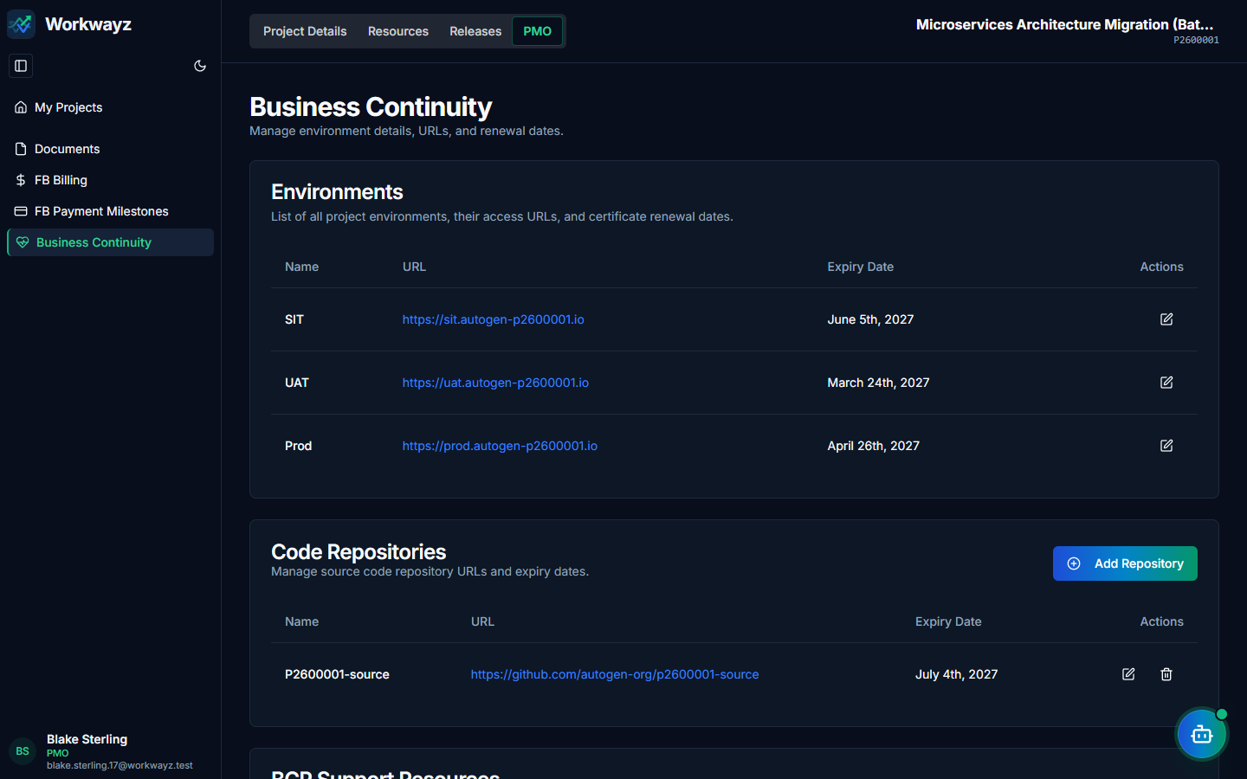
Figure 6.22 — PMO: Business Continuity (Environments, Repositories & BCP Resources)

6.23 Project Settings & Project Trash
Project Managers and Leads can customize agile execution parameters and recover deleted project items:
• Board Settings (/project-settings/board): Add, rename, drag-to-reorder, or remove custom Kanban swimlanes.
• Sprint Settings (/project-settings/sprint): Configure default Sprint Duration (1–8 weeks) and Sprint Start Day.
• Effort Settings (/project-settings/effort): Define conversion ratios for Man-Month to Man-Days, Man-Day to Man-Hours, and Story Point to Man-Hours.
• Project Trash (/project-trash): Restore or permanently delete soft-deleted stories, sub-tasks, test cases, RAID items, and documents.
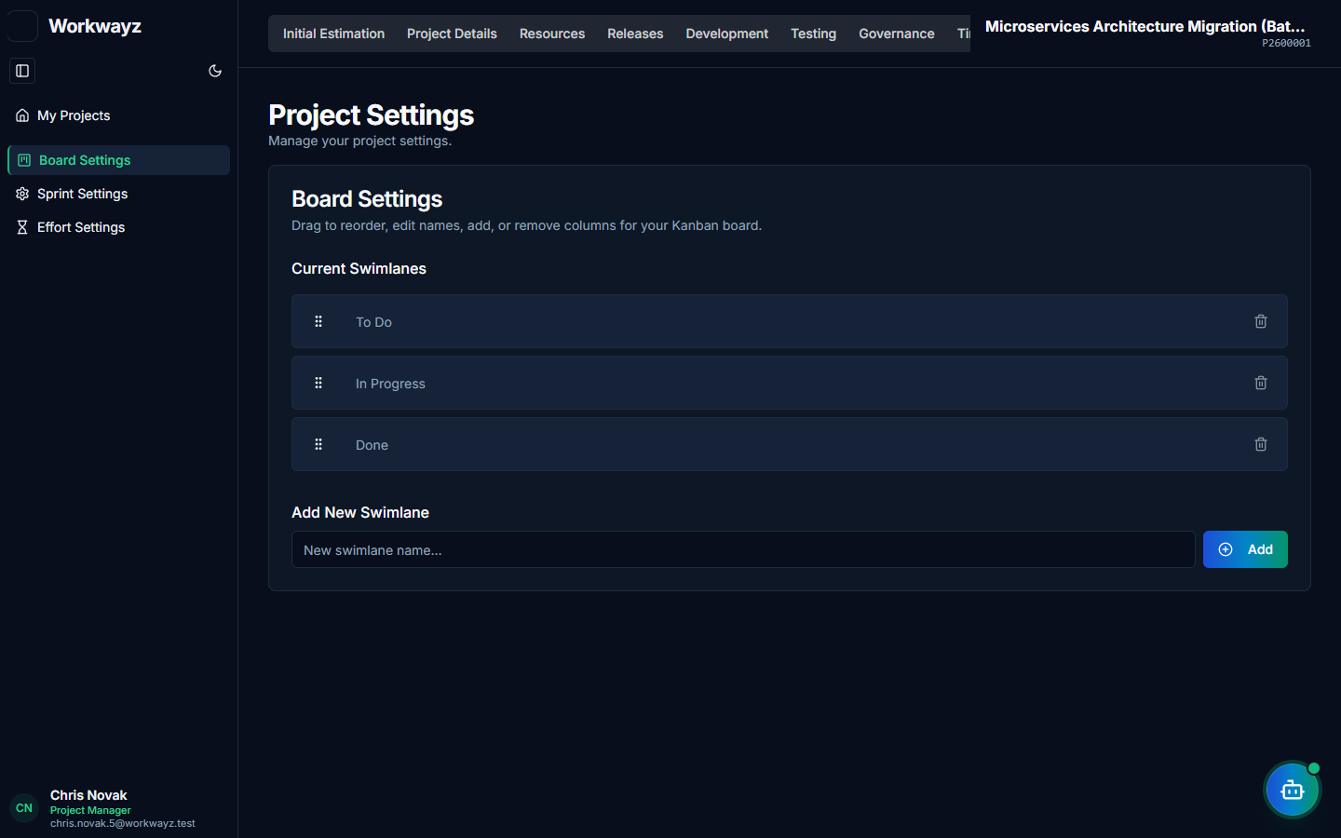
Figure 6.23a — Project Settings: Kanban Board Swimlane Settings
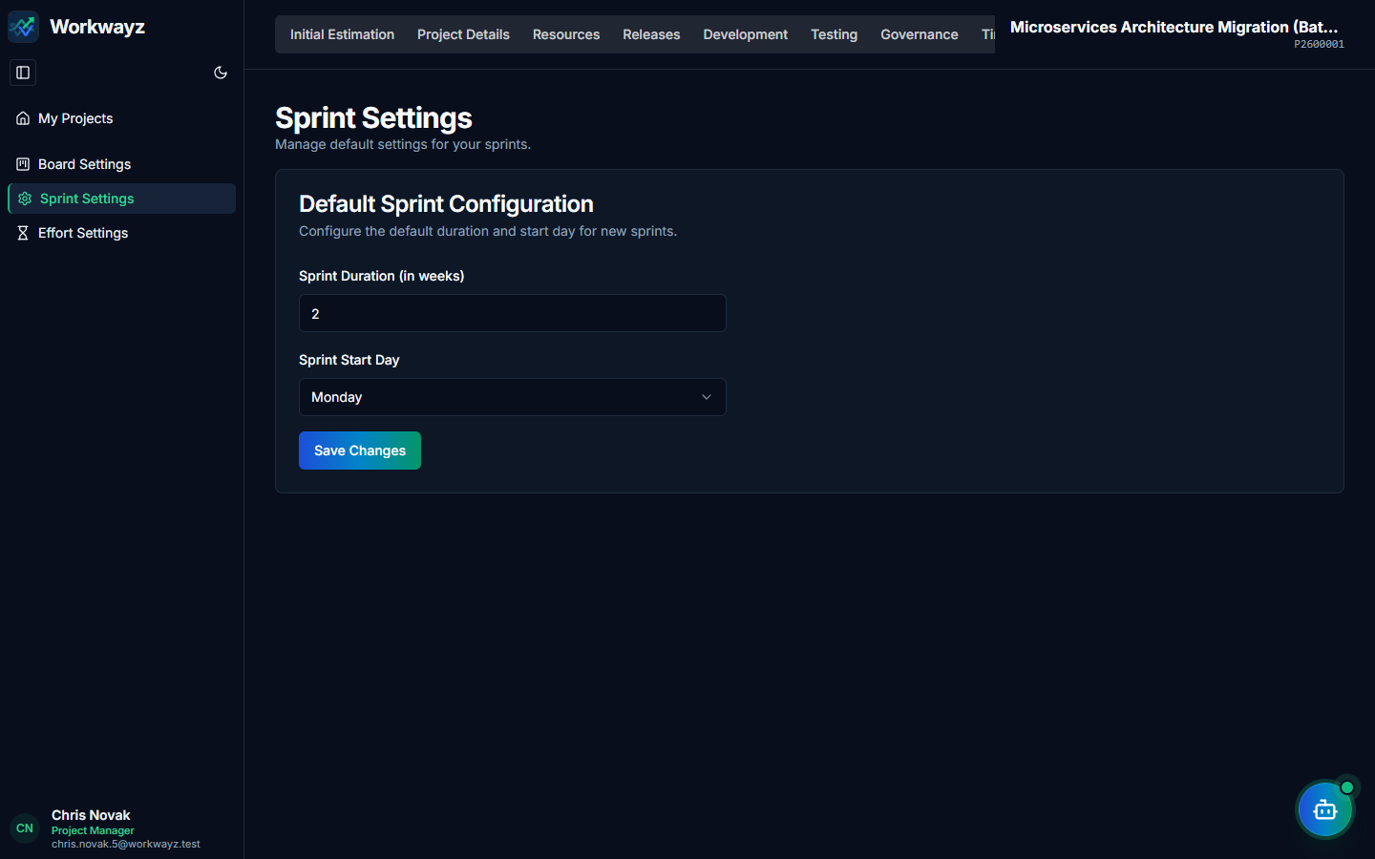
Figure 6.23b — Project Settings: Default Sprint Configuration
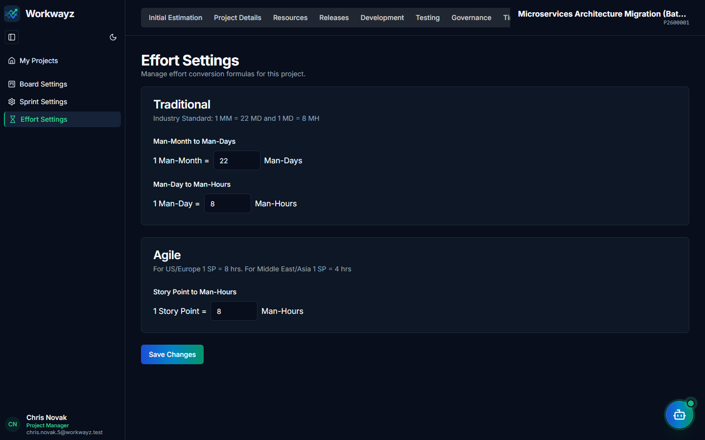
Figure 6.23c — Project Settings: Effort Conversion Formulas
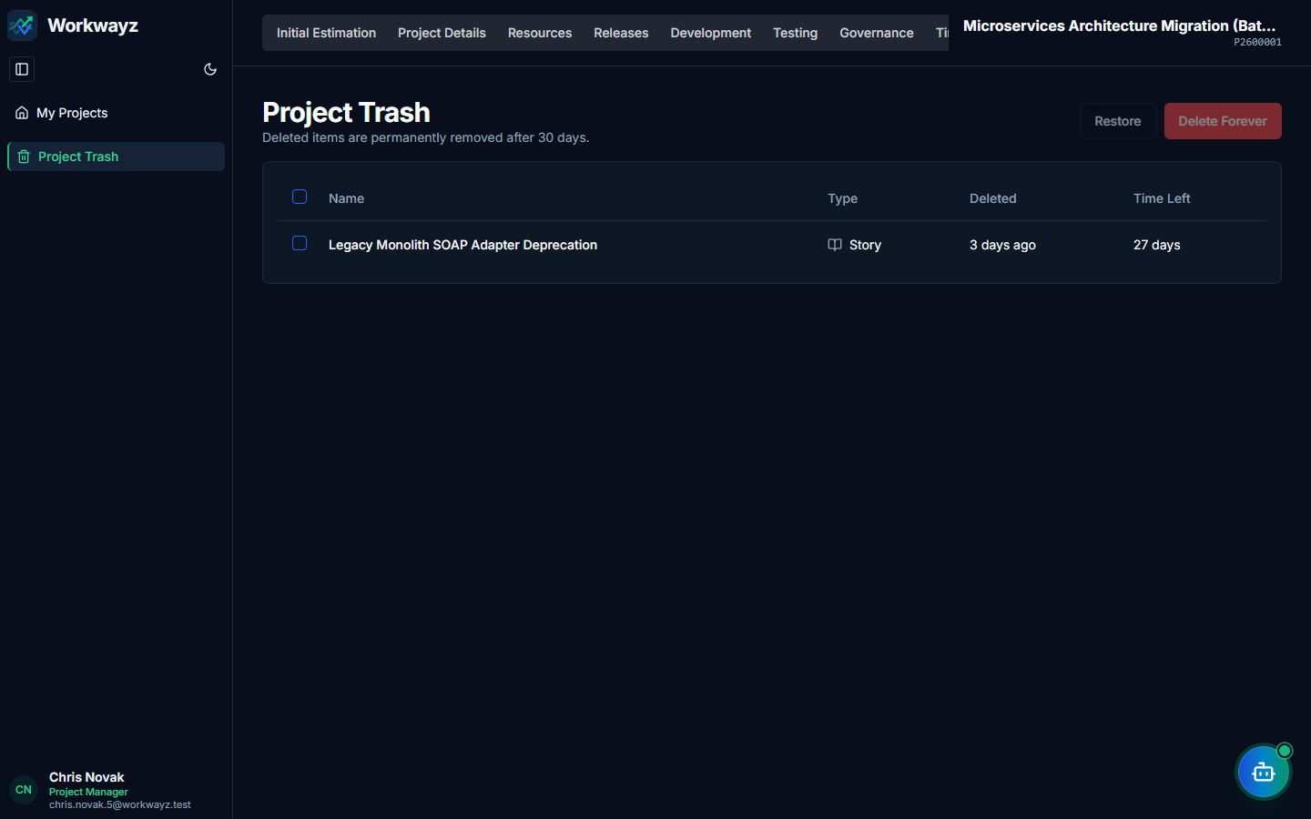
Figure 6.23d — Project Trash & Item Recovery

7. Admin Flow
Accessible exclusively to Super Admin and Administrator roles via the Portfolio Settings (gear icon) and Portfolio Trash (trash icon) tabs, the Admin Flow governs platform-wide security permissions, infrastructure bindings, scheduled jobs, synthetic test data, and retention policies.

7.1 Portfolio Settings — Access Settings (/portfolio-settings/access-settings)
Configures role-based permissions across two matrices:
• Page Access Tab: Toggles visibility of Admin Level Pages, Portfolio Level Pages, and Project Level Pages (aligned with the consolidated 7 project lifecycle tabs) for Administrator, Senior Management, Project Manager, Lead, Team Member, and PMO roles.
• CRUD Access Tab: Configures granular Create (C), Read (R), Update (U), and Delete (D) permissions across Portfolio Level, Project Level, Story/Feature Change/Task Level, and Sub-tasks/Bugs/Test Cases Level.
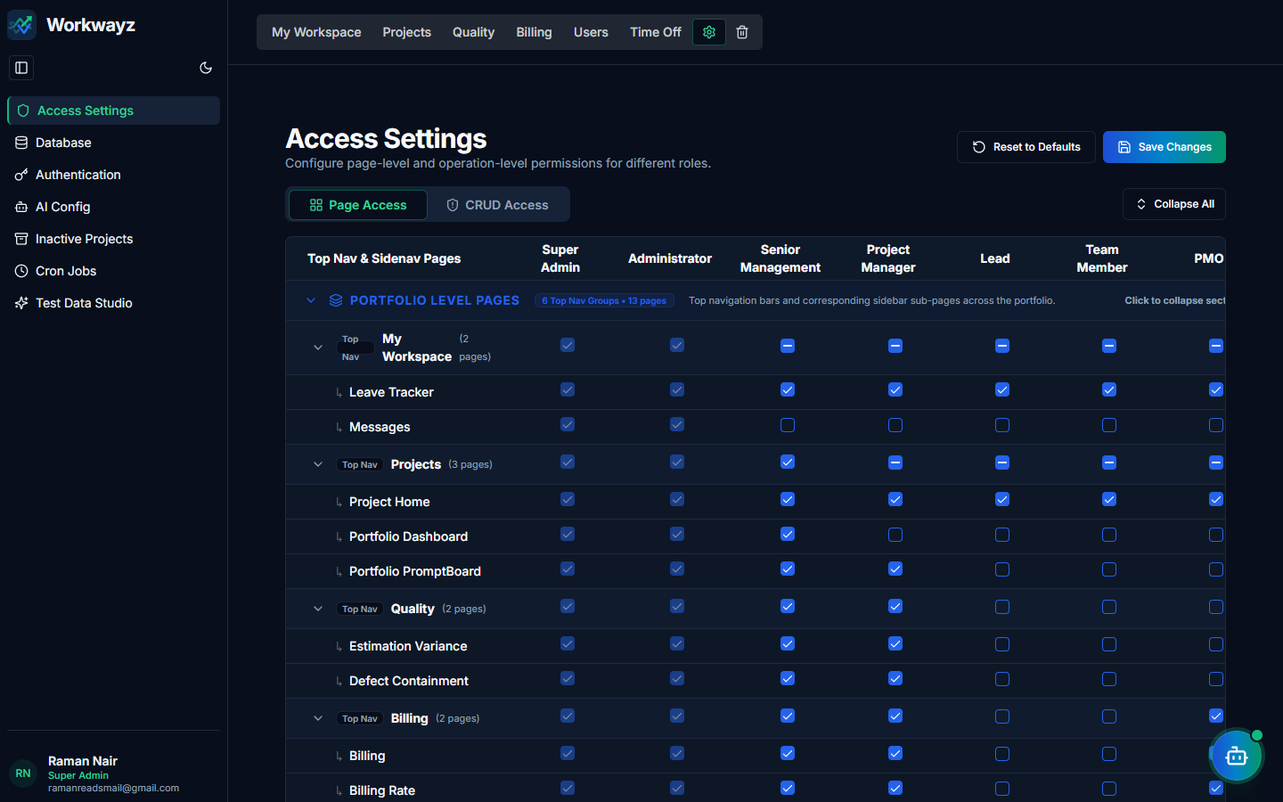
Figure 7.1a — Access Settings: Page Access Permission Matrix
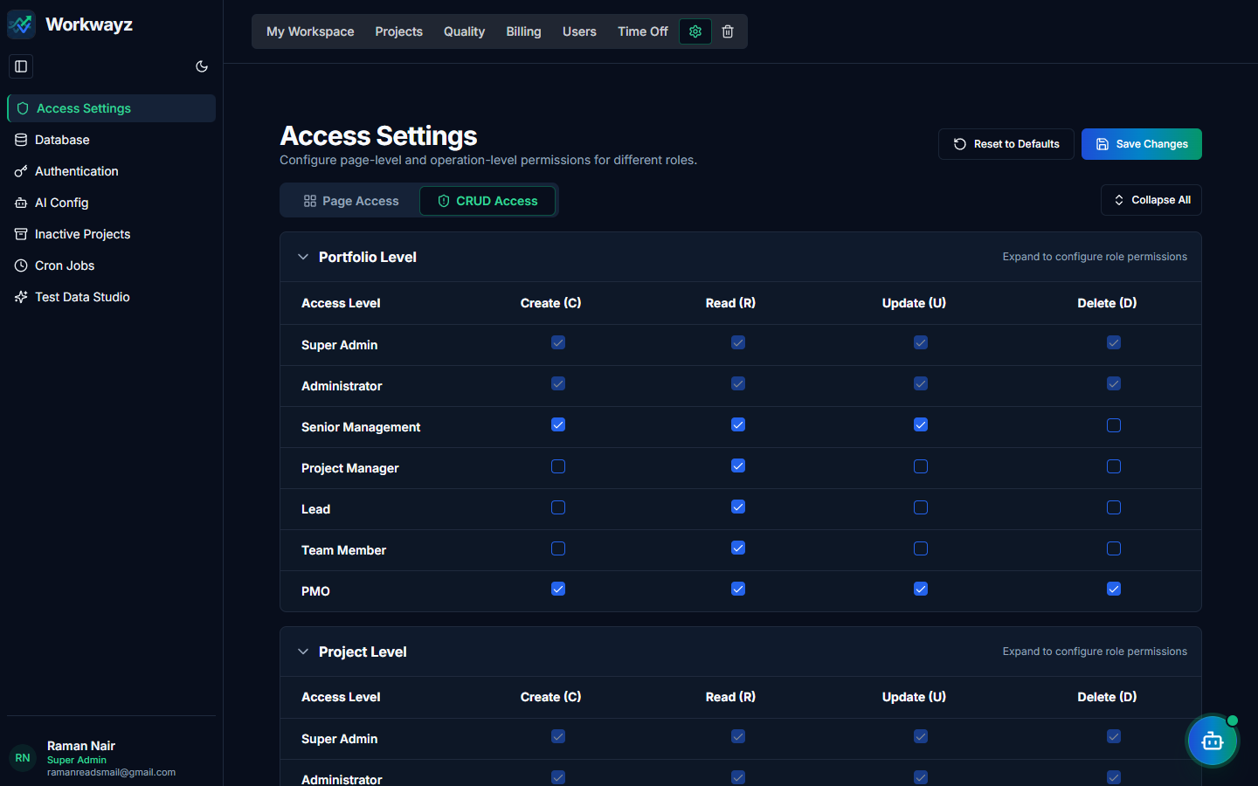
Figure 7.1b — Access Settings: CRUD Operation Permission Matrix

7.2 Portfolio Settings — Database (/portfolio-settings/database)
Displays the active database binding and allows Administrators to configure, test, and switch connection profiles between Local Embedded Database, Supabase, and Firebase.
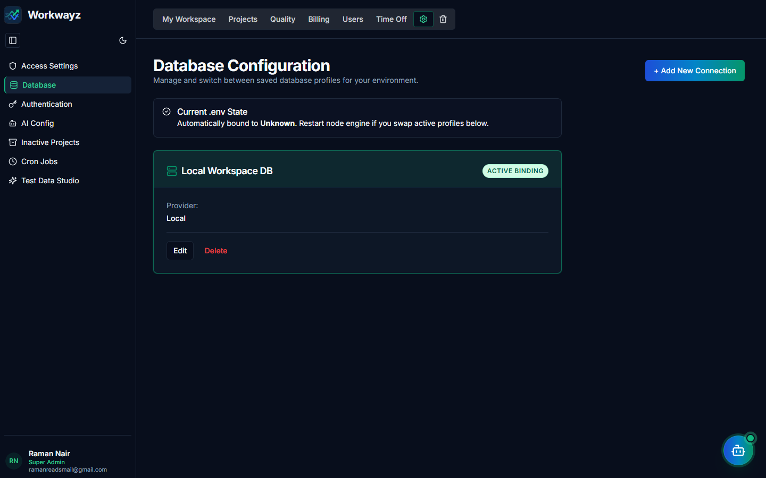
Figure 7.2 — Portfolio Settings: Database Connection Management

7.3 Portfolio Settings — Authentication (/portfolio-settings/authentication)
Manages the active authentication provider profile and Single Sign-On (SSO) integrations.
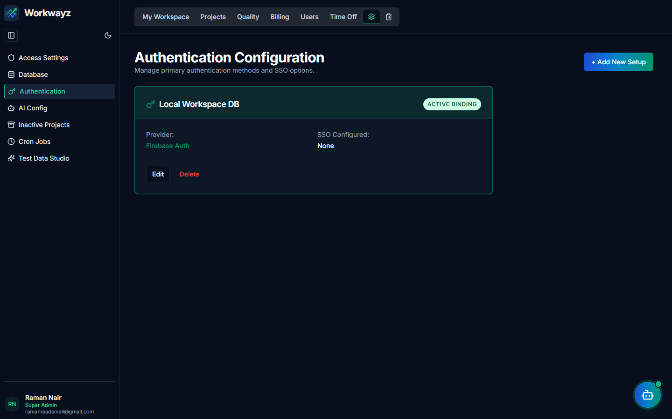
Figure 7.3 — Portfolio Settings: Authentication Configuration

7.4 Portfolio Settings — AI Config (/portfolio-settings/ai-config)
Manages generative AI connection profiles (Google Gemini, OpenAI, Anthropic Claude, Ollama, LM Studio), API keys, default model overrides, and live token/cost rate utilization telemetry.
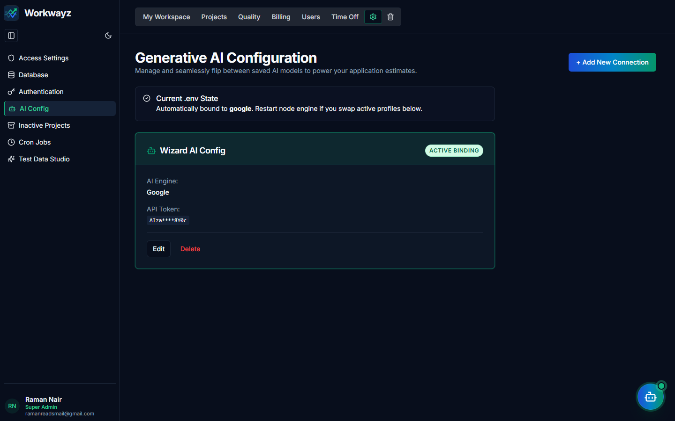
Figure 7.4 — Portfolio Settings: Generative AI Configuration & Telemetry

7.5 Portfolio Settings — Inactive Projects & Archiving (/portfolio-settings/archive)
Configures automated project archiving timeframes for completed projects and auto-deletion rules for archived projects, and provides manual archiving controls.
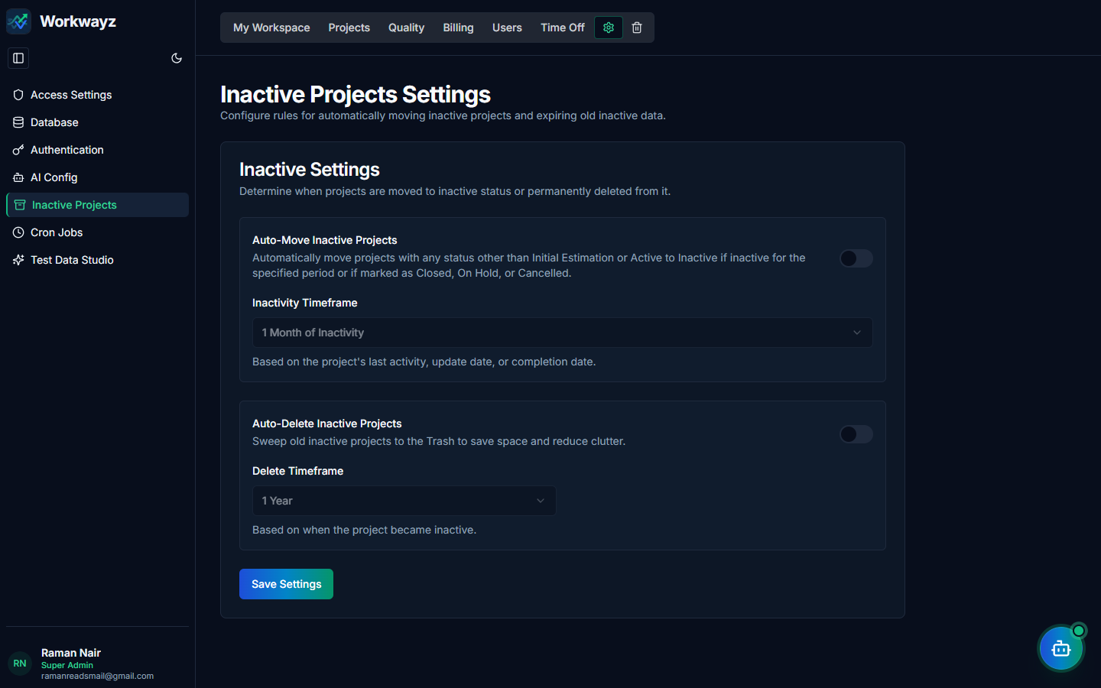
Figure 7.5 — Portfolio Settings: Inactive Projects & Archive Policy

7.6 Portfolio Settings — Cron Jobs Management (/portfolio-settings/cron-jobs)
Centralized administration console for all scheduled WayFinder PromptBoard report jobs across portfolios and projects. Administrators can inspect execution counts, trigger immediate runs, pause/resume schedules, or delete jobs.
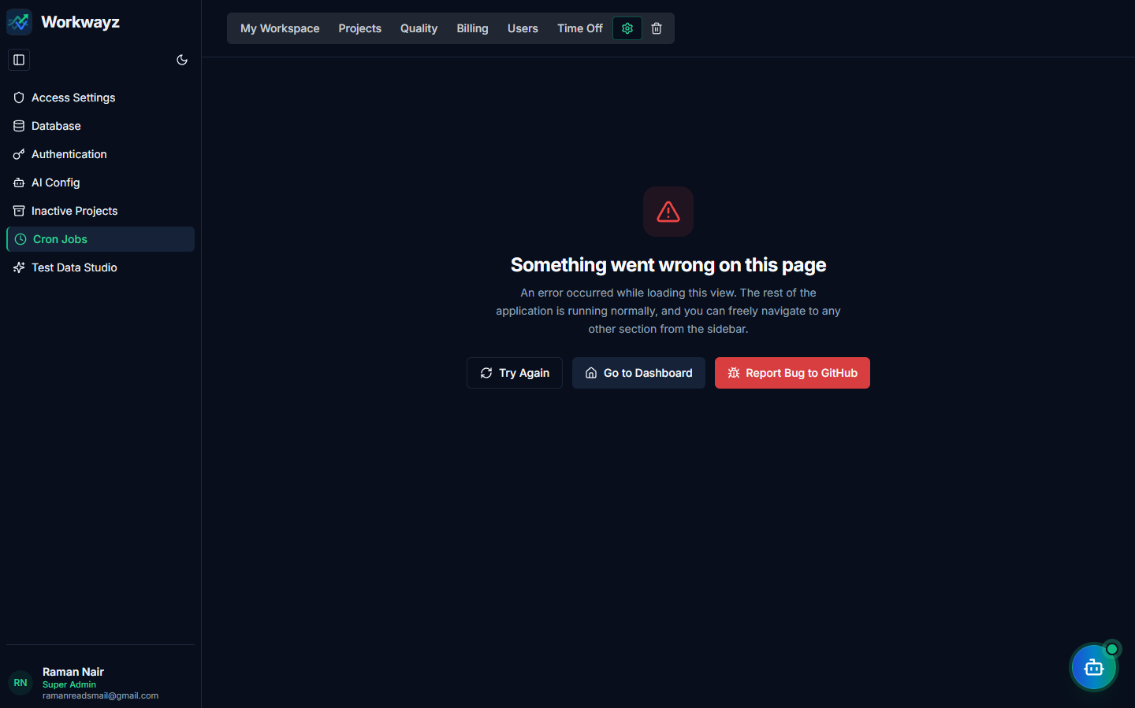
Figure 7.6 — Portfolio Settings: Automated Cron Jobs Management

7.7 Portfolio Settings — Test Data Studio (/portfolio-settings/test-data-studio)
Interactive synthetic data generator allowing Administrators to seed realistic portfolios, employees across all access levels, active projects (with stories, sprints, test cases, worklogs, and RAID items), and initial estimations, or cleanly wipe studio-generated test data batches.
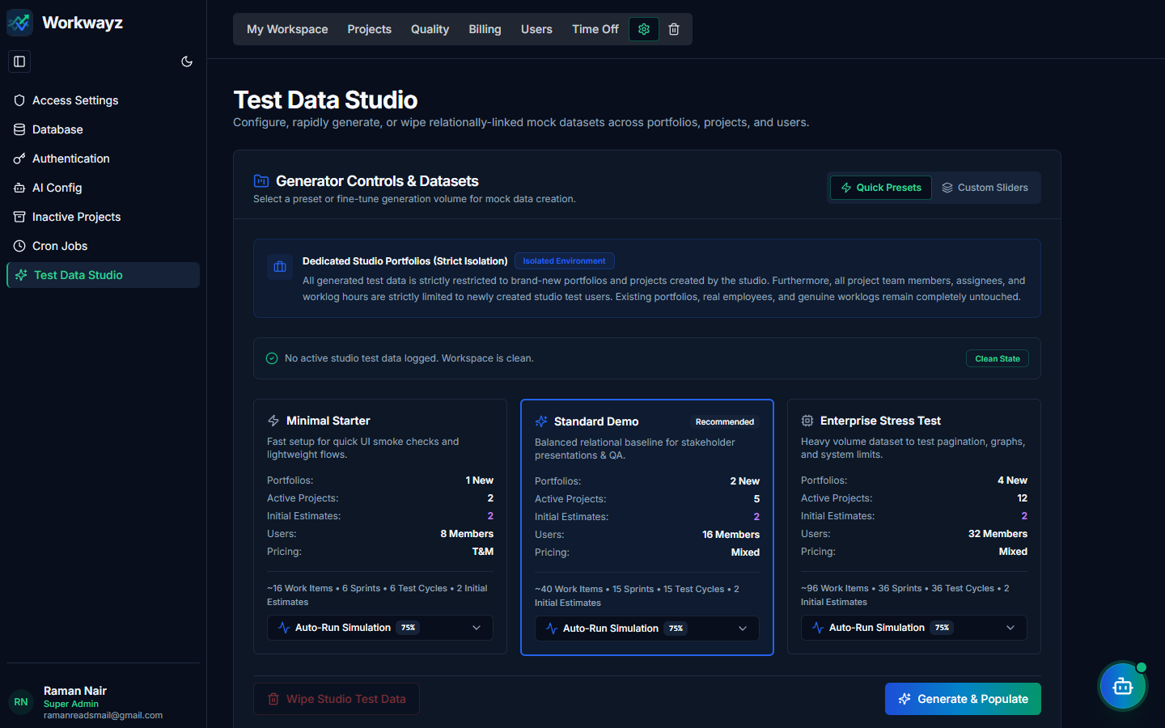
Figure 7.7 — Portfolio Settings: Test Data Studio

7.8 Portfolio Trash (/portfolio-trash)
Holds soft-deleted portfolios, projects, and users for a 30-day retention window before permanent deletion, allowing Administrators to restore accidentally deleted items or permanently erase them.
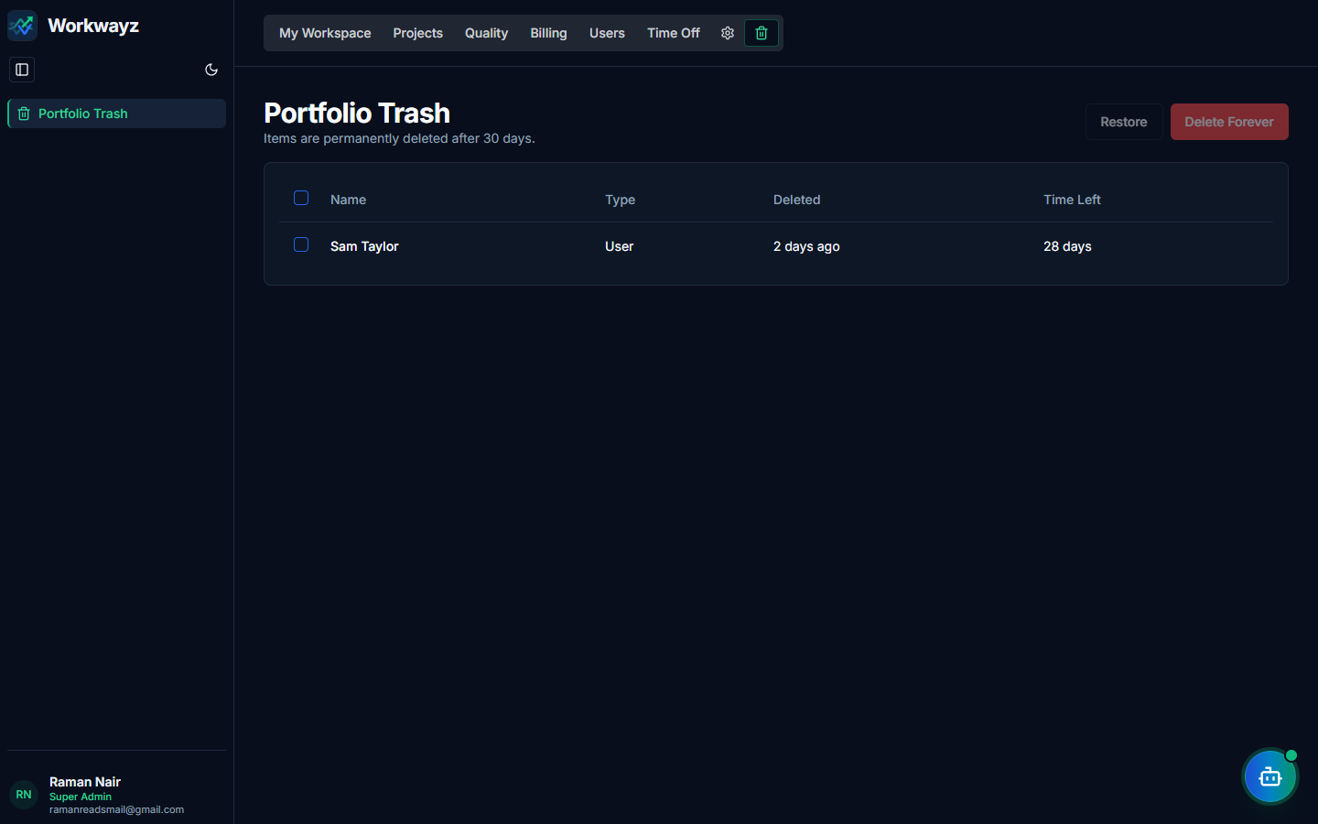
Figure 7.8 — Portfolio Trash & 30-Day Recovery Terminal

